COMHAIRLE CONTAE ÁTHA CLIATH THEAS
SOUTH DUBLIN COUNTY COUNCIL

MEETING OF CLONDALKIN AREA COMMITTEE
Wednesday, NOVEMBER 17, 2010
Motion NO. 8
QUESTION: Councillor T. Ridge
That the Manager provide a map outlining the proposed lockable gates and other measures to combat anti social activity in and at St. Cuthbert's Park, Clondalkin.
REPORT:
There are a total of 12 entrances into St Cuthberts Park. These are indicated on the enclosed map and comprise of the following:
Entrance No. | Location | Type | Condition
1 | Westbourne Rise | Vehicle & Kissing gate | Good
2 | Bawnogue Road | Kissing Gate | Good
3 | Bawnogue Road | Kissing Gate | Gate vandalised. Cut off.
4 | Bawnogue Road | Kissing Gate | Good
5 | Deansrath Park | Kissing Gate | Gate good. Adjacent wall vandalised – stone missing. Boulder partially blocking gap.
6 | Deansrath Green | Kissing Gate | Gate vandalised. Cut off. Wall vandalised –stone missing.
7 | Melrose Green | Kissing Gate | Gate good. Wall vandalised. 2 boulders partially blocking gap
8 | Melrose Park | Kissing Gate | Gate good. Boulder blocking gap
9 | Lindisfarne Grove | Gap with boulder | Good
10 | Lealand Ave | Gap | Good
11 | Lealand Ave | K barrier | Good
12 | Lealand Walk | K barrier | Good

The Park is surrounded by a low stub wall varying in height from 450mm – 830mm. The entrances have been provided at strategic locations to allow for pedestrian movement in and out of the park. Their design is to enable unrestricted pedestrian access while deterring vehicle access. This is proving difficult to manage and has resulted in two gates being vandalised (mechanically cut using an angle grinder) at locations 3 and 6 resulting in unimpeded access for motorbikes, horses etc.
The only gate that is locked is the vehicle gate at location No 1. The existing pedestrian entrances have not been designed to enable locking. In the event that they were to be locked it would not prevent access to the park on account of the low nature of the boundary wall and given the experiences of gates being vandalised it is likely that any locked gates would be subjected to further vandalism.
The vandalism of the boundaries is a continual problem that is experienced at St Cuthberts Park and one which necessitates the use of significant resources. The 2 gates that are currently vandalised and the damaged walls will be repaired as part of the works programme for the area subject to the identification of the necessary resources.
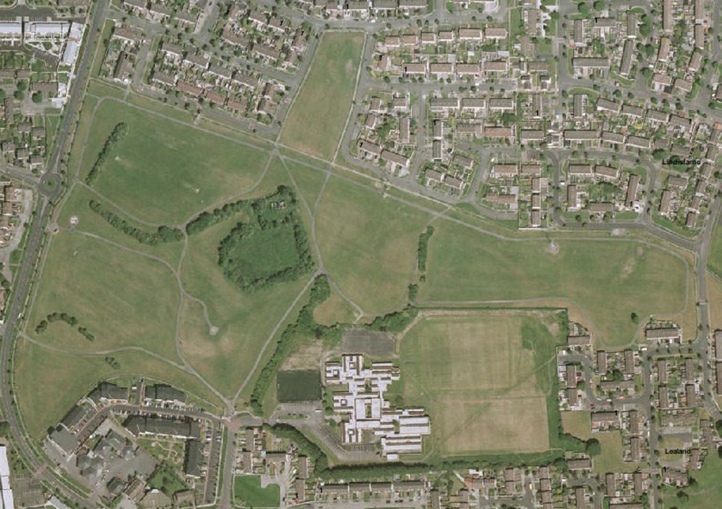
1
10
12
9
8
7
6
5
4
3
2
11

St Cuthberts Park - map indicating 12 entrances

