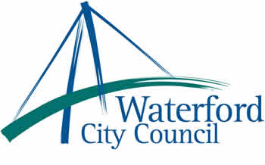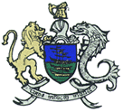

27th October 2010

To: The Meetings Administrator

The following motion was unanimously adopted by Waterford City Council at its monthly meeting held on the 11th October 2010.

“That this Council,
Recognising that,
- The National Minimum Wage is an important instrument designed to prevent
worker exploitation.
- Low paid workers and those on the minimum wage are struggling to get by
and cannot afford to take any reduction in their incomes.
- Any reduction in the minimum wage or the incomes of low paid workers would force more families to rely on supplementary welfare assistance from the state.
- Economic recovery will not be achieved by driving down wages or by becoming a low wage economy.
Opposes any reduction in the National Minimum Wage.

Yours sincerely,

Billy Duggan
Meetings Administrator

