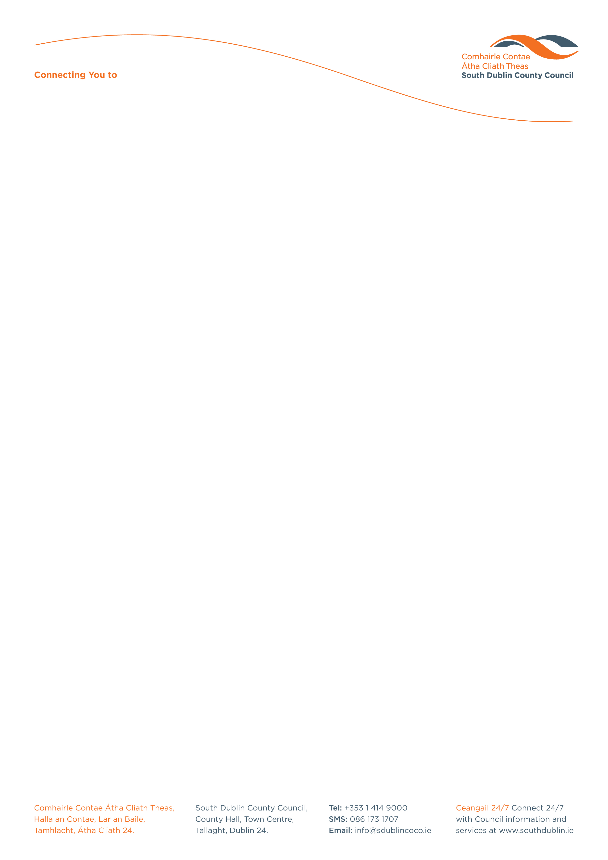

Halla an Chontae, Lár an Bhaile County Hall, Town Centre
Tamhlacht, Baile Átha Cliath 24 Tallaght, Dublin 24
Telefon: 01-4149052 Telephone: 01-4149052

Facs: 01-4149332 Fax: 01-4149332
www.southdublin.ie

The Manager
EIRCOM,
1 Heuston South Quarter,
St. John's Road,
Dublin 8. October 4th, 2010

RE: Tallaght Area Committee Meeting – 27th September, 2010

Dear Sir/Madam,

At South Dublin County Council’s Tallaght Area Committee Meeting, held on 27th September, 2010, the following Motion was passed:

“That this committee calls on the Manager to request service providers such as the ESB, Eircom, NTL and Dublin Bus to take appropriate action to repair and enhance their properties i.e. substations and bus shelters in the West Tallaght area to provide a positive and attractive element to the local community - suggestions such as creating mural art on ESB substations etc to be explored”.

I should be obliged if you would let me have a reply on the matter at your earliest convenience.

Thanking you in anticipation.

Yours sincerely,

Allyson Rooney,
SENIOR STAFF OFFICER,
HOUSING ADMINISTRATION.

Housing Administration

