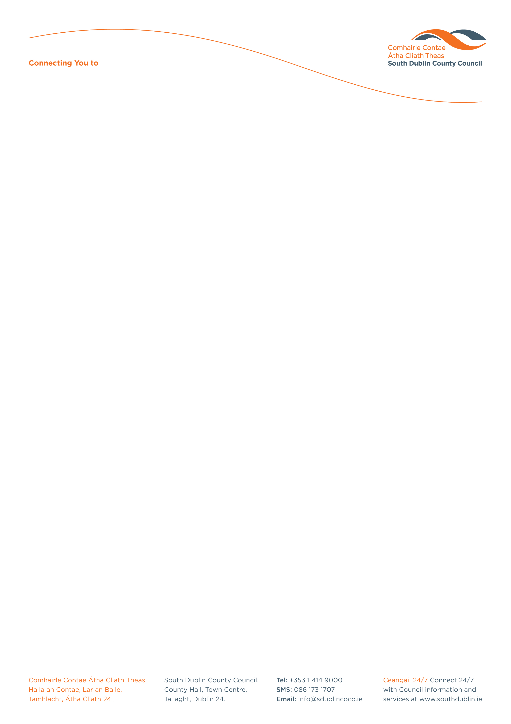

Halla an Chontae, Lár an Bhaile County Hall, Town Centre
Tamhlacht, Baile Átha Cliath 24 Tallaght, Dublin 24
Telefon: 01-4149052 Telephone: 01-4149052

Facs: 01-4149332 Fax: 01-4149332
www.southdublin.ie

The Manager,
Dublin Bus,
O’Connell Street,
Dublin 1.
October 4th , 2010

RE: Tallaght Area Committee Meeting – 27th September, 2010

Dear Sir/Madam,

At South Dublin County Council’s Tallaght Area Committee Meeting, held on 27th September, 2010, the following question was raised:

"To ask the Manager for an update from Dublin Bus with regard to bus 74 which services Ballycullen?"

I should be obliged if you would let me have a reply on the matter at your earliest convenience.

Thanking you in anticipation.

Yours sincerely,

Allyson Rooney,
SENIOR STAFF OFFICER,
HOUSING ADMINISTRATION.

Housing Administration

