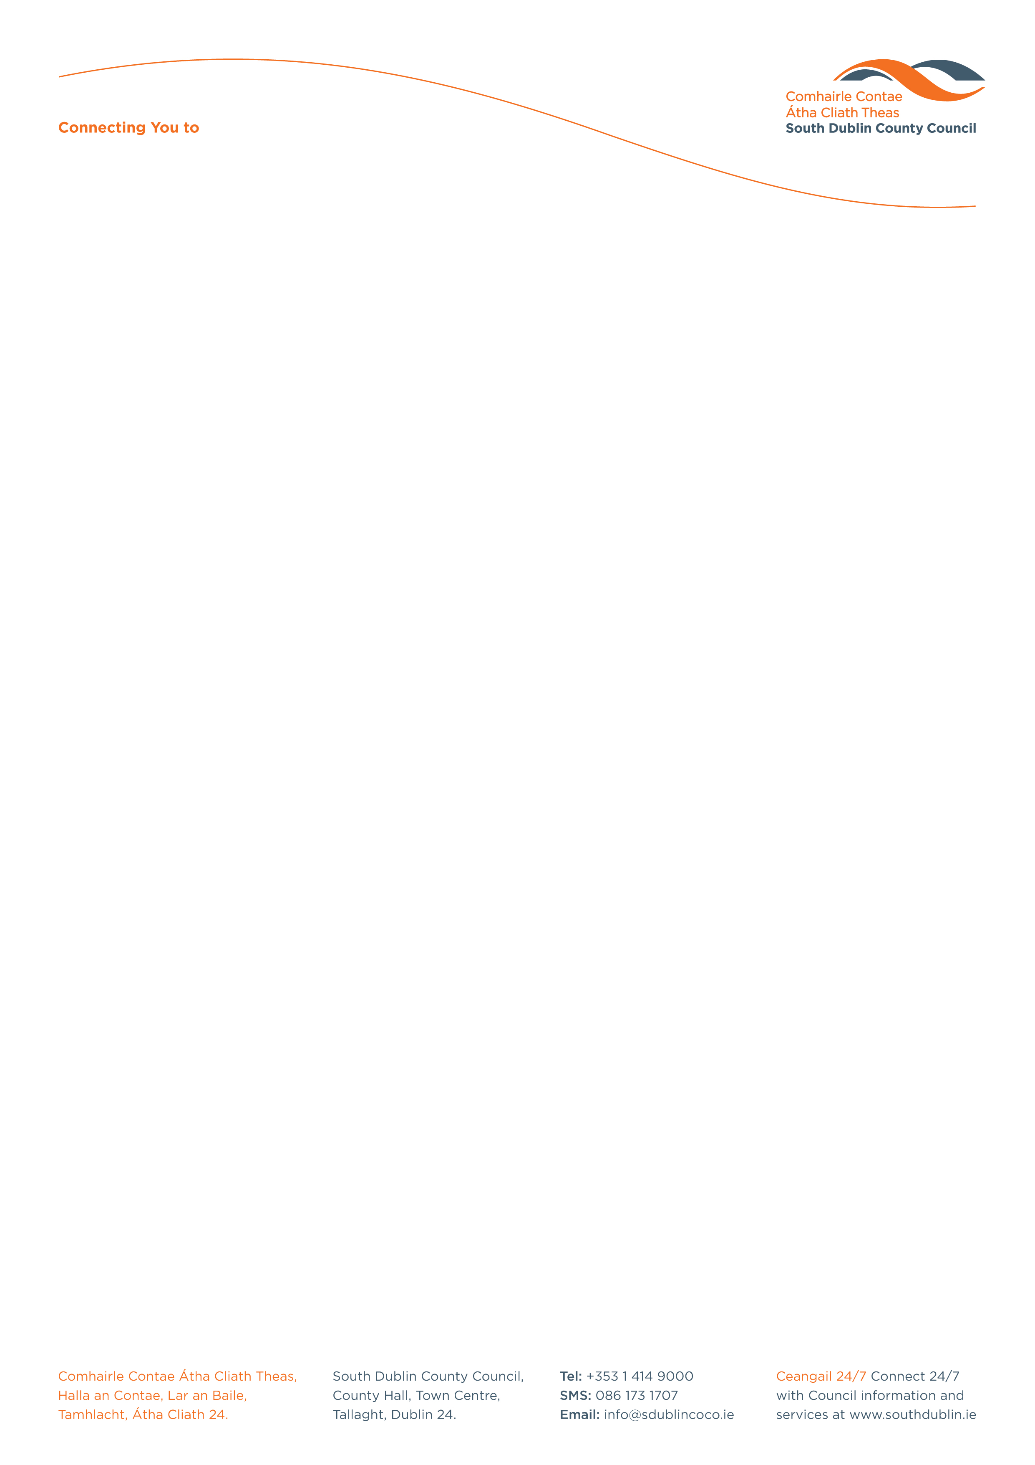

Halla an Chontae, Lár an Bhaile County Hall, Town Centre
Tamhlacht, Baile Átha Cliath 24 Tallaght, Dublin 24
Telefon: 01-4149052 Telephone: 01-4149052

Facs: 01-4149332 Fax: 01-4149332
www.southdublin.ie

IBAL,
c/o An Taisce,
Environmental Education Unit,
5A Swifts Alley
Francis Street
Dublin 8

October 13th, 2010

RE: Tallaght Area Committee Meeting (1) – 20th September, 2010

Dear Sir/Madam,

At South Dublin County Council’s Tallaght Area Committee Meeting, held on 20th September, 2010, the following motion was passed:
“That this Committee calls on the Manager to arrange for additional efforts to be made by the cleansing section to target the locations in the Tallaght area identified in the recent IBAL survey while acknowledging the work carried out by individual staff members and the Community and questioning the relevance, affect and accuracy of the IBAL survey itself.”
The members agreed to invite IBAL to a Question & Answer session at a meeting of the Tallaght Area Committee dealing with Environmental Services business.

I should be obliged if you would let me have a reply on the matter at your earliest convenience.

Thanking you in anticipation.

Yours sincerely,

Allyson Rooney,
SENIOR STAFF OFFICER,
HOUSING ADMINISTRATION.

Housing Administration

