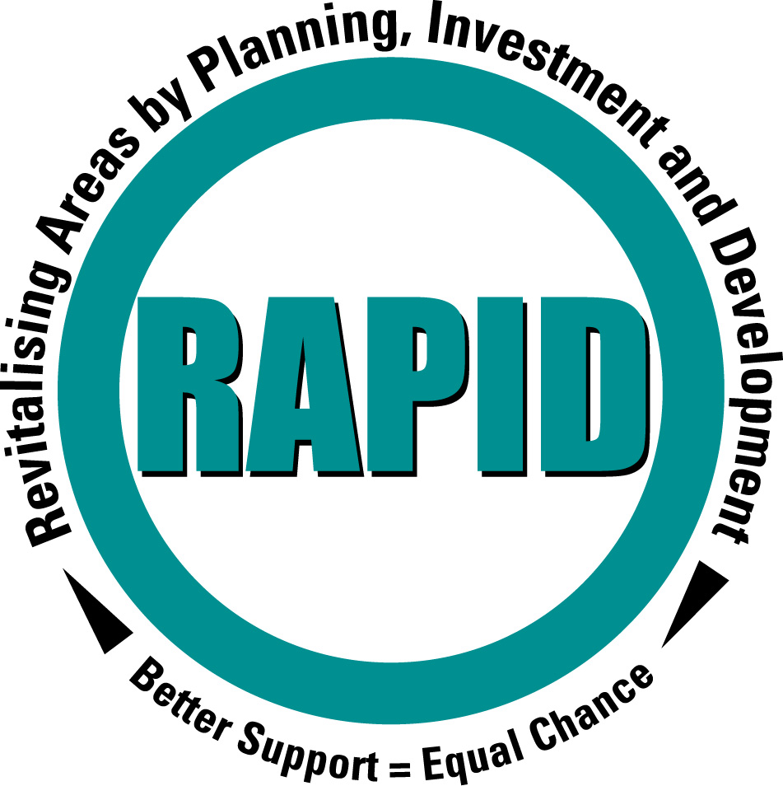
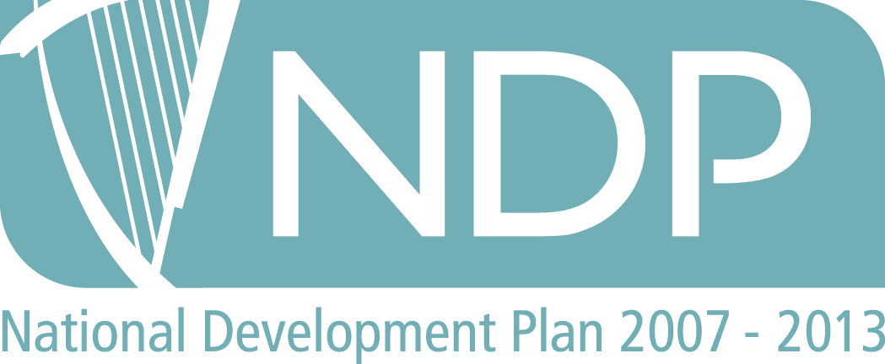
RAPID Programme
North Clondalkin

RAPID Office

Civic Offices, Clondalkin
Dublin 22.
Telephone: 01-414 9270
Mobile: 086-851-3449
Website: www.southdublin.ie
Email: alane@sdublincoco.ie

AL00909A.LTR
9th September 2010
Willie Shiels
The Senior Executive Officer
Community Department
South Dublin County Council
County Hall
Tallaght
Dublin 24

Dear Willie

Re: Rowlagh Community Centre- Alteration, refurbishment and Extension

The consultation on and the proposals regarding the alteration, refurbishment and extension of Rowlagh community Centre were discussed at the last North Clondalkin RAPID Area Implementation Team (AIT) held on the 1st September 2010. The RAPID AIT recognised that this development was to be funded from the funding identified in 2001/2 for a multiplex in the North Clondalkin area and that considerable consultation had been carried out to identify a location for a library in North Clondalkin. It was recognized that such a location could not be identified that met the needs of the local community and the library service. At this meeting the following concerns/suggestions were made:

1. What provision would there be in relation to a virtual library being located within the refurbished Centre/

2. Would the design of the refurbished Centre require extra staff and if so how would these staff be funded?

3. How the Community Centre links in with the surrounding area and Aras Rualach in particular. The existing Centre is outward looking with access from Liscarne Gardens. There would appear to be an opportunity to address this by locating the entrance to the Centre looking out over the car park to Aras Rualach and Supervalu. This would encourage the use of the Centre by Aras Rualach who need improved rest facilities for their trainees and for the patrons of the shops in the area. It would also help to reduce the impact on residents living in Liscarne Gardens.

Yours sincerely

Andy Lane
North Clondalkin RAPID Co-ordinator
on behalf of North Clondalkin Area Implementation Team

