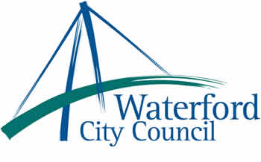

4th October 2010

To: The Meetings Administrator

The following motion was unanimously adopted by Waterford City Council at its monthly meeting held on 13th September 2010:

“Waterford City Council call on the Taoiseach and Minister for Social and Family
Affairs to publish the National Carers Strategy as committed to in the Social Partnership
Agreement - Towards 2016 and in the programme for Government as a matter of
principal.”

Yours sincerely,

Billy Duggan
Meetings Administrator

