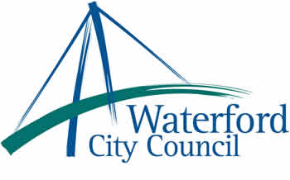

7th July 2010

To: The Meetings Administrator

The following motion was unanimously adopted by Waterford City Council at its monthly meeting held on 14th June 2010:

“That Waterford City Council:
- condemns the Israeli attack on the Gaza Freedom Flotilla’s aid mission which has resulted in deaths and injuries of those attempting to bring much needed aid to the besieged city of Gaza, which has been subject to an Israeli blockade which is illegal under international law.
- Commends those Irish citizens who participated in this humanitarian mission to bring 10,000 tones of aid to the people of Gaza.
- Recognizing that this attack is an affront to international law and has endangered the lives of Irish citizens, calls on the Irish Government to
  - Expel the Israeli Ambassador.
  - Support and seek the backing of other countries for a new international aid mission to Gaza which will ensure that necessary vital supplies reach the
suffering people of that besieged area."

Yours sincerely,

Billy Duggan
Meetings Administrator

