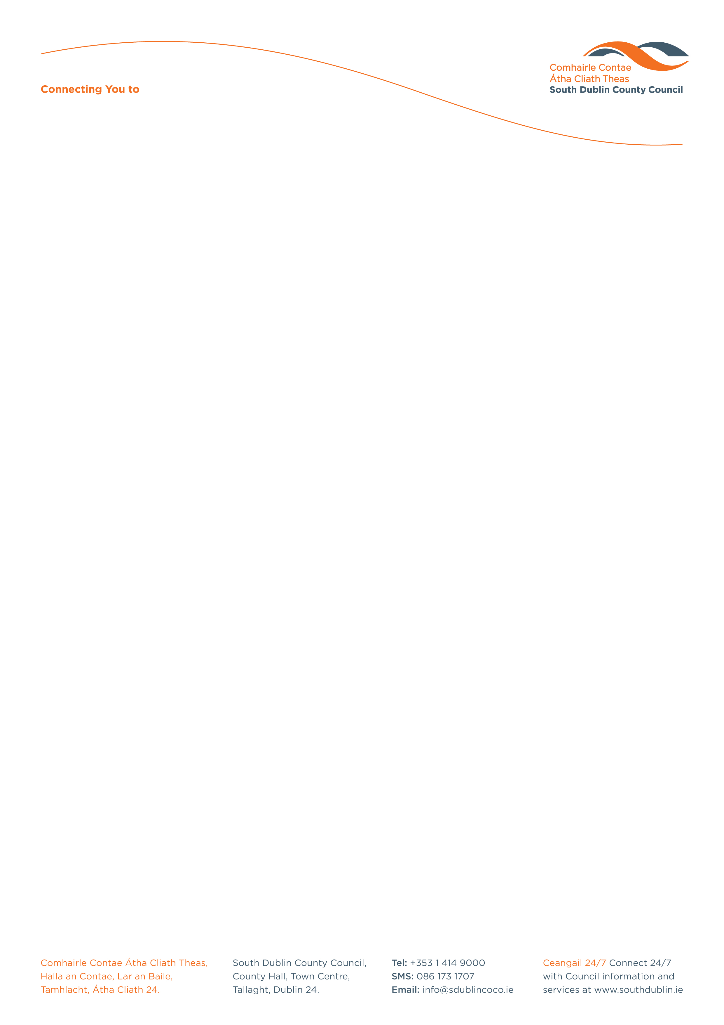

Halla an Chontae, Lár an Bhaile County Hall, Town Centre
Tamhlacht, Baile Átha Cliath 24 Tallaght, Dublin 24
Telefon: 01-4149052 Telephone: 01-4149052

Facs: 01-4149332 Fax: 01-4149332
www.southdublin.ie

Mr John Gormley
Minister for Environment,
Heritage & Local Government,
Customs House,
Dublin 1.

May 31st , 2010
RE: Tallaght Area Committee Meeting – 24th May, 2010

Dear Sir,

At South Dublin County Council’s Tallaght Area Committee Meeting, held on 24th May, 2010, the following motion was passed:
“That this Committee requests the Minister for the Environment and Local Government to place a refundable deposit on bottles of alcohol within the Tallaght area as a pilot project for a limited period – to be rolled out nationally going forward as a budgetary measure”.
I should be obliged if you would let me have a reply on the matter at your earliest convenience.

Thanking you in anticipation.

Yours sincerely,

Allyson Rooney,
SENIOR STAFF OFFICER,
HOUSING ADMINISTRATION.

Housing Administration

