

Report on Meeting of the South Dublin County Joint Policing Committee, Friday 5th February at 3.00 p.m. in County Hall, Tallaght.

Attendance: Committee Members

Cllr. R. Dowds (Chair) | Mayor Cllr. M. Duff
Cllr. S. Crowe | Cllr. P. Cosgrove
Cllr. M. McDonagh | Cllr. G. O’ Connell
Cllr. W. Lavelle | Cllr. P. Kearns
Cllr. J. Lehart | Cllr. E. Walsh
Chief Superintendent J. Manley | C. O.Connor T.D
J. Lawlor (Comm. Forum) | Chief Superintendent D. Coburn
T. Aspil (Comm. Forum) | Billy Coman Housing Dept. SDCC
Michelle Kearns (Comm. Platform)

In attendance: Senator Frances Fitzgerald, Packie Bonner (FAI) Gerry Riordan
Apologies: J. Tuffy, T.D. J. Horan (County Manager) Cllr. J. Hannon. B Lawlor
Also Present: Willie Sheils, Anne Byrne, SDCC., S. O’Gorman, RAPID., Superintendent E. Dolan, Superintendent Pat Clavin, Superintendent John Quirke, Garda Pat Conway

1. Meeting Report of 20 November 2009

The Committee adopted the report of the meeting of Friday 20th November 2009.

The Chair recommended that a presentation be made by representatives of the FAI before other matters be considered.

2. FAI Presentation

P. Bonner and G. Riordan from the FAI gave a comprehensive presentation on the late night football leagues held in the Dublin region. They acknowledged the commitment of South Dublin County Council to sports and the provision of facilities and programmes such as Tallaght Stadium, the Wheatfield Prison Programme and the employment with the FAI of Sports Development Officers.
The presentation raised the following:
- Grassroots Football
- FAI Community Development Officers
- FAI Programmes – many in conjunction with local community organisations and schools
- 2009 Citywide Leagues
- Ballymun Late Night League
- Night leagues – a response to anti-social behaviour
It is proposed to extend these late night football leagues to South Dublin County.

A discussion followed and the following issues were raised:
- Benefit to young offenders of a programme such as this
- Need for more parks and pitches to be developed using funding approved
- Homeless Soccer Leagues
- Projects to target those most in need
P. Bonner raised the matters of resources, manpower and facilities. All present agreed to support the project and provide as much assistance as possible. P. Bonner and G. Riordan acknowledged the support of the Council and the Gardai in the past and also acknowledged that their support is crucial to the success of the night leagues project.
B. Coman thanked the FAI and John Delaney for their commitment to the County.

Cllr. R. Dowds thanked the FAI and in particular P. Bonner and G. Riordan for their extensive presentation and their time in attending the JPC.

3. Matters Arising

Consultation on Crime Prevention and Safety
A submission on behalf of the South Dublin County Joint Policing Committee was send to the Department.

Local Policing Fora
B. Coman reported that following discussions with the Gardai three pilot projects will be set up covering the following areas:
- Tallaght West Covering Brookfield, Fettercarin, Kilmartin, Rossfield and Drumcairn
- North Clondalkin covering the North Clondalkin RAPID area.
- South West Clondalkin
Work will start on these immediately and will take into account the existing local safety projects in North Clondalkin and South West Clondalkin.

Case Management
J. Manley reported on the case management programme at the last meeting which is ongoing in the DMRS region. Details of the programme have been circulated.

Coillte
Behaviour on the Dublin Mountains was discussed at previous meetings. Coillte have now introduced Bye-Laws and a link to their website which details the bye-laws, was circulated.

4. County Manager’s Report

Annual Workplan
It was agreed to carry the actions from the 2009 workplan into the 2010 plan. A. Byrne will write to members requesting items for inclusion in the 2010 plan and following consultation with members a new plan for 2010 will be forwarded to members.

Parks Sub-Group Report
Cllr. W. Lavelle reported that the sub-group has met three times to date and two of these were site visits to St. Cuthbert’s Park and Killinarden Park. They met with staff in the Parks and agreed issues that they will try and address and make recommendations to the JPC which may include:
Litter/graffiti/dumping
Control of Scrambler bikes
Community policing
CCTV monitoring of parks
Underage drinking/off licences
Physical improvements
Urban design
Positive alternatives to anti-social behaviour
Community sense of ownership of parks
Location of SDCC depots and staff
Use of employment schemes

Going forward, the group plan to meet first with residents in South West Clondalkin and Killinarden and then with young people in the areas. A number of site meetings at other parks are planned and meetings with Council staff. A final report setting out recommendations will be presented to a future JPC meeting

Cllr. Lavelle thanked his fellow members on the committee for their commitment to the action. Cllr. Dowds thanked Cllr. Lavelle for his report.

Annual Report 2009
Each JPC is required to submit a report of its activities each year to the County Council, Garda Commissioner and the Minister for Justice. A report of the South Dublin County Joint Policing Committee for 2009 has been prepared and was circulated. This was accepted by the members present.

5. Garda Reports

Report from Chief Superintendent John Manley,
DMR Southern Division to South Dublin Joint Policing Committee
on 5th February 2010

Report for Tallaght, Rathfarnham,
Terenure and Crumlin Stations

Crime Statistics 2009 in comparison with 2008

Please note that these statistics are provisional, operational and may be subject to change

Tallaght Station |  | 2008 | 2009 | % Change
Burglary |  | 746 | 928 | + 24%
Robbery |  | 93 | 67 | - 28%
 | Robbery from the person | 64 | 53 | - 17%
 | Robbery from Establishment | 29 | 14 | - 52%
Theft |  | 1,912 | 1,792 | - 6%
 | Theft from Person | 36 | 66 | + 83%
 | Theft from MPV | 332 | 390 | + 17%
 | Theft from Shop | 560 | 538 | - 4%
 | Theft (Other) | 248 | 208 | - 16%
 | Theft of MPV | 736 | 590 | - 20%

Property Crime 2,970 3,015 + 2%

The detection rate for overall crime in Tallaght Sub-District is 53%

Rathfarnham Station |  | 2008 | 2009 | % Change
Burglary |  | 427 | 395 | - 7%
Robbery |  | 35 | 25 | - 29%
 | Robbery from the person | 23 | 17 | - 26%
 | Robbery from Establishment | 12 | 8 | - 33%
Theft |  | 670 | 602 | - 10%
 | Theft from Person | 5 | 16 | + 220%
 | Theft from MPV | 181 | 142 | - 22%
 | Theft from Shop | 133 | 146 | + 10%
 | Theft (Other) | 135 | 131 | - 3%
 | Theft of MPV | 216 | 167 | - 23%

Property Crime 1,228 1,155 - 6%
The detection rate for overall crime in Rathfarnham Sub-District is 49%

Crumlin Station |  | 2008 | 2009 | % Change
Burglary |  | 184 | 241 | + 31%
Robbery |  | 15 | 28 | + 87%
 | Robbery from the person | 1 | 4 | + 300%
 | Robbery from Establishment | 14 | 24 | + 71%
 |  | 363 | 330 | - 9%
 | Theft from Person | 6 | 14 | + 133%
 | Theft from MPV | 51 | 72 | + 41%
 | Theft from Shop | 110 | 68 | - 38%
 | Theft (Other) | 94 | 79 | - 16%
 | Theft of MPV | 102 | 97 | - 5%

Property Crime 616 649 + 5%

The detection rate for overall crime in Crumlin Sub-District is 46%

Terenure Station |  | 2008 | 2009 | % Change
Burglary |  | 172 | 265 | + 54%
Robbery |  | 16 | 33 | + 106%
 | Robbery from the person | 4 | 15 | + 275%
 | Robbery from Establishment | 12 | 18 | + 50%
Theft |  | 302 | 283 | - 6%
 | Theft from Person | 9 | 16 | + 89%
 | Theft from MPV | 81 | 93 | + 15%
 | Theft from Shop | 42 | 51 | + 21%
 | Theft (Other) | 114 | 74 | - 35%
 | Theft of MPV | 56 | 49 | - 13%

Property Crime 563 694 + 23%

The detection rate for overall crime in Terenure Sub-District is 47%

Property Related Crime was up 6% in the DMR South Division in 2009 as opposed to 2008. This was driven by a notable increase in Property Crime in Terenure District (26%).

Theft from Vehicles was up (9%) and Thefts from the Person were up (23%). Thefts from Shops showed a reduction (-1%), as did Theft of Other Property (-9%). Robbery from the Person incidents were up (52%). Robbery from Establishments showed an increase of 4%.

Burglaries at the end of the year showed a total increase of 19%. Incidents of Burglary were up in all three Garda Districts – Tallaght (+13%), Terenure (+33%) and Crumlin (+22%). Specific operations remain in place in each District in an effort to tackle and reduce the level of burglaries occurring in the Division. In response to the significant increase in the Terenure District, a continued focus on high profile criminals has been emphasised and those known to be involved in these crimes are targeted. Areas susceptible to high incidents of burglary are identified by crime analysis and are targeted with constant patrols which concentrate on the areas affected.

Campaigns were run throughout the Division aimed at enlightening the public on ways to prevent burglaries, thefts and unauthorised takings. Extra anti-burglary patrols continue to operate in areas that have been identified as black spots for high volume crime.

There were 268 detections of drugs for sale or supply in the Division in 2009 which is on par with 2008. The number of incidents of simple possession at 1,595 shows a reduction of 10% on 2008. In 2009 9,083 searches under the Drugs Act (including on street searches) were carried out in the Division. 3,165 of these searches were carried out in the Tallaght area. An operation in currently in place under Operation Cleanstreet involving the Tallaght District Drugs Unit, Local Gardai and the Garda National Drugs Unit targeting individuals selling drugs in the Tallaght area.

There were 601 persons apprehended for driving/ in charge of a vehicle whilst over the legal alcohol limit in 2009, a reduction of -23% on the 2008 figure. The figures suggest an increased number of people are being responsible on the road. There were 50 drug driving detections in 2009 as opposed to 40 in 2008.

A total of 849 mandatory alcohol checkpoints were carried out in 2009 as opposed to 865 in 2008.

Five fatal road traffic accidents occurred in 2009, the same figure as 2008. Intercepted street detections by speed limit zones at 2,083 showed a -9% reduction on the 2008 figure of 2,296.

1,571 incidents of Public Disorder were recorded in 2009 which was on par with 2008. Criminal Damage incidents at 2,778 showed an 8% reduction on 2008. The number of incidents of Assault at 699 showed an increase of 8% in 2009.

CCTV Footage has been installed and is in operation in the Tallaght Sub-District. The Control Room in Tallaght Garda Station is operational with 34 cameras fully operational. Work remains ongoing on the remaining cameras and Gardai have been trained in the operation of the system.

There were four incidents of Homicide in the Division in 2009. One male and one female have been arrested and charged for their respective roles in two of the murders. The other two incidents are being actively investigated.

Chief Superintendent Manley again explained that these were provisional figures only and subject to change.

A discussion followed regarding:
- CCTV – Members were concerned with a delay in the monitoring of the Community CCTV schemes. This was acknowledged and the system will be finalised as soon as possible
- Rising Trend in Burglaries particularly in certain areas and the effect of the LUAS on crime
- Raids in relation to drugs and drug seizures
- Drug related deaths and the ‘quality’ of drug available – Chief Superintendent Manley explained that until post mortem results are available cause of death cannot be ascertained. However the Gardai are now aware of the concern of the Community and the members.
- Dublin Bus and the recent difficulties experienced by communities in West Tallaght was discussed. Chief Superintendent Manley explained that the Gardai are working closely with the community, Dublin Bus and the Dublin Bus Forum. However he explained that some of this anti-social behaviour was caused by children as young as 10 and 12 years.
- Special operations targeting specific high profile criminals are in place
- Kingswood area – consideration is being given to bringing this area under one garda station.

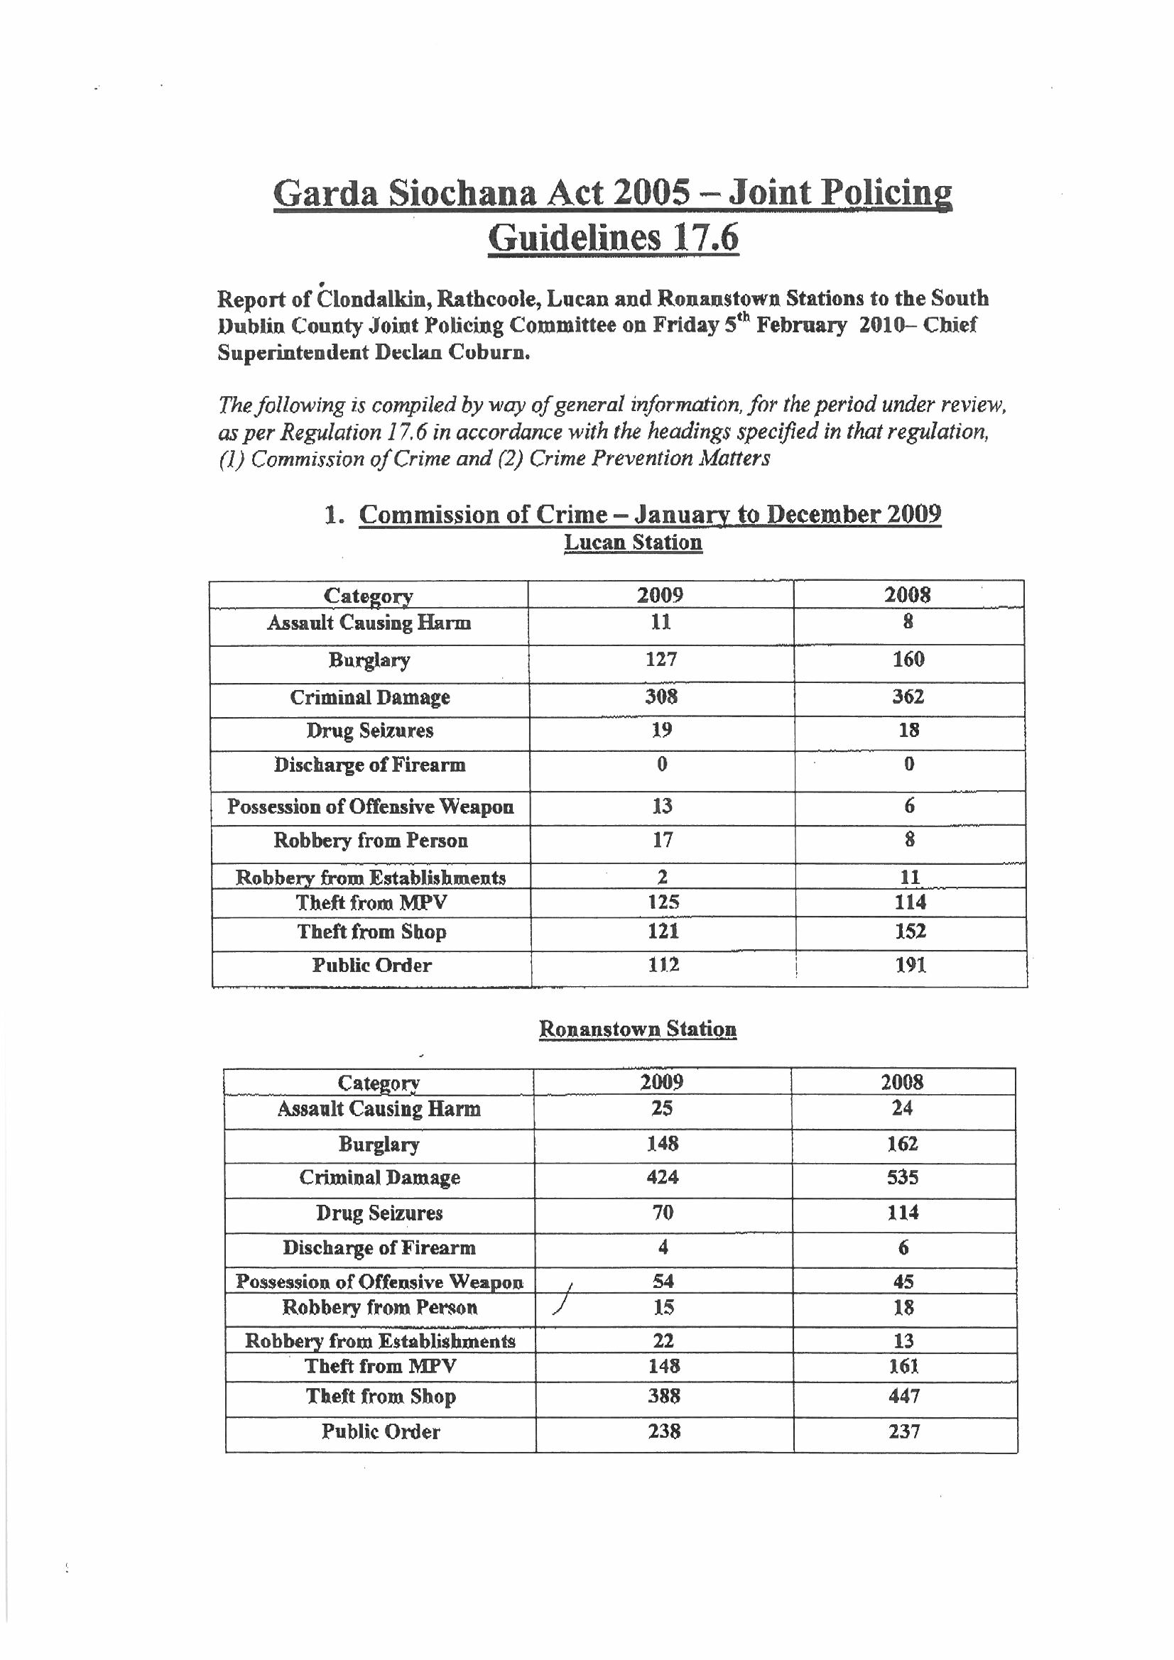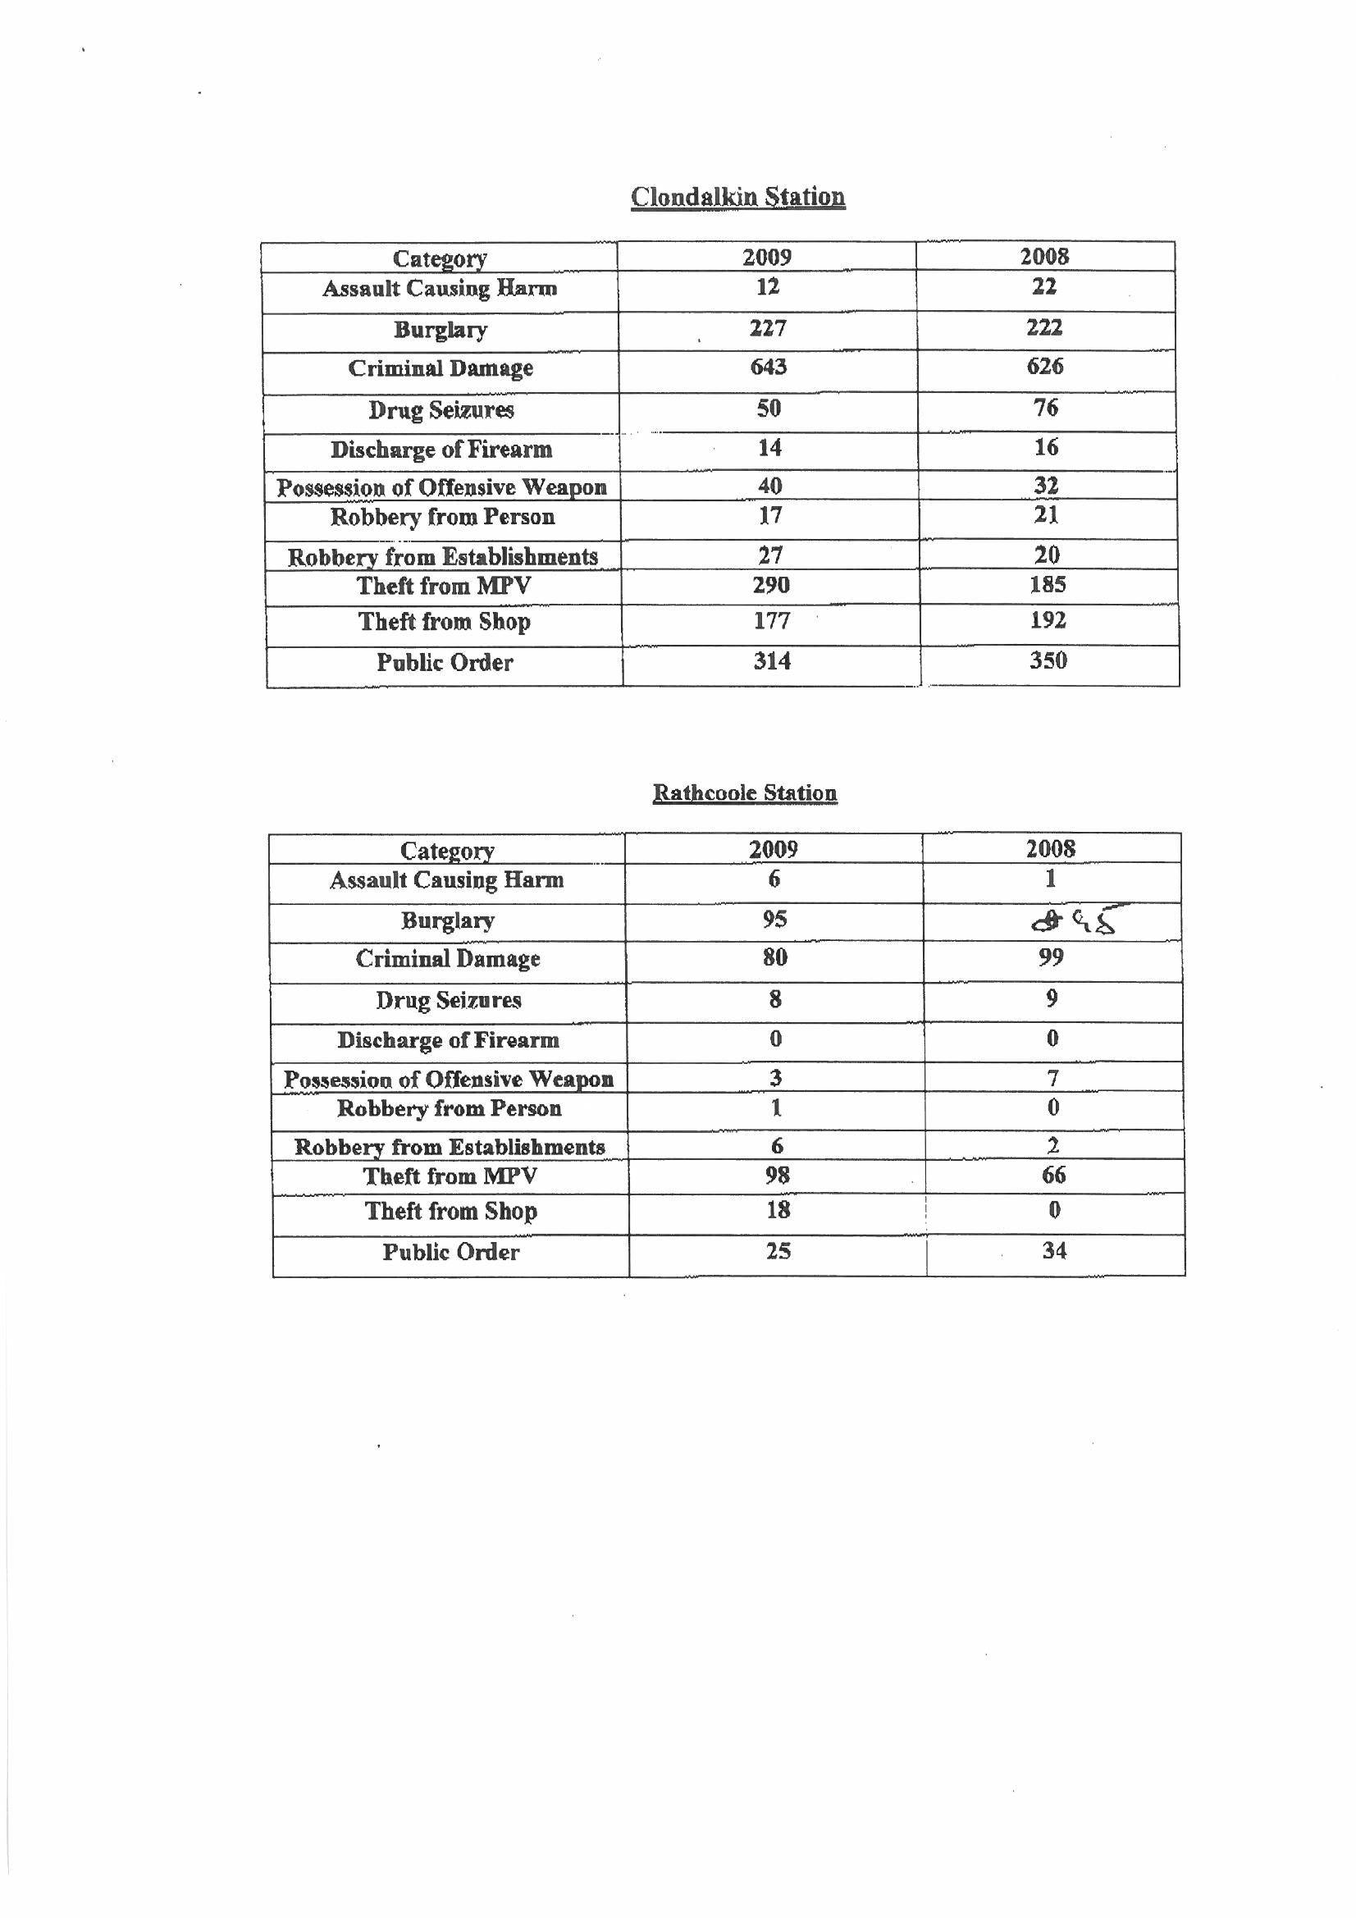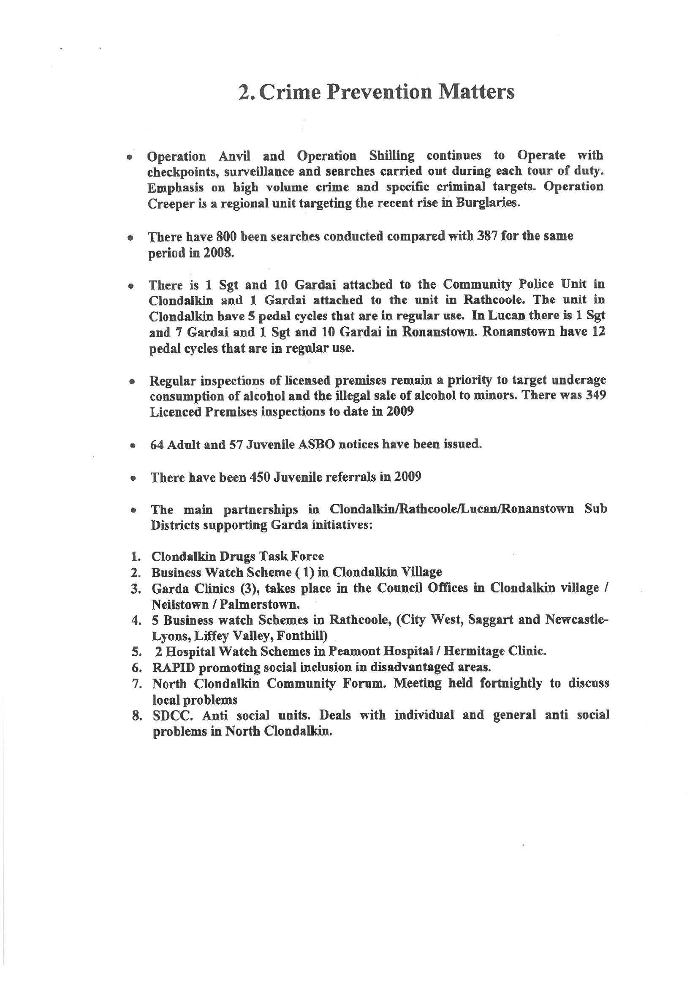
Chief Superintendent Coburn again explained that the statistics provided are provisional, operational and may be subject to change. A discussion followed which covered the following items:
- Community Policing Meetings – The members presented thanked the Gardai for holding these
- Anti-social behaviour at Moyglass / Castle Riarda areas. Chief Superintendent explained that this is a quiet area except for the embankment area where trouble does occur, however Gardai are aware of this and are concentrating resources here.
- Glenaulin Park remains a cause of concern but Gardai in both Ronanstown and Ballyfermot are working together. However there are no plans at present to bring this area under one Garda station
- Burglaries in the DMRW area were of concern to the members. Gardai reported that much of these were carried out between 4 p.m.and 10 p.m. Burglaries often happen together in areas and this causes fear in an area and a perception that burglaries are increasing throughout the County while this may not be the case. However the 2010 numbers are giving some cause for concern.
- Underage drinking – an operation is underway at present to try combat underage drinking
- Head shops – existing legislation at present does not allow for them to be closed, however Gardai do visit them on a regular basis and monitor those visiting.
- Clothing collections – bags being dropped into post boxes in the early morning can cause concern
- Drug seizures – Chief Superintendent Coburn explained that in 2008 there were some very large seizures, however at present searches are up but the number of seizures are down on the previous figures.
- Anti-social behaviour – as a result of local policing meetings the Superintendent put specific operations in place in Rowlagh and Neilstown
- HGV Vehicles - Gardai will continue to monitor this

5. Any other business
B. Coman proposed that the Joint Policing Committee meetings be restructured and have a more policy and strategic focus. It was acknowledged that this is a wonderful opportunity to have the members, Council, Community and the Gardai together and it should be used to its best advantage. A set of proposals for the restructuring of meetings will be brought to the May JPC.

6. Date of next meeting
The next meeting of the JPC will take place in County Hall on Friday 14th May 2010 at 3 p.m.

