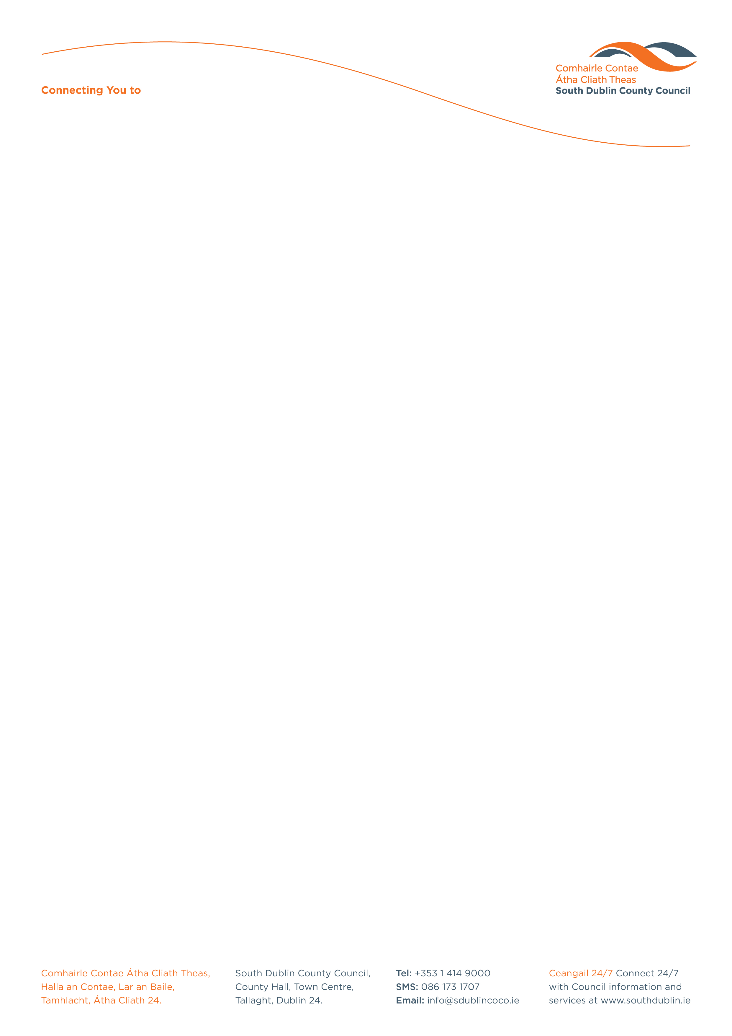

Halla an Chontae, Lár an Bhaile County Hall, Town Centre
Tamhlacht, Baile Átha Cliath 24 Tallaght, Dublin 24
Telefon: 01-4149052 Telephone: 01-4149052

Facs: 01-4149332 Fax: 01-4149332
www.southdublin.ie

Mr John Gormley
Minister for Environment,
Heritage & Local Government,
Customs House,
Dublin 1.

April 30th , 2010
RE: Tallaght Area Committee Meeting – 26th April, 2010

Dear Sir,

At South Dublin County Council’s Tallaght Area Committee Meeting, held on 26th April, 2010, the following motion was passed:

“That this Council Committee, concerned at the lack of adequate legislation regarding the height of trees and hedges on private and public property, aware of similar concerns in other local Authorities and the difficulties being experienced by residents, calls for the introduction of a single legislative measure which would apply in these cases and agrees to write to the Minister concerned to prioritise legislation in this area.”
I should be obliged if you would let me have a reply on the matter at your earliest convenience.

Thanking you in anticipation.

Yours sincerely,

Allyson Rooney,
SENIOR STAFF OFFICER,
HOUSING ADMINISTRATION.

Housing Administration

