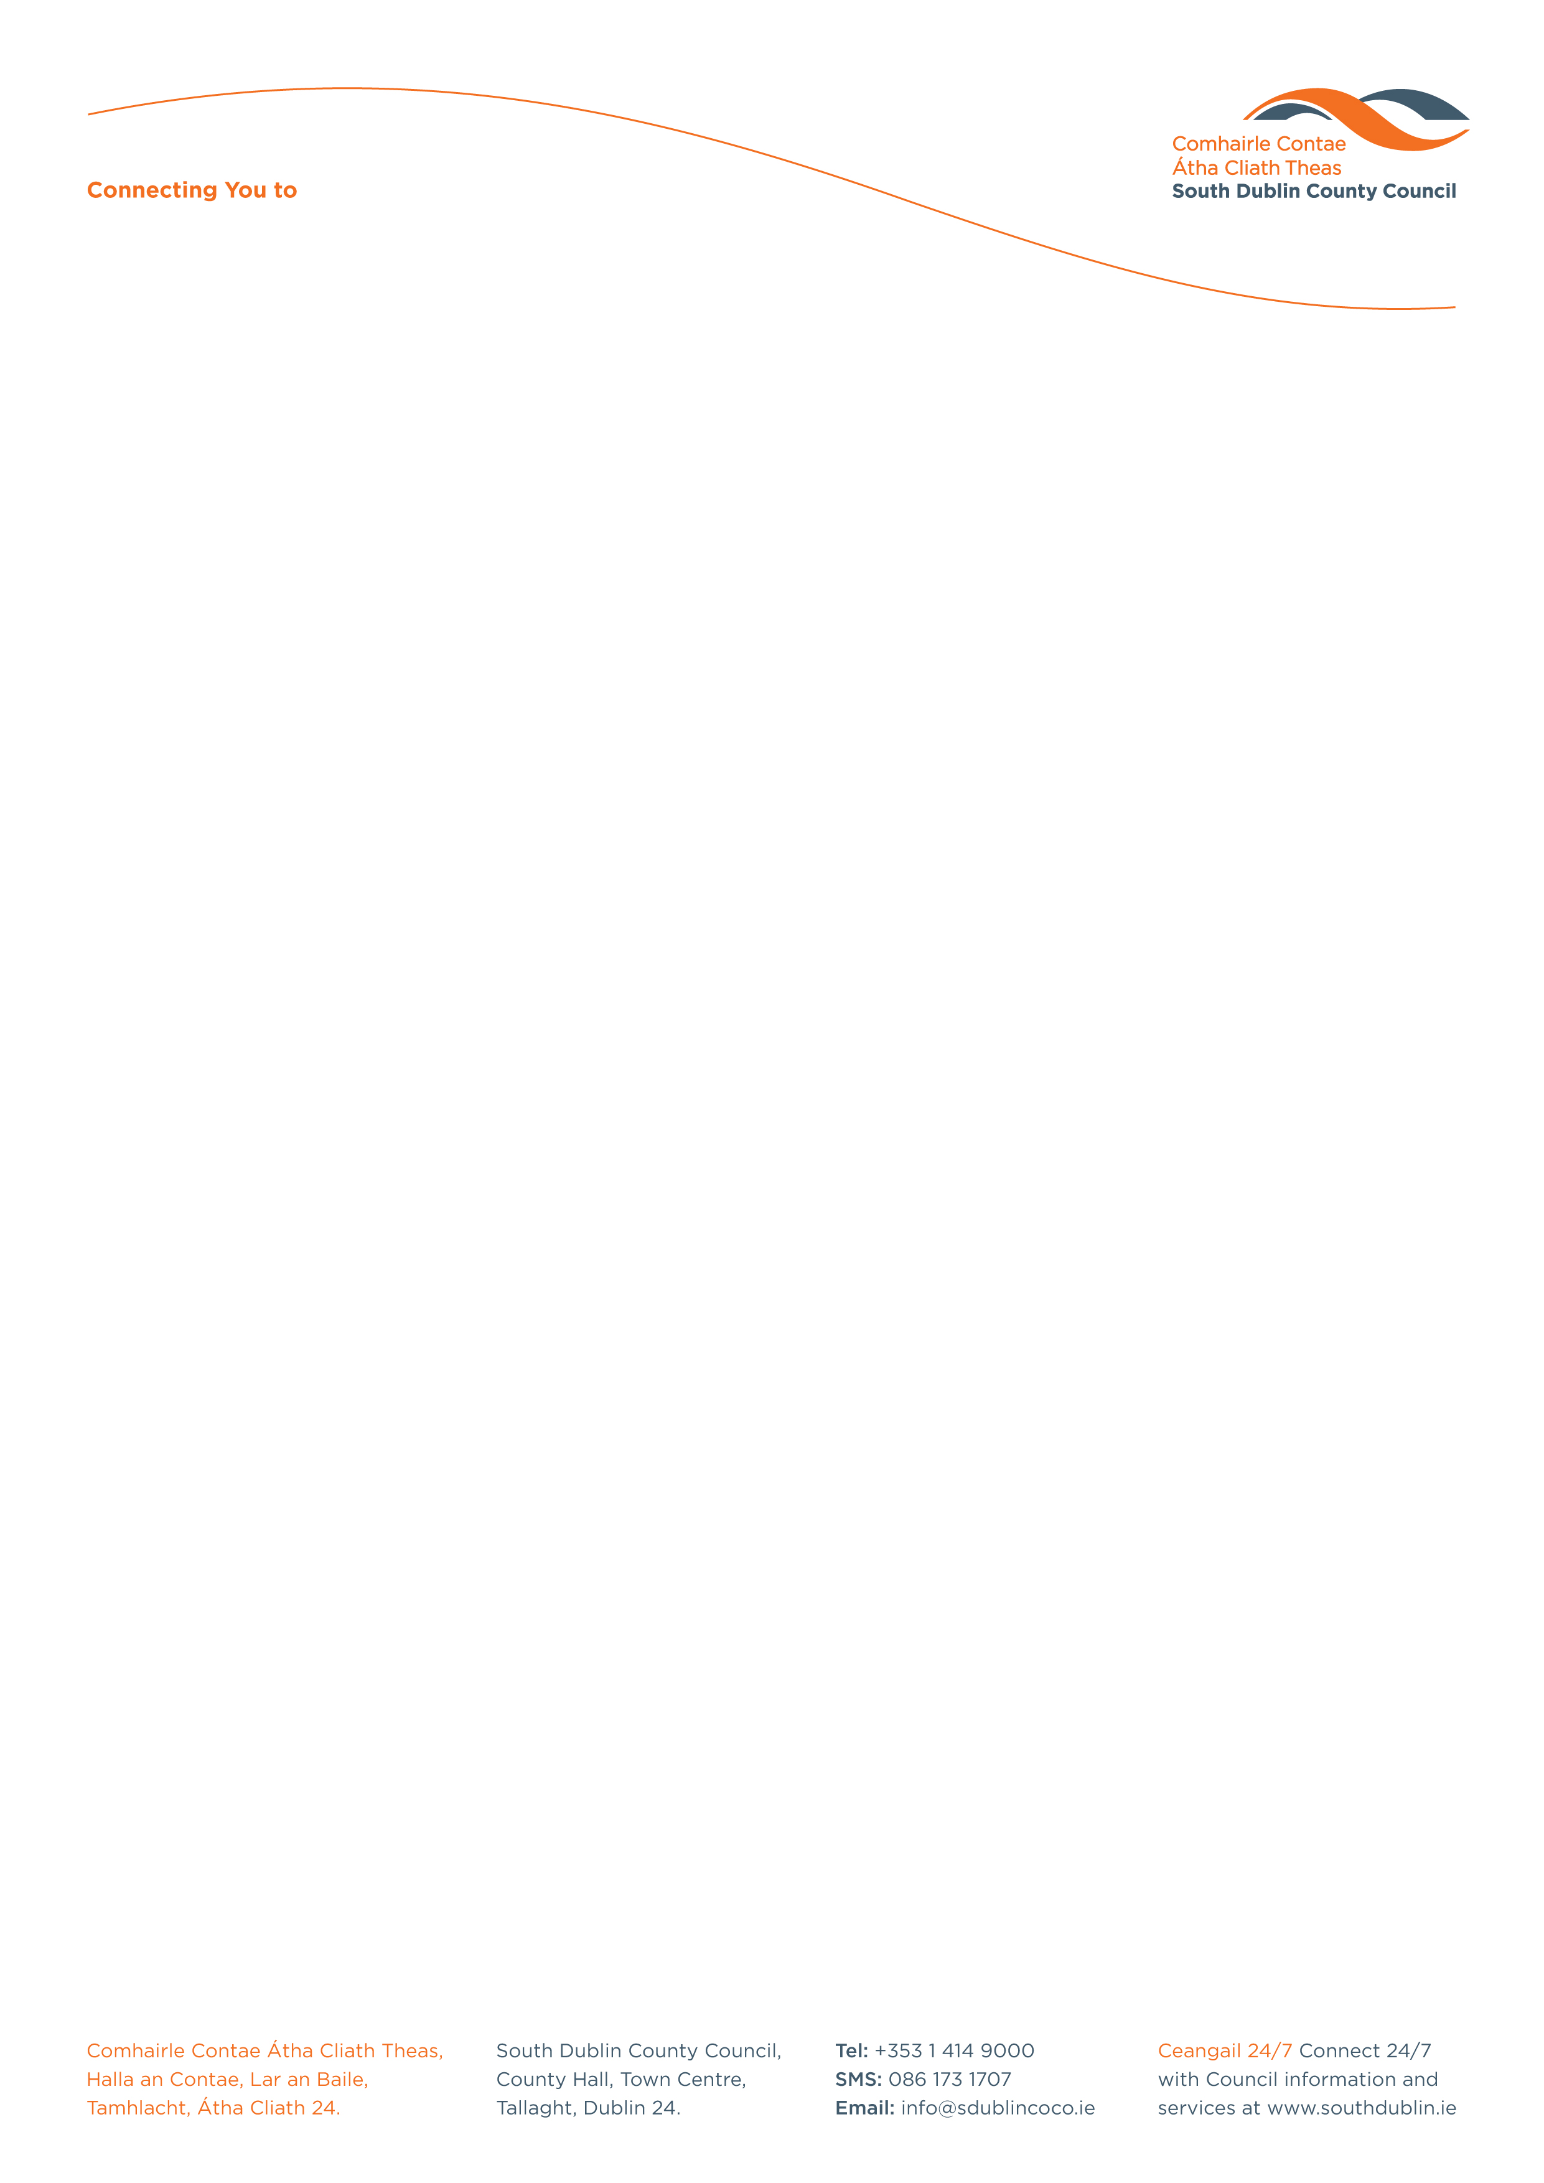

Halla an Chontae, Lár an Bhaile County Hall, Town Centre
Tamhlacht, Baile Átha Cliath 24 Tallaght, Dublin 24
Telefon: 01-4149052 Telephone: 01-4149052

Facs: 01-4149332 Fax: 01-4149332
www.southdublin.ie

The Superintendent,
Tallaght Garda Station,
Tallaght,
Dublin 24.
April 30th, 2010
RE: Tallaght Area Committee Meeting – 26th April, 2010

Dear Sir,

At South Dublin County Council’s Tallaght Area Committee Meeting, held on 26th April, 2010, the following motion was passed:

“That this Committee recognising the weakness inherent in the present policing structures and in view of the overwhelming support among residents in Kingswood for the Garda Authorities in Tallaght to patrol and take responsibility for policing for the whole of the area, agrees to write and contact the relevent authorities, including the Garda Commissioner and the Justice Minister concerned, calling on them to urgently address and prioritise this issue, in the interest of improving the quality and the level of support for policing in the immediate area. ”
I should be obliged if you would let me have a reply on the matter at your earliest convenience.

Thanking you in anticipation.

Yours sincerely,

Allyson Rooney,
SENIOR STAFF OFFICER,
HOUSING ADMINISTRATION.

Cc Minister for Justice
Garda Commissioner

Housing Administration

