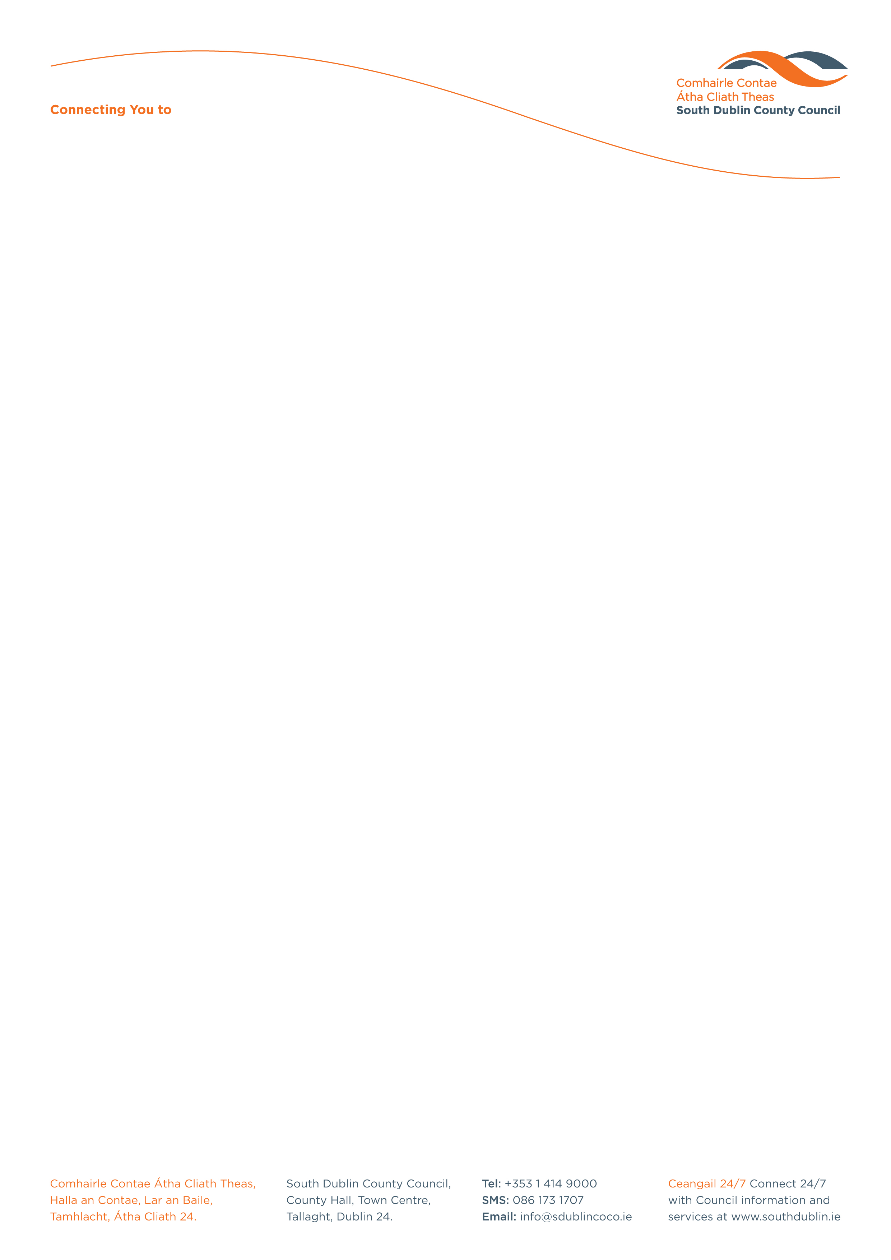

Halla an Chontae, Lár an Bhaile County Hall, Town Centre
Tamhlacht, Baile Átha Cliath 24 Tallaght, Dublin 24
Telefon: 01-4149052 Telephone: 01-4149052

Facs: 01-4149332 Fax: 01-4149332
www.southdublin.ie

The Manager,
Dublin Bus,
O’Connell Street,
Dublin 1.
April 30th, 2010

RE: Tallaght Area Committee Meeting – 26th April, 2010

Dear Sir/Madam,

At South Dublin County Council’s Tallaght Area Committee Meeting, held on 26th April, 2010, the following motion was passed:

“That this Committee opposes any further reduction in the bus service within Tallaght, resulting from the proposed review of services by Dublin Bus.”

I should be obliged if you would let me have a reply on the matter at your earliest convenience.

Thanking you in anticipation.

Yours sincerely,

Allyson Rooney,
SENIOR STAFF OFFICER,
HOUSING ADMINISTRATION.

Housing Administration

