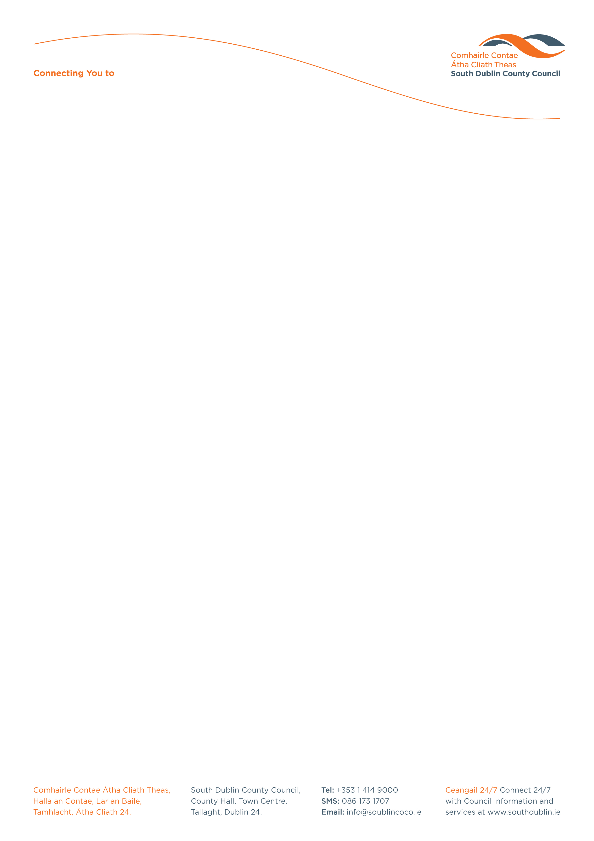

Halla an Chontae, Lár an Bhaile County Hall, Town Centre
Tamhlacht, Baile Átha Cliath 24 Tallaght, Dublin 24
Telefon: 01-4149052 Telephone: 01-4149052

Facs: 01-4149332 Fax: 01-4149332
www.southdublin.ie

The Superintendent,
Tallaght Garda Station,
Belgard Road,
Tallaght,
Dublin 24.

May 11th, 2010

RE: Tallaght Area Committee Meeting (1) – 19th April, 2010

Dear Sir,

At South Dublin County Council’s Tallaght Area Committee Meeting, held on 19th April, 2010, the following motion was passed:

“That urgent and effective action be taken, in conjunction with the Gardai, to end the use of quad bikes, motor bikes etc. on lands near the Old Mill, Tallaght, given that this activity has continued unabated for the past 2 years and is hazardous, and a cause of noise and air pollution.”

I should be obliged if you would let me have a reply on the matter at your earliest convenience.

Thanking you in anticipation.

Yours sincerely,

Eamon Conlon,
STAFF OFFICER,
HOUSING ADMINISTRATION.

Housing Administration

