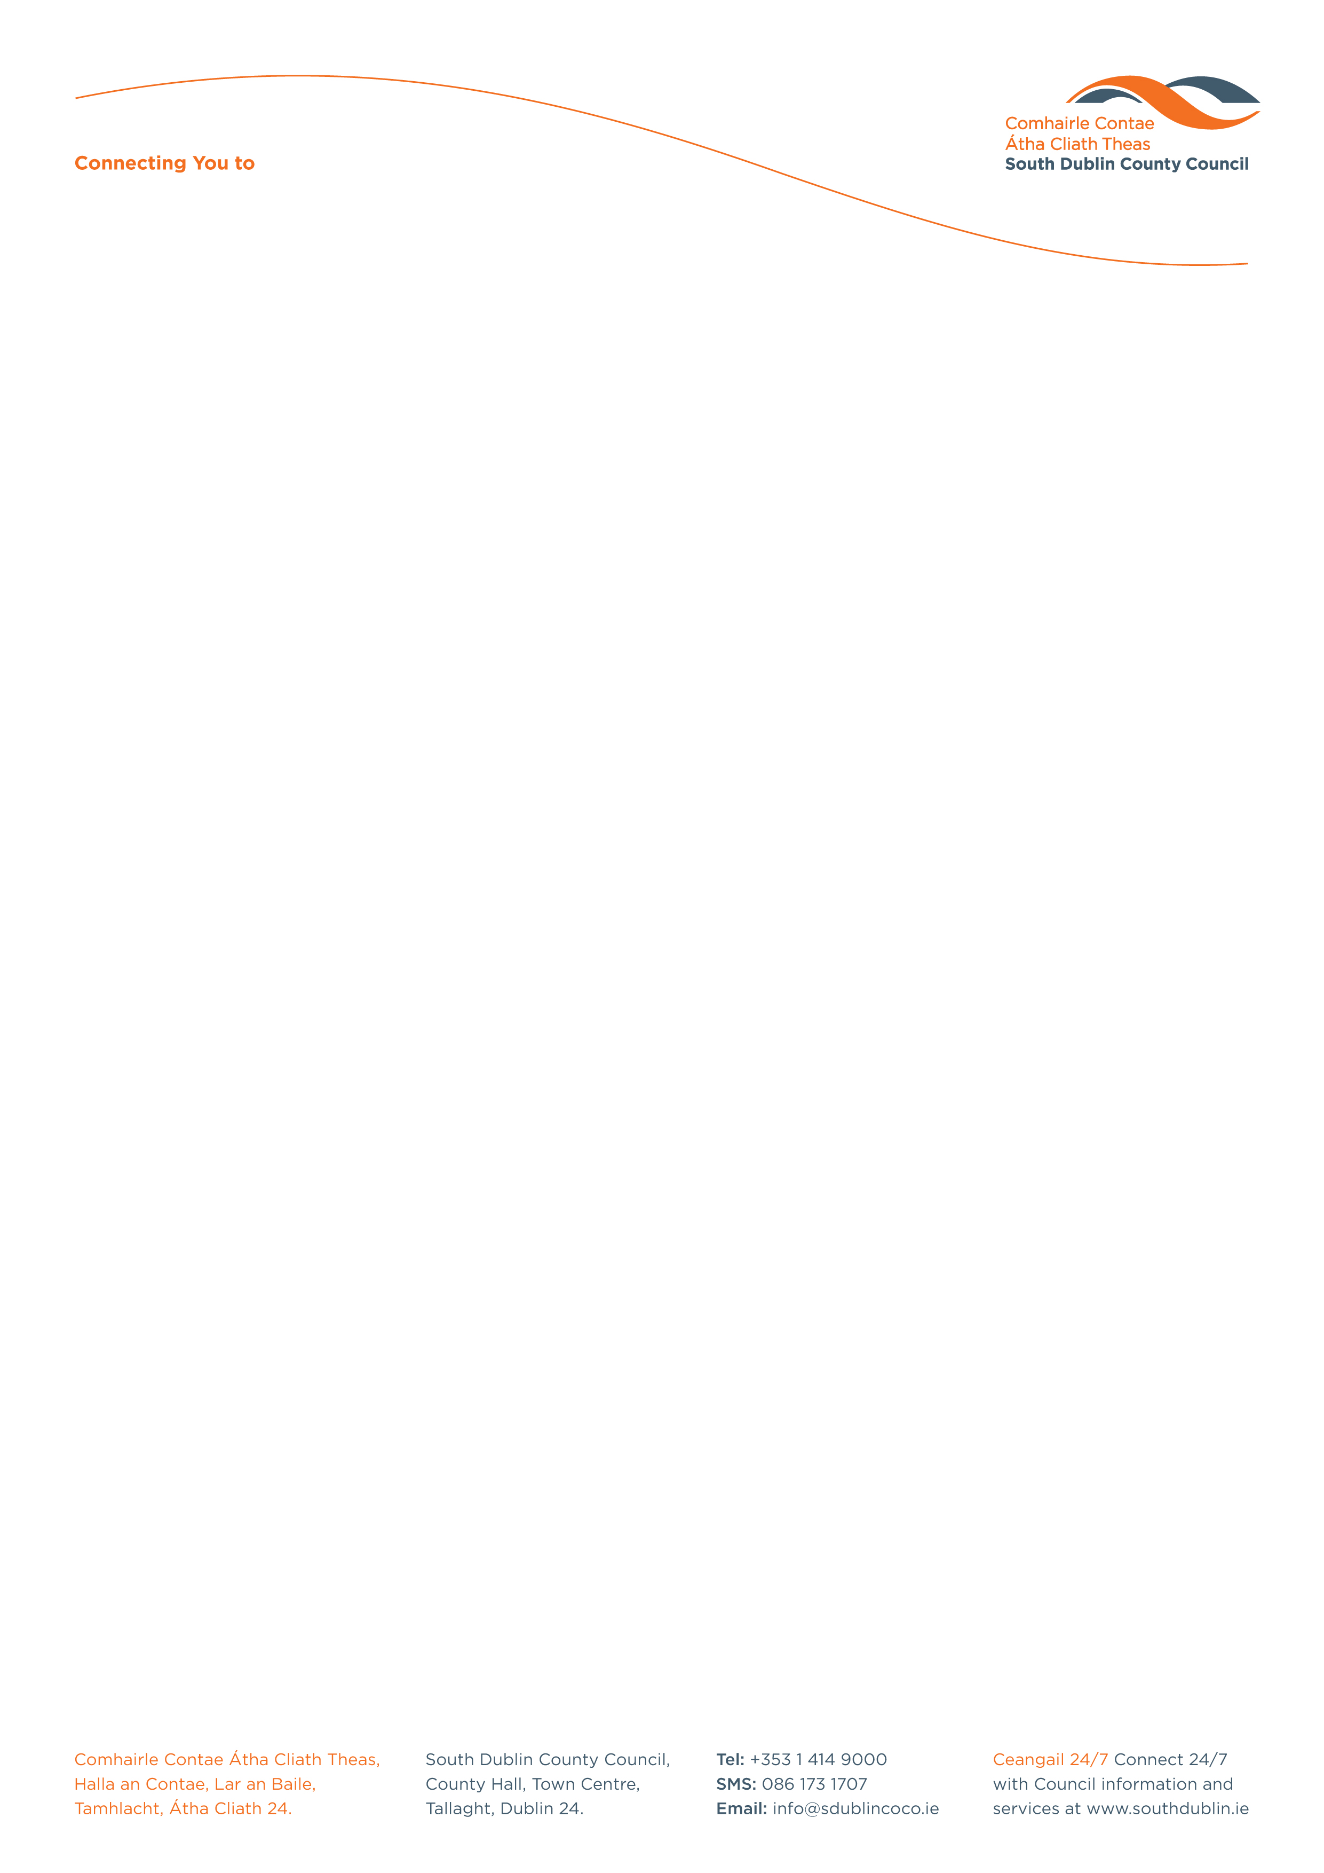

Halla an Chontae, Lár an Bhaile County Hall, Town Centre
Tamhlacht, Baile Átha Cliath 24 Tallaght, Dublin 24
Telefon: 01-4149052 Telephone: 01-4149052

Facs: 01-4149332 Fax: 01-4149332
www.southdublin.ie

Mr. John Gormley,
Department of the
Environment, Heritage and Local Government,
Head Office,
Custom House,
Dublin 1.
March 31, 2010

RE: Tallaght Area Committee Meeting – 22nd March, 2010

Dear Minister,

At South Dublin County Council’s Tallaght Area Committee Meeting, held on 22nd March, 2010, it was requested that the Derelict Sites Act 1990 be reviewed and re-evaluated with regard to the description of a derelict site given the current economic climate.

I should be obliged if you would let me have a reply on the matter at your earliest convenience.

Thanking you in anticipation.

Yours sincerely,

Allyson Rooney,
SENIOR STAFF OFFICER,
HOUSING ADMINISTRATION.

Housing Administration

