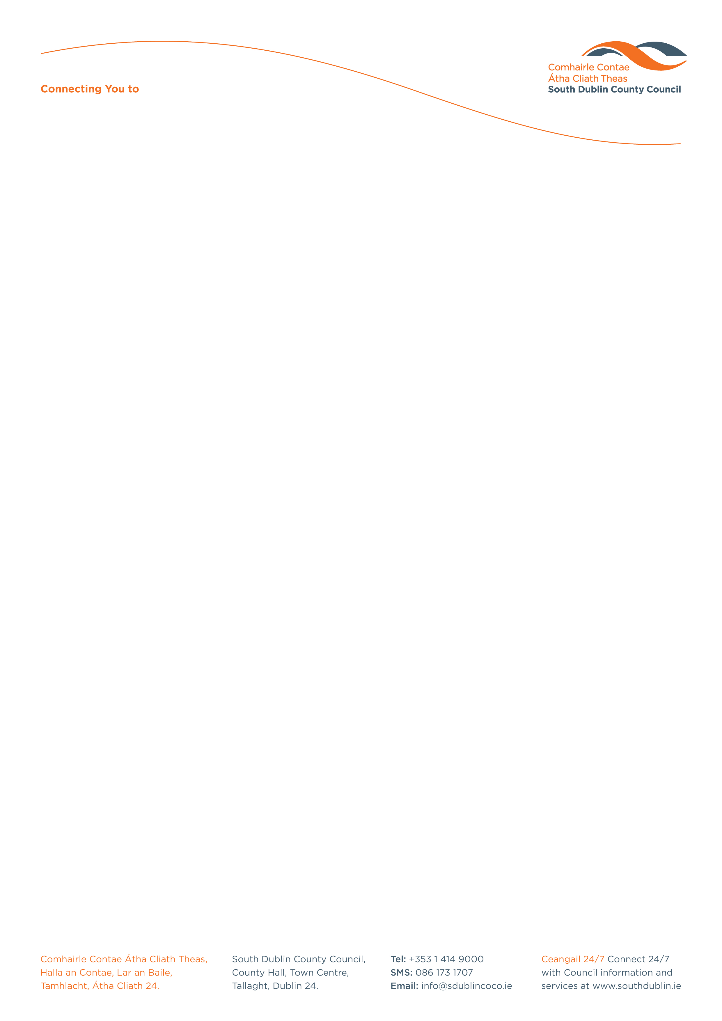

Halla an Chontae, Lár an Bhaile County Hall, Town Centre
Tamhlacht, Baile Átha Cliath 24 Tallaght, Dublin 24
Telefon: 01-4149052 Telephone: 01-4149052

Facs: 01-4149332 Fax: 01-4149332
www.southdublin.ie

IBAL,
c/o An Taisce,
Environmental Education Unit,
5A Swifts Alley
Francis Street
Dublin 8

March 12th, 2010

RE: Tallaght Area Committee Meeting (1) – 15th February, 2010

Dear Sir/Madam,

At South Dublin County Council’s Tallaght Area Committee Meeting, held on 15th February, 2010, the following motion was passed:
“That the Manager reports on efforts to date to ensure that Kelland Homes pay attention to the upkeep of their properties in the Sundale Estate and that this Committee considers requesting IBAL to include this area in its regular surveys of Tallaght.”
I should be obliged if you would let me have a reply on the matter at your earliest convenience.

Thanking you in anticipation.

Yours sincerely,

Allyson Rooney,
SENIOR STAFF OFFICER,
HOUSING ADMINISTRATION.

Housing Administration

