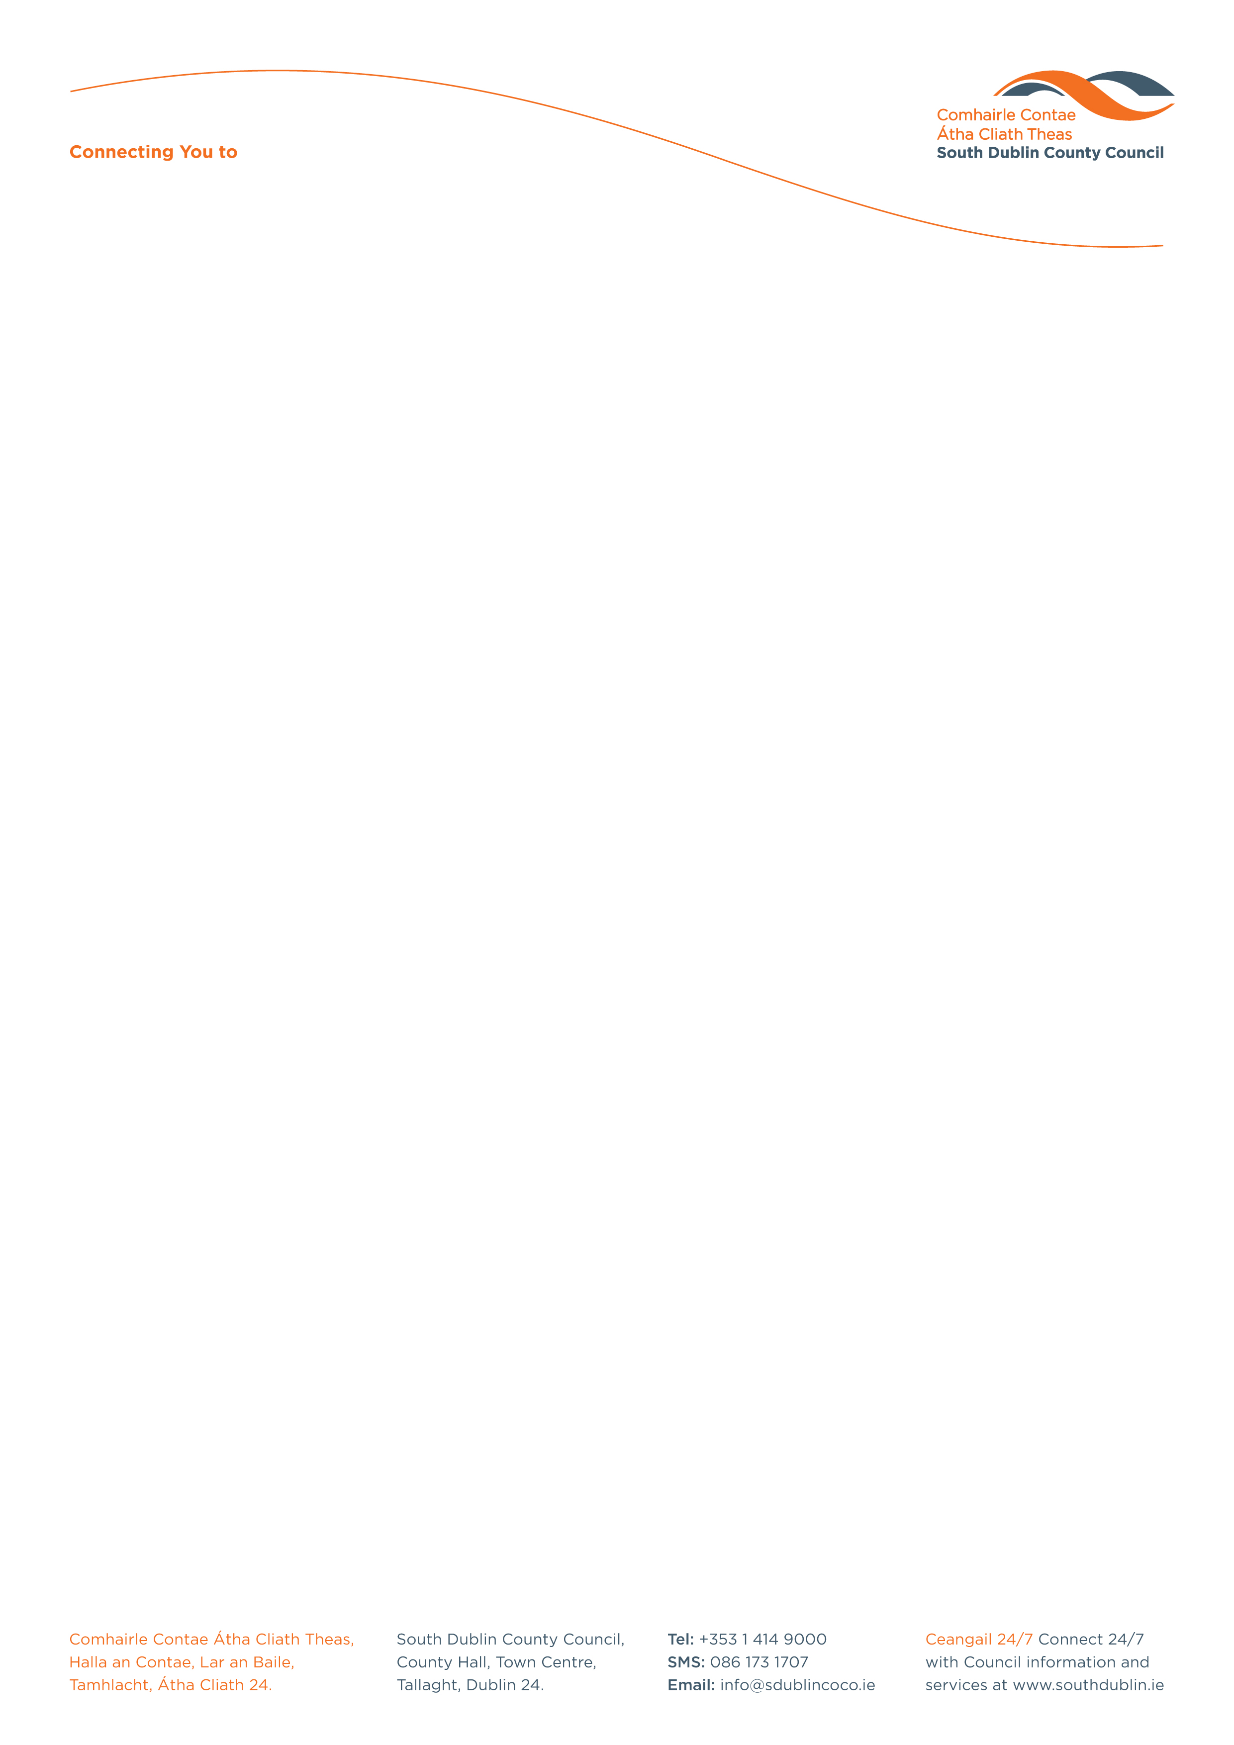

Halla an Chontae, Lár an Bhaile County Hall, Town Centre
Tamhlacht, Baile Átha Cliath 24 Tallaght, Dublin 24
Telefon: 01-4149052 Telephone: 01-4149052

Facs: 01-4149332 Fax: 01-4149332
www.southdublin.ie

The Manager,
Dublin Bus
O’Connell Street
Dublin 1.

March 2, 2010

RE: Tallaght Area Committee Meeting – 22nd February, 2010

Dear Sir/Madam,

The following Question, submitted by Councillor D. Looney, was passed at the Tallaght Area Committee meeting, which took place on 22nd February, 2010:
"To ask the Manager to make contact with Bus Átha Cliath to ask if they would consider facilitating residents in the Walkinstown and Greenhills areas access to St James' Hospital, through the extension of the 123 route, the provision of a feeder bus to the LUAS line, or some other option.?"

I should be obliged if you would let me have a reply on this matter at your earliest convenience.

Thanking you in anticipation.

Yours sincerely,

ALLYSON ROONEY,
SENIOR STAFF OFFICER,
HOUSING ADMINISTRATION.

Housing Administration

