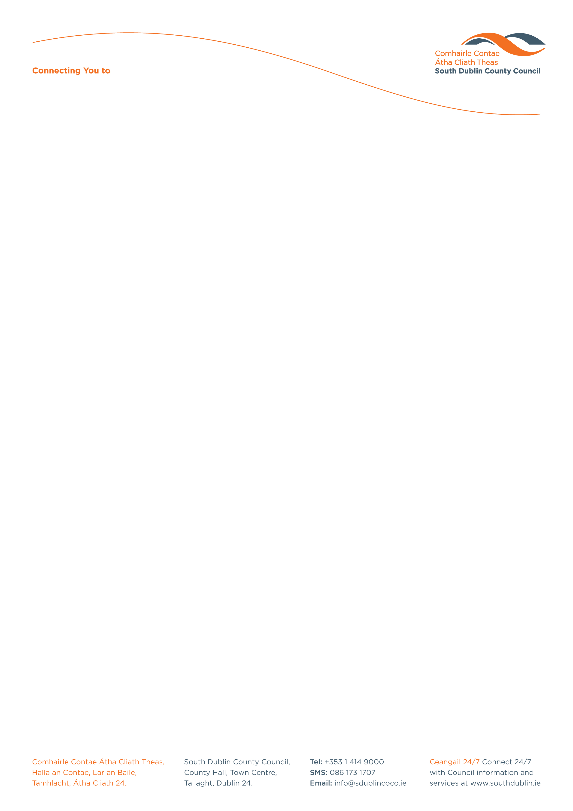

Halla an Chontae, Lár an Bhaile County Hall, Town Centre
Tamhlacht, Baile Átha Cliath 24 Tallaght, Dublin 24
Telefon: 01-4149052 Telephone: 01-4149052

Facs: 01-4149332 Fax: 01-4149332
www.southdublin.ie

Mr. Michael Finneran, T.D.,
Minister of State,
Department of the
Environment, Heritage and Local Government,
Head Office,
Custom House,
Dublin 1.
February 25th, 2010

RE: Tallaght Area Committee Meeting – 22nd February, 2010

Dear Minister,

At South Dublin County Council’s Tallaght Area Committee Meeting, held on 22nd February, 2010, the following motion was passed:

“That the Tallaght Area Committee requests the Minister for the Environment and Local Government, Mr. J. Gormley, to amend the Local Government Act 2001, to allow for the granting of city status for Tallaght, and seeks the support of the Council for this amendment.”

I should be obliged if you would let me have a reply on the matter at your earliest convenience.

Thanking you in anticipation.

Yours sincerely,

Allyson Rooney,
SENIOR STAFF OFFICER,
HOUSING ADMINISTRATION.

Housing Administration

