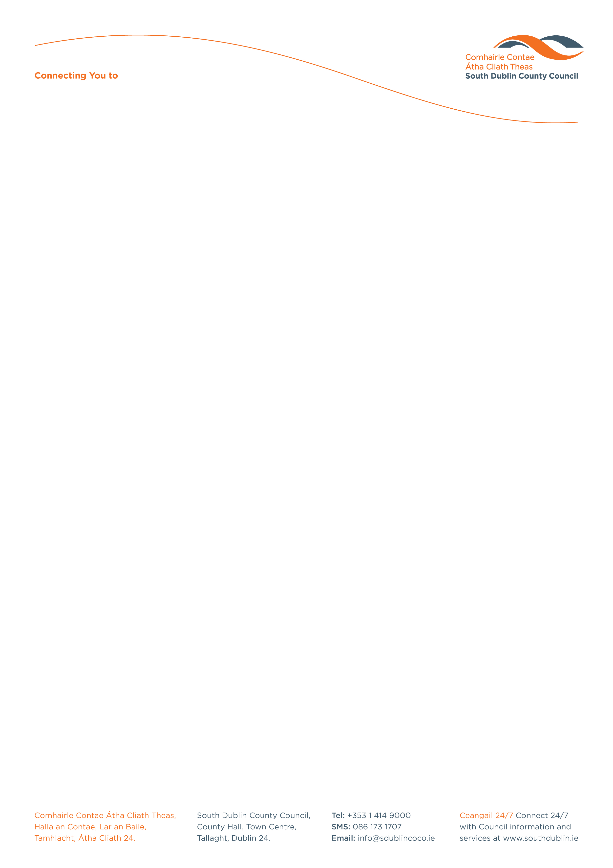

Halla an Chontae, Lár an Bhaile County Hall, Town Centre
Tamhlacht, Baile Átha Cliath 24 Tallaght, Dublin 24
Telefon: 01-4149052 Telephone: 01-4149052

Facs: 01-4149332 Fax: 01-4149332
www.southdublin.ie

The Superintendent,
Tallaght Garda Station,
Belgard Road,
Tallaght,
Dublin 24.

February 10th, 2010

RE: Tallaght Area Committee Meeting (1) – 18th January, 2010

Dear Sir/ Madam,

At South Dublin County Council’s Tallaght Area Committee Meeting, held on 18th January, 2010, the following motion was passed:

“This Committee, in view of the concern in many communities, calls on the Manager to give an up to date report on the roll out of CCTV in this Committee area focusing on the obvious delay and measures the various agencies including this Council are taking to resolve this problem.”

It was resolved to invite the Garda Superintendent to attend a meeting of the Tallaght Area Committee to address the issue.

I should be obliged if you would let me have a reply on the matter at your earliest convenience.

Thanking you in anticipation.

Yours sincerely,

Allyson Rooney,
SENIOR STAFF OFFICER,
HOUSING ADMINISTRATION.

Housing Administration

