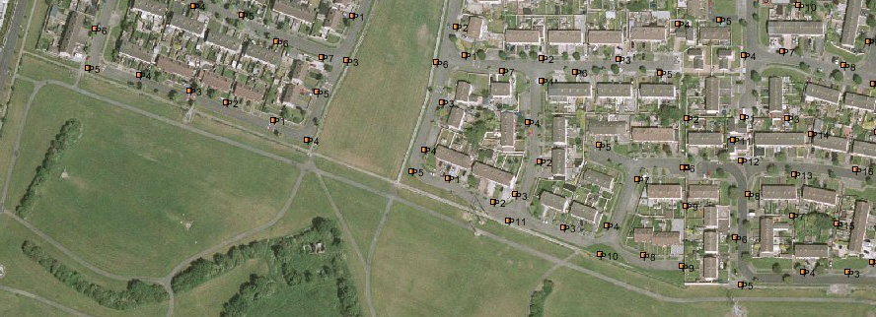
Deansrath Green
Melrose Park
Melrose Green
Lindisfarne Grove
Deansrath Park

The green line represents the existing lit routes on public footpaths. The blue line is the proposed link through the park from Deansrath Green to Melrose Green (with proposed lamp standards represented by a yellow box). The solid red line is the existing footpath within the Park. The dashed red line is the former footpath link between Melrose Park and Lindisfarne Grove (adjacent to 78 Lindisfarne Grove) which is now obsolete as a result of the construction of the Park boundary wall. Existing lamp standards are indicated by an orange box.

