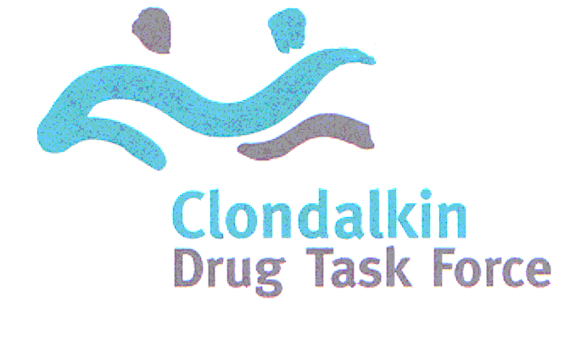
Unit 5, Oakfield, Clondalkin, Dublin 22
Tel: 01 457 9445 Fax: 01 457 9422
Email: cdtf1@indigo.ie

CLONDALKIN DRUGS TASK FORCE
ESTABLISHMENT OF LOCAL POLICING FOR A
DISCUSSION DOCUMENT

BACKGROUND
There are currently two local Community Safety Forums operating in the Clondalkin Drugs Task Force area, the North Clondalkin Community Safety Forum, which was established in 2002 and is managed by the North Clondalkin CDP and the South West Clondalkin Community Safety Forum which was established in 2004 and is managed by the South West Clondalkin CDP (The Dolcain Project).

Both of these Forums receive mainstreamed Clondalkin Drugs Task Force funding from the Department of Environment and Local Government through the SDCC to employ full time Forum Coordinators.

The guidelines for the establishment of LPC’s state that “where local fora are already in existence, and a Management Committee is already in place, JPC’s should formalise such arrangement in consultation with the Local Drugs Task Force” (5.1 Garda Siochana Act 2005 guidelines)

The Clondalkin Drugs Task Force is in a unique position in that there are two well established and resourced Forums in existence since 2003 in the area. The work of both of these Forums over the last 7 years has included capacity building amoung local community leaders to highlight issues of concern specifically with regard to anti social behaviour and crime including drug related crime and has been vital in facilitating community leaders and members of the broader community to work more collaboratively with key agencies including the Gardai and the local authority to address these issues.

Both the North Clondalkin and the South West Clondalkin Safety Forums have a very high profile and their work is very highly valued by the local community as well as services providers and state agencies in there respective areas. The formal recognition of the already existing Safety Forums as the Local Policing Forums is essential if we are retain the current level of trust that exists between the Gardai, other key agencies and the community and continue to facilitate the active and effective engagement of the community with other key stakeholders to address issues of anti social behaviour, crime and intimidation.

CLONDALKIN DRUGS TASK FORCE RECOMMENDATIONS
Following discussions with representative of the North Clondalkin CDP, the South West Clondalkin CDP, South Dublin County Council, community representatives and local service providers, the Clondalkin Drugs Task Force recommends that the existing Forums be formally recognised as the LPF’s for the Clondalkin Drugs Task Force area.

The CDTF recognise the fact that there are issues including geographical boundaries which will need to be considered by an Garda Siochana and may have an impact of the time frame for implementation of this recommendation in both areas of Clondalkin however members believe that these concerns can be addressed and will work closely with all the key stakeholders to achieve this if required.

In relation to current public consultation meetings which have been very successfully organised by the Gardai in each area, it is envisaged that each Local Policing Forum would develop a locally based action plan which would include the continuation of the local public consultation meeting which are hosted by the Gardai.

