An Garda Siochana

An tArd-Cheannfort,  Reigiun Chathair Atha Cliath (Theas)  Staisiun an Garda Croimghlinn,  Baile Atha Cliath 12.  Tel/Teileafon: 01-6666292/93  Fax/Facs: 01-6666299  Please quote the following reference number  DS | 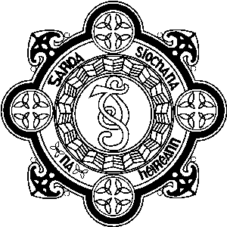 | Chief Superintendent,  D.M.R. South Division,  Crumlin Garda Station,  Dublin 12.  Web site: www.garda.ie  E-mail: Crumlin_DV@Garda.ie  Date: 30/07/2026

CASE MANAGEMENT

Case Management is the process of co-ordinating and managing young offenders who are frequently appearing before the courts. The process places one Garda member as a case manager for each individual young person.

They are then responsible for leading, co-ordinating and managing the young persons charges before the courts.

They liaise as necessary with the HSE/ Social services and/or other agencies as appropriate.

The case manager becomes fully familiar with all issues surrounding the young persons and is in a position to give an overview of all matters to the Judge where cases are listed for hearing.

One Sergeant in the DMR South, Continuous Professional Development Unit has been trained to deliver case management training to selected personnel.

It is intended that this training will be rolled out in the near future.

_____________________
John Manley
Chief Superintendent

