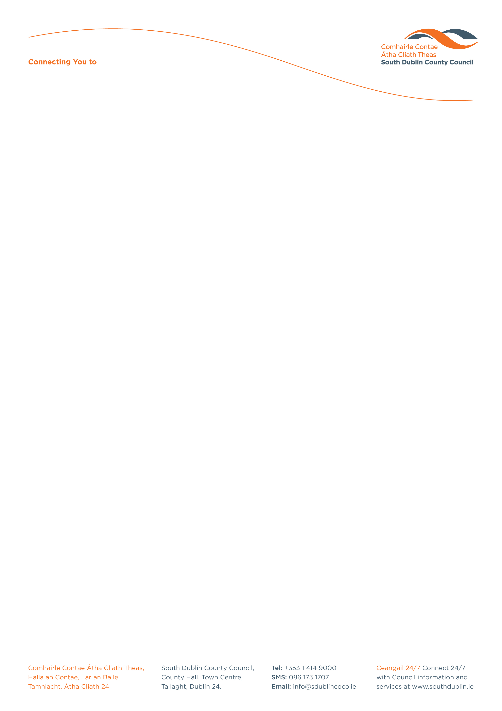

Halla an Chontae, Lár an Bhaile County Hall, Town Centre
Tamhlacht, Baile Átha Cliath 24 Tallaght, Dublin 24
Telefon: 01-4149052 Telephone: 01-4149052

Facs: 01-4149332 Fax: 01-4149332
www.southdublin.ie

The Manager
An Post
GPO
Dublin 1.

21st December, 2009

RE: Tallaght Area Committee Meeting – 16th December 2009

Dear Sir/Madam,

At the Tallaght Area Committee Meeting of 16th December , 2009, the following motion was passed:

“That this Committee calls on An Post to provide a post office in the Citywest area in light of the obvious need for such a service in this rapidly expanding area.”

I should be obliged if you would let me have a reply on this matter at your earliest convenience.

Thanking you in anticipation.

Yours sincerely,

ALLYSON ROONEY,
SENIOR STAFF OFFICER,
HOUSING ADMINISTRATION.

Housing Administration

