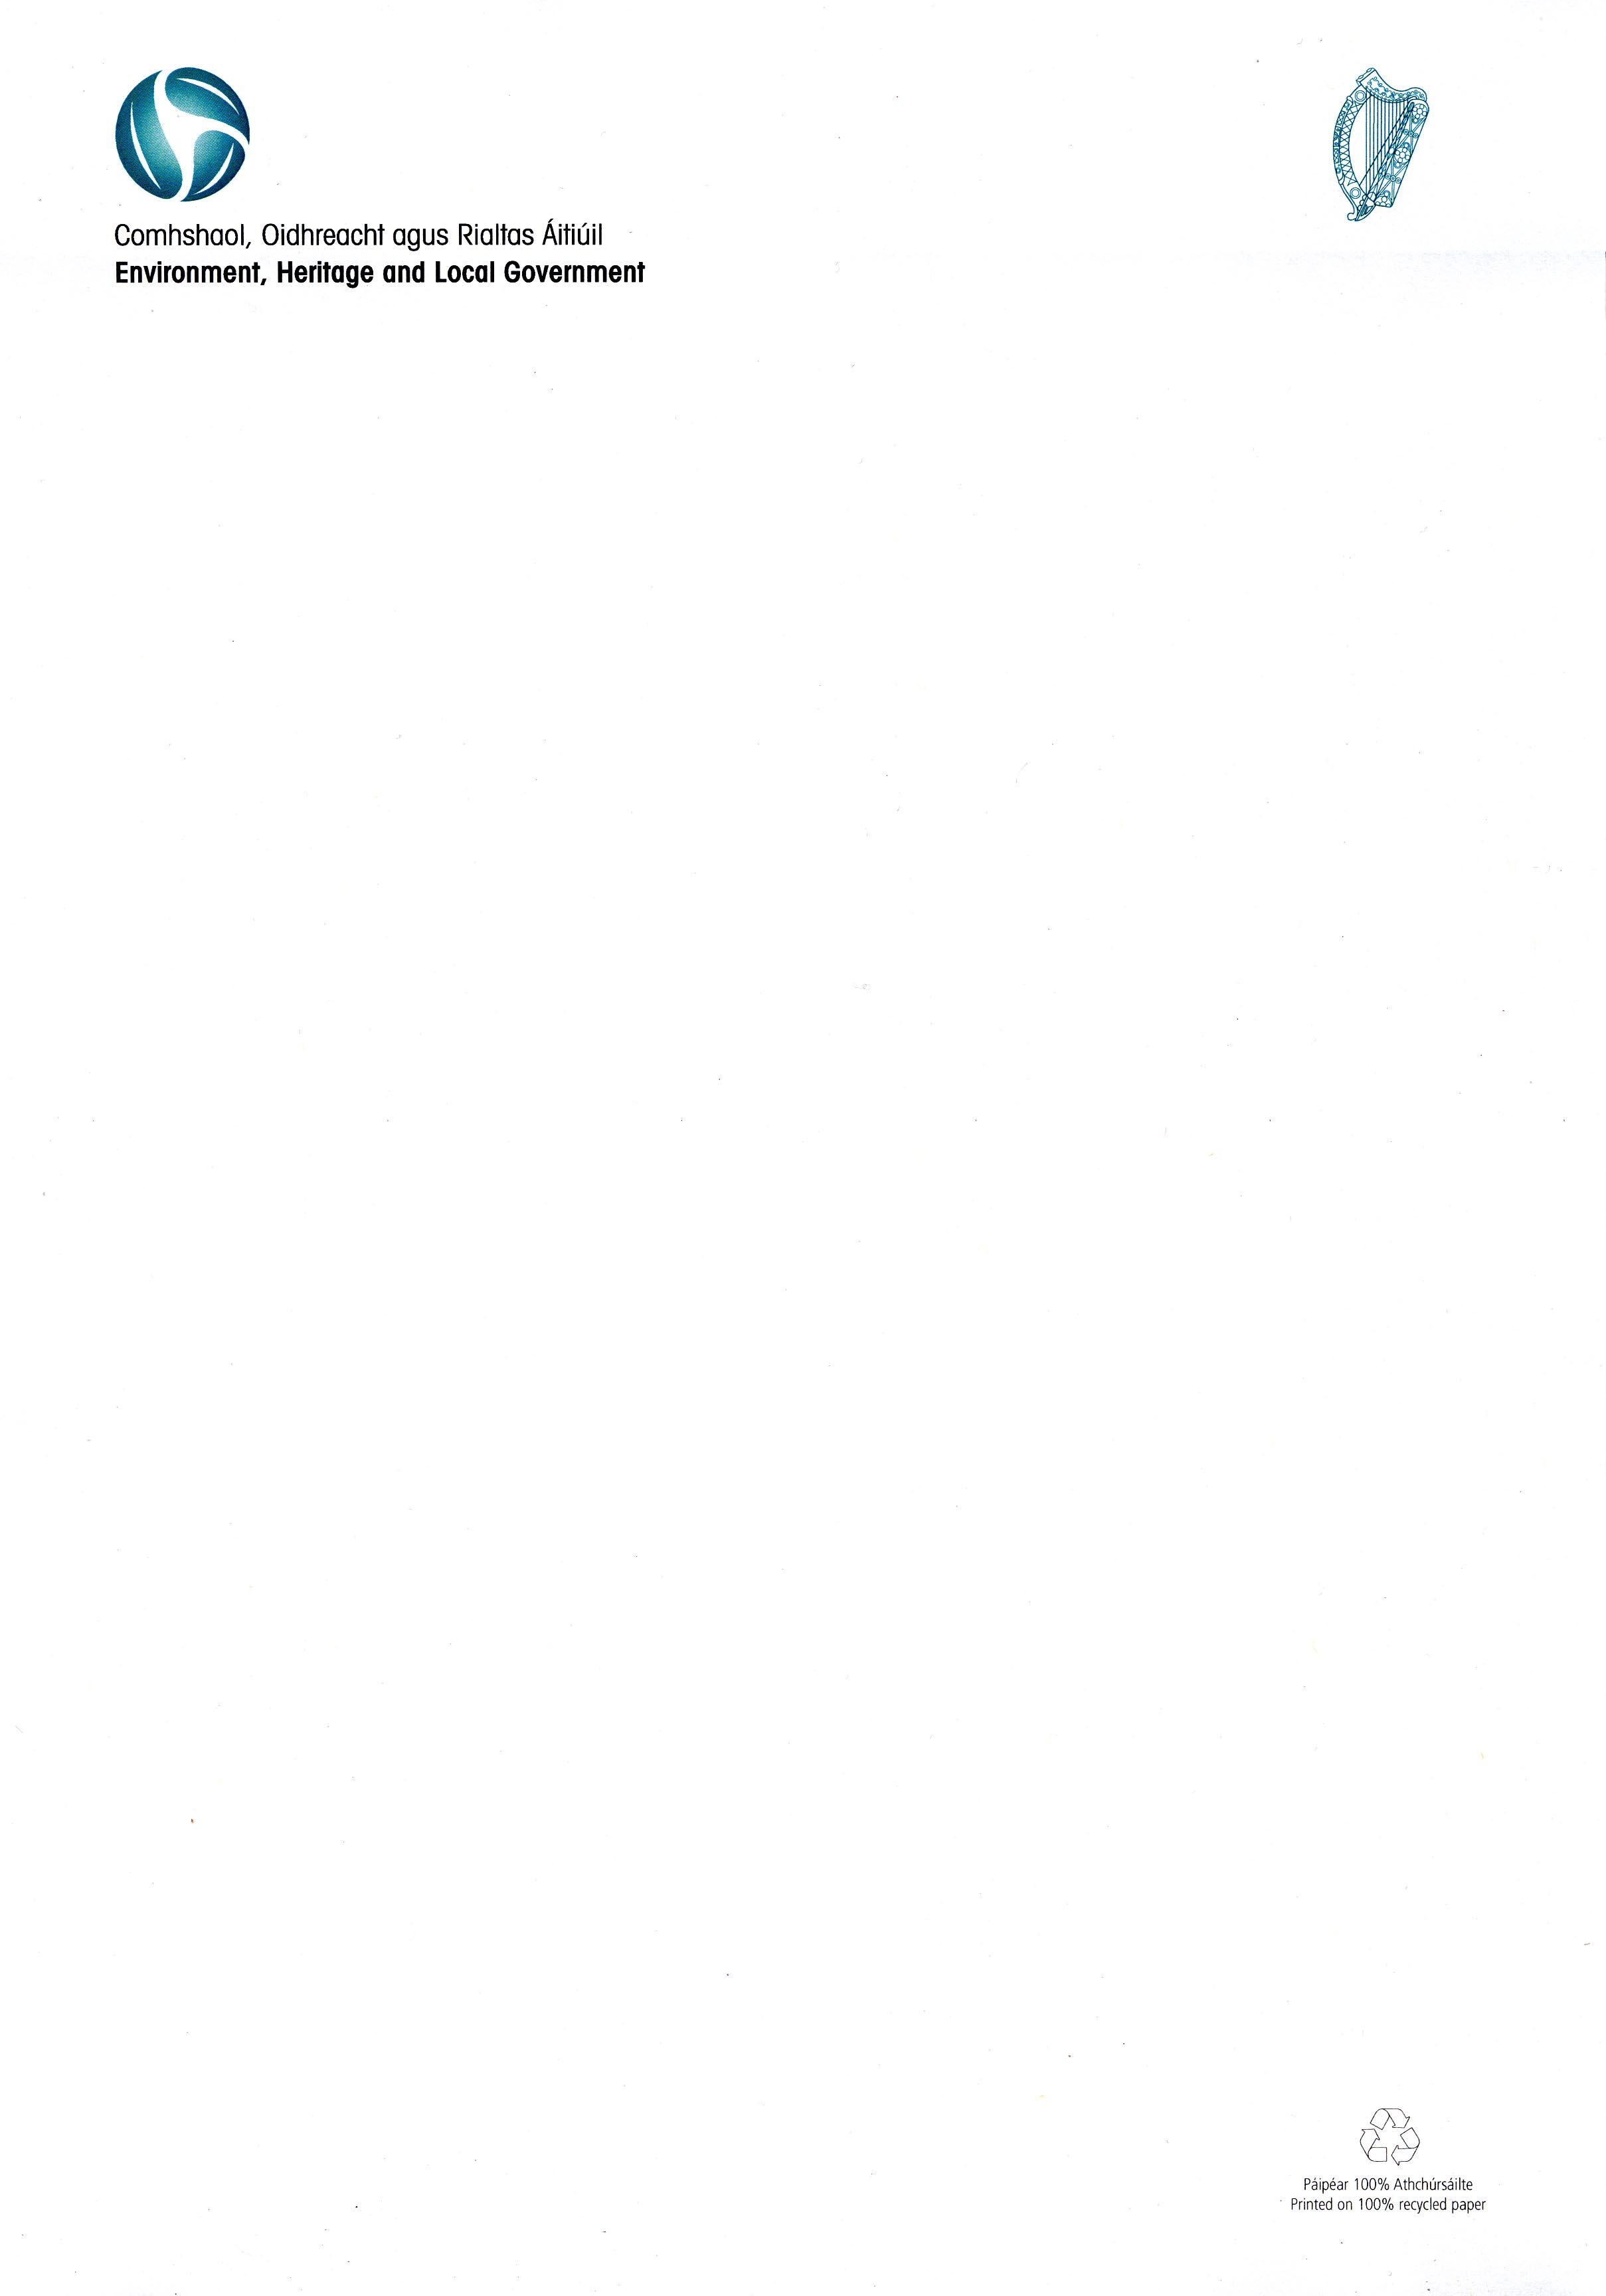
Circular Fin 11/2009

12 November 2009

Local Authority 2010 Budget Meetings

I am directed by the Minister for the Environment, Heritage and Local Government to inform you that the prescribed periods that apply for the holding of 2010 Budget meetings are as follows:

• County Councils: 24 November 2009 to 13 January 2010

• City/Borough/Rating Town Councils: 24 November 2009 to 15 January 2010

• Non-Rating Town Councils/Joint Bodies: 15 November 2009 to 16 December 2010

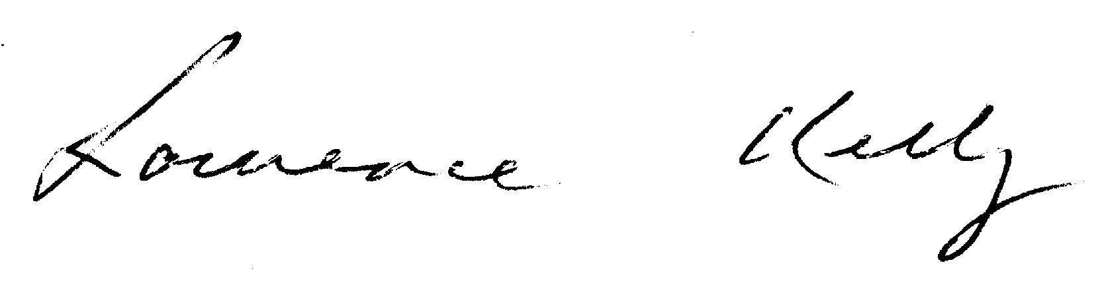
_______________________
Laurence Kelly
Principal Officer
Local Government Finance

To: All Local Authorities

