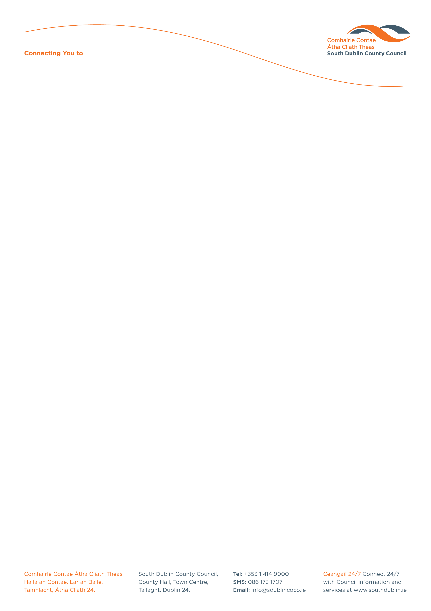

Halla an Chontae, Lár an Bhaile County Hall, Town Centre
Tamhlacht, Baile Átha Cliath 24 Tallaght, Dublin 24
Telefon: 01-4149052 Telephone: 01-4149052

Facs: 01-4149332 Fax: 01-4149332
www.southdublin.ie

Mr J. Culbert
Eircom
Waterford.
Ph. 051-873266
Email: jculbert@eircom.net

November 3, 2009

RE: Tallaght Area Committee Meeting – 27th October, 2009

Dear Sir/Madam,

The following question was submitted by Councillor E. Maloney, in the order of business of the Tallaght(2) Area Committee meeting, which took place on 27th October 2009:
"To ask the Manager to request the relevant telephone company to remove from Tallaght village the remains of the public-telephone, located outside Ulster Bank Ltd.?"

I should be obliged if you would confirm if this unit is under your remit and forward me a reply on this matter at your earliest convenience.

Thanking you in anticipation.

Yours sincerely,

ALLYSON ROONEY,
SENIOR STAFF OFFICER,
HOUSING ADMINISTRATION.

Housing Administration

