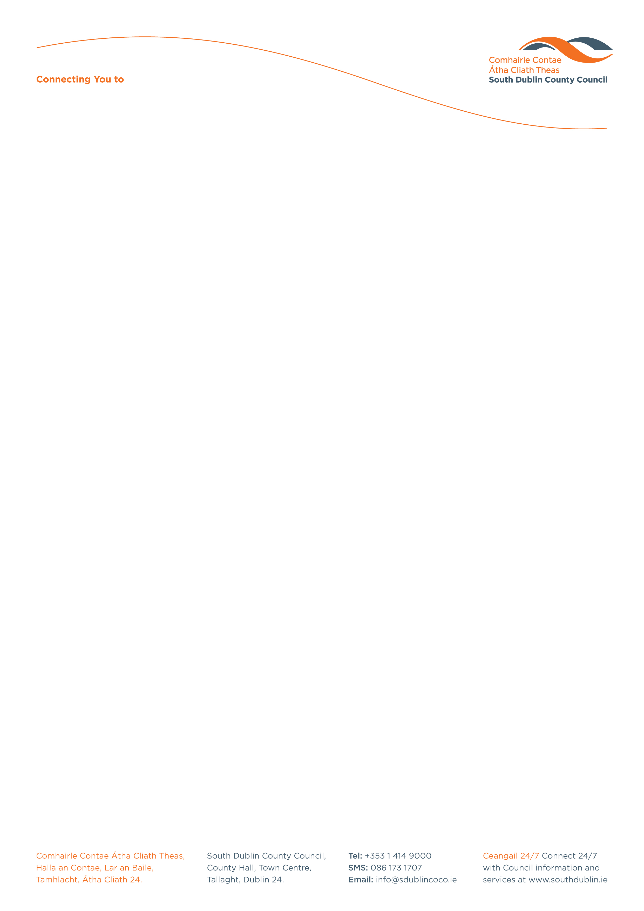

Halla an Chontae, Lár an Bhaile County Hall, Town Centre
Tamhlacht, Baile Átha Cliath 24 Tallaght, Dublin 24
Telefon: 01-4149052 Telephone: 01-4149052

Facs: 01-4149332 Fax: 01-4149332
www.southdublin.ie

Citywest Limited
27 Dawson Street
Dublin 2.

4th November 2009

RE: Tallaght Area Committee Meeting – 27th October, 2009

Dear Sir/Madam,

At the Tallaght Area Committee Meeting of 27th October 2009, the following motion was passed:

“This Committee calls on the Manager to investigate in conjunction with the Garda Authorities and other landowners in the area the viability of taking measures to eliminate the regular incursions by scrambler and quad bikes and now by anti social elements on the lands at the rear of Lidl and the side of Ard Mor Estate.”
I should be obliged if you would let me have a reply on this matter at your earliest convenience.

Thanking you in anticipation.

Yours sincerely,

ALLYSON ROONEY,
SENIOR STAFF OFFICER,
HOUSING ADMINISTRATION.

CC Superintendent, Tallaght Garda Station.
Housing Administration

