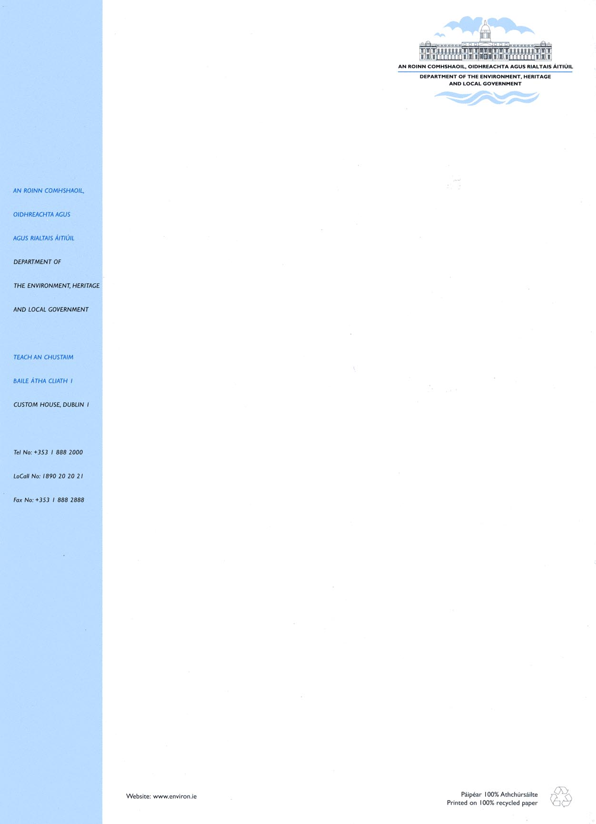
Circular Fin 11/2007

23 May 2007

Audit Function in Local Authorities

Dear Manager,

As advised in Circular Fin 01/07 of 5 January 2007, the Local Government (Business Improvement Districts) Act 2006 (BIDS Act) provides for an enhanced role for audit committees in local authorities. These new provisions reflect best practice and developments in corporate governance in both the public and private sectors, and also flow from recommendations in Report No. 23 by the Value for Money Unit of the Local Government Audit Service. The latter report was primarily designed to provide an update on the Development of Internal Audit in Local Authorities.

Purpose of Circular
The purpose of this circular is twofold, to:

- request local authorities to put arrangements in hand to set up audit committees (pending finalisation, shortly, of regulations under the BIDS Act), and
- to remind local authorities of their responsibilities in relation to internal audit.

Background
Local government modernisation over the past decade has brought significant improvements in the governance of local authorities through, for example, the formation of corporate policy groups and strategic policy committees, strengthening of the finance function, modernisation of accounting systems to a full accrual basis and the introduction of risk management to the sector.

The scale, complexity and diversity of local government business, allied to the need for transparency and accountability in regard to the performance of each authority, serve to highlight the importance of regularly reviewing the effectiveness of internal financial and operational controls.

The scale, complexity and diversity of local government business, allied to the need for transparency and accountability in regard to the performance of each authority, serve to highlight the importance of regularly reviewing the effectiveness of internal financial and operational controls.

Audit Committees
Section 5 of the BIDS Act replaces the narrowly defined provisions in Section 122 of the Local Government Act 2001 in relation to audit committees in local authorities. The new provisions provide for enhancement of the role of audit committees and will allow for the inclusion of outside expert membership on such committees.

The functions of an audit committee under the new provisions are to:

- review financial and budgetary reporting practices and procedures within a local authority,
- foster the development of best practice in the internal audit function,
- review auditors’ reports and special reports and assess follow-up action by management,
- assess and promote efficiency and value for money,
- review risk management systems, and
- make such recommendations to the authority as the committee considers appropriate in relation to the foregoing.

The new provisions provide for the making of regulations by the Minister in relation to the membership of audit committees, the holding of meetings, reporting, performance of the functions of an audit committee, etc. Pending the making of regulations, each city and county council is now requested to put in place arrangements for the setting up of an audit committee as early as possible, and not later than end October 2007, along the lines set out below. The committee should remain in place for the duration of the current elected council, with subsequent committees to be established within three months of the first meeting of each council.

General
The Audit Committee will have an independent role in advising the Council on financial reporting processes, internal control, risk management and audit matters, as part of the systematic review of the control environment and governance procedures of the Council.

The committee will be non-executive and will be independent in the determination of its work programme and in formulating any recommendations, taking account of the functions referred to above.

The audit committee should operate under a clear Charter which would include, inter alia, the role and functions of the committee, membership structure and eligibility, details of meetings arrangements, working procedures, access of committee to persons, and reporting arrangements. A draft charter for this purpose is set out in Appendix 1.

Role of Committee
Within the statutory functions set out in the BIDS Act, the role of the committees will be to:

- review the Council’s financial and budgetary reporting practices and procedures,

- foster the development of best practice in the internal audit function and, as part of this:
  - review the internal audit charter and bring any recommendations to the attention of the Manager,
  - review and assess the draft annual internal audit plan,
  - monitor implementation of the internal audit plan on a quarterly basis and the extent to which audit objectives are being achieved,
  - assess the outcome of the internal audit process, having regard to any findings and recommendations of the internal audit unit and management responses thereto,
  - assess the implementation of agreed corrective actions by management having regard to follow-up audits,
  - review the report of audit activities by the internal audit unit, within three months of the year end,

- request special reports from Internal Audit as considered appropriate,

- review Local Government Auditors’ reports and assess management response and follow-up actions,

- assess and promote value for money/efficiency, including collection performance across income streams,

- consider whether processes are in place to manage risks effectively, in accordance with organisational guidelines and business plans,

- report to the Council at least annually, and in any event within three months of the end of each calendar year, providing such advice and making such recommendations, if any, to the Council as the committee considers appropriate.

Membership
- An audit committee should generally have five members, including at least three external members, and not more than two serving or retired Councillors (i.e. a former Councillor no longer holding an elected position at national or local political level). Where total expenditure (current and capital) by a local authority in 2005 exceeded €250m, the local authority may wish to consider having a seven member committee, including at least four external members, and not more than three serving or retired Councillors.

- The Committee should be established by resolution of the Council and the external members should be approved by the Council on the nomination of the Manager following consultation with the Cathaoirleach/Mayor.

- At least one of the external members should have financial management/audit expertise in the case of a five member committee. Where a local authority chooses to have a seven member committee, at least two of the external members should have financial management/audit expertise.

- The chair of a committee will be selected by its members and, in line with best practice, will be one of the external members.

- Council officials cannot be committee members.

- Appointments to a committee will be for the duration of the elected council.

Meetings
- There should be at least four meetings each calendar year.

- The quorum will be three members in the case of a five member committee or four members in the case of a seven member committee.

- In the absence of the chairperson, those present will elect a chairperson for the meeting.

Access, Reporting and Working Procedures
- The committee will be entitled to discuss issues arising in the course of its work with the Manager, Directors of Service (including the Head of Finance) and the Head of the Internal Audit Unit.

- The Manager, Directors of Service (including the Head of Finance) and the Head of the Internal Audit Unit should attend meetings, when requested to do so by the committee.

- The relevant Local Government Auditor should be invited to meet the committee at least once a year to discuss matters of mutual interest. In addition, the Local Government Auditor or the Head of the Internal Audit Unit may, with the agreement of the chairperson of the committee, request a meeting to discuss a matter of exceptional importance.

- The Local Government Auditor and the Head of Internal Audit may communicate with the Committee as they consider necessary.

- In presenting a report to the Council, the committee shall simultaneously forward a copy of the report to the Manager.

- Following presentation of an annual or other report by the committee, the Council will be entitled to discuss the findings with the Manager.

- The committee will adopt it own working procedures.

- The Director of Corporate Services should act as Secretary to the committee.

Miscellaneous
- The committee may, following due notice to the Council and the Manager, seek independent professional advice.

- Training and support should be provided to assist members in discharging their functions.

- The charter of the committee may be amended or updated by resolution of the Council.

Internal Audit
Statutory requirements in relation to internal audit are set out in Article 16 of the Local Government (Financial Procedures and Audit) Regulations 2002, which require local authorities to ‘maintain an adequate and effective system of internal audit of its accounting records and control systems’.

Report No. 23 – Follow-up Report on the Development of Internal Audit in Local Authorities - by the Value for Money Unit of the Local Government Audit Service, which addressed the role and objectives of internal audit, indicated that, while the majority of local authorities have an internal audit function, progress by many authorities in the development of the internal audit function since the Local Government Audit Service’s earlier report of December 2000 has been disappointing. The findings from the survey carried out by the Local Government Audit Service are summarised in section 7 of the report, with the detailed findings set out in Appendices 2 to 6. Section 8 of the Report makes a number of recommendations in relation to enhancement of the internal audit function.

The Minister considers that Report No. 23 by the Local Government Audit Service is a timely reminder of the need to give priority to the internal audit function in local authorities in order to meet modern corporate governance requirements. Each Manager is requested, therefore, to review his/her internal audit arrangements in light of the findings and recommendations in Report No. 23 with a view to achieving appropriate levels of audit performance to meet the needs of each local authority under his/her control. In the case of town councils, Managers should consider the making of appropriate arrangements under Part 10 of the Local Government Act 2001.

It is recommended that each authority should draw up a Charter in respect of the internal audit function. A draft charter for this purpose is set out in Appendix 2.

Conclusion
It is estimated that local authority spending in 2006 totalled approximately €9 billion between current and capital expenditure - funded through central and local taxation and charges for services. The establishment of audit committees and enhancement of the internal audit function will have substantial significance for the public, business, and local authority elected members and management, and should further enhance internal control, risk management, accountability and value for money.

The Minister has asked the Department to monitor progress in particular on the establishment and operation of audit committees.

Any queries arising from this circular may be addressed to Mr. Noel O’ Reilly, Local Government Finance Section, Custom House, Dublin 1 (tel: (01) 8882482 or email noel.o’reilly@environ.ie)

Mise le meas
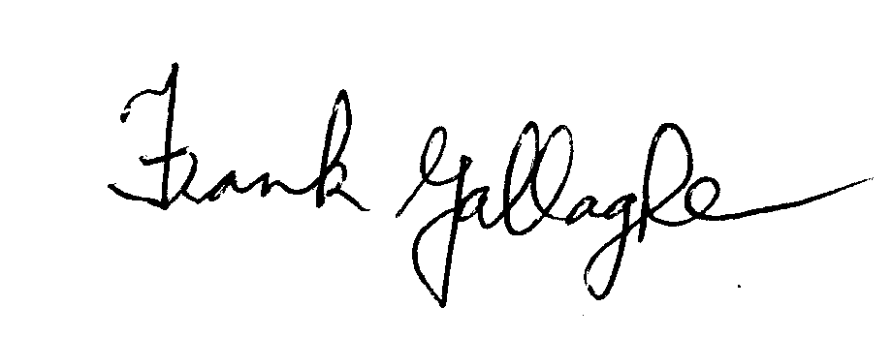
_____________________
Frank Gallagher
Principal Officer
Local Government Finance Section

Appendix 1

XXX Council

Draft Audit Committee Charter

Role of the Committee

The Audit Committee will have an independent role in advising the Council on financial reporting processes, internal control, risk management and audit matters, as part of the systematic review of the control environment and governance procedures of the Council.

The Committee will have a role in promoting good accounting practices, ensuring better and more informed decision-making, and improving the focus on value for money throughout the organisation. It will also support the work of the Internal Audit Unit and advise the Manager in relation to the operation and development of the Unit.

The Committee’s role is advisory.

Functions

The functions of the Committee shall be to:
- Review the Council’s financial and budgetary reporting practices and procedures,

- Generally foster the development of best practice in the internal audit function and, as part of this:
  - Review the internal audit charter and bring any recommendations to the attention of the Manager,
  - Review and assess the draft annual internal audit plan,
  - Monitor implementation of the internal audit plan on a quarterly basis and the extent to which audit objectives are being achieved,
  - Assess the outcome of the internal audit process, having regard to any findings and recommendations of the internal audit unit and management responses thereto,
  - Assess the implementation of agreed corrective actions by management having regard to follow-up audits,
  - Review the report of audit activities by the Internal Audit Unit, within three months of the year end,

- Request special reports from Internal Audit as considered appropriate,

- Review Local Government Auditors’ reports, and assess management response and follow-up actions,

- Assess and promote value for money/efficiency, including collection performance across income streams,

- Consider whether processes are in place to manage risks effectively, in accordance with organisational guidelines and business plans,

- Report to the Council at least annually, and in any event within three months of the end of each calendar year, providing such advice and making such recommendations, if any, to the Council as the committee considers appropriate.

Membership

An audit committee should generally have five members, including at least three external members, and not more than two serving or retired Councillors (i.e. a former Councillor no longer holding an elected position at national or local political level). Where total expenditure (current and capital) by a local authority in 2005 exceeded €250m, the local authority may wish to consider having a seven member committee, including at least four external members, and not more than three serving or retired Councillors.

The Committee will be established by resolution of the Council and the external members will be approved by the Council on the nomination of the Manager following consultation with the Cathaoirleach/Mayor. Appointments to the Committee shall be for the duration of the elected Council, with subsequent committees to be established within three months of the first meeting of each council.

The Chair of the Committee shall be selected by its members, and shall be one of the external members.

At least one of the external members of the Committee shall have relevant financial management/audit expertise. Where a local authority chooses to have a seven member committee, at least two of the external members should have financial management/audit expertise. Training and support should be provided to assist members in discharging their functions.

Meetings

The Committee shall meet at least four times a year. The quorum necessary for the transaction of business shall be three members in the case of a five member committee, or four members in the case of a seven member committee. In the absence of the chairperson, those present shall select a chairperson for the meeting. A copy of the minutes of meetings shall be forwarded to the Manager.

The Manager, Directors of Service (including the Head of Finance) and the Head of the Internal Audit Unit should attend meetings, when requested to do so by the committee.

The Manager will facilitate the Committee in relation to briefings required by them from him/her and/or other council officials.

Independence

The committee shall be independent in the performance of its functions and responsibilities and shall not be subject to direction or control from any other party.

Working Procedures

The Committee will adopt its own working procedures, which may include as necessary the commissioning of independent professional advice following due notice to the Council and the Manager.

Access

The Chairperson of the Committee, or any other member of the committee acting with the specific authority of the Chairperson, will have the right of access to the Manager and to the Cathaoirleach of the Council.

The Chairperson of the Committee will invite the relevant Local Government Auditor to meet the Committee at least once a year to discuss matters of mutual interest.

The Local Government Auditor or the Head of the Internal Audit Unit may, with the agreement of the chairperson of the committee, request a meeting to discuss a matter of exceptional importance.

The Local Government Auditor and the Head of Internal Audit may communicate with the Committee as they consider necessary.

Reporting

In presenting a report to the Council, the committee shall simultaneously forward a copy of the report to the Manager.

Following presentation of an annual or other report by the committee, the Council will be entitled to discuss the findings with the Manager.

Amendment of Charter

This Charter may be amended or updated by resolution of the Council.

Signed: ______________ ________________
Chairperson Manager

Dated:

Appendix 2

XXX Council

Internal Audit Charter

Council policy

It is the policy of the Council to maintain and support a quality internal audit function.

Definition and Role

Internal Audit is an independent appraisal function established by the management of an organisation for the review of the internal control systems as a service to the organisation. It objectively examines, evaluates and reports on the adequacy of internal controls as a contribution to the proper, economic, effective and efficient use of resources. Internal control has been defined as the whole system of controls, financial and otherwise, established by management in order to carry on the business of the enterprise in an orderly and efficient manner, ensure adherence to management policies, safeguard the assets and secure, as far as possible, the completeness and accuracy of records.

Internal Audit is responsible for giving assurance to the Manager on the existence, adequacy and effectiveness of the Council’s internal control and risk management systems. Internal Audit also assists line managers by evaluating and reporting on the elements of the internal control systems for which they are responsible and making recommendations for improvement where necessary. Line management has full responsibility for the establishment and maintenance of the internal control systems.

The Internal Audit function of XXX Council will have regard to any recommendations made by the Local Government Audit Service’s Value for Money reports on the internal audit function.

Duties and Responsibilities of Internal Audit

The primary responsibility of Internal Audit is critically and objectively to review and appraise the following:

- The design and operation of all systems and procedures (financial, management, etc.) which are intended to control the Council’s operations including those used by management to measure the extent to which programmes and other operations run by the Council are successful in the achievement of policy objectives
- The adequacy, reliability and integrity of the information being provided for decision-making and for accountability and the extent to which this information is used
- The degree of compliance with local policies, plans and procedures and also with national and international policies, laws and regulations
- The procedures and arrangements for the acquisition, safeguarding and disposal of assets
- The arrangements for economic, efficient and effective use of resources.

In discharging this responsibility, Internal Audit will also identify and report on any deficiency or weakness in systems and controls and make appropriate recommendations for improvement.

Internal audit will maintain ongoing liaison with the local government auditor responsible for the Council’s external audit.

In exceptional circumstances, Internal Audit may also be assigned other duties.

Authority

Internal Audit is authorised to carry out a comprehensive programme of internal audit in all areas of the Council. In the implementation of the audit programme, internal audit staff are authorised to have full, free and unrestricted access to all the Council’s records, assets and personnel. In addition, internal audit staff are entitled to request and receive all the information and explanations they require for the proper performance of their duties.

Independence

Internal auditors must be independent of the activities they audit and should not have any operational responsibilities outside audit. However, Internal Audit may, if deemed appropriate by the Head of Internal Audit and/or the Audit Committee, or if requested by management, review systems under development and advise on appropriate controls without prejudicing its right to subsequently audit such systems.

Reporting Arrangements

Reporting by the internal audit function (through the Head of Internal Audit) shall be directly to the Manager and quarterly, or otherwise as requested, to the Audit Committee. The Head of Internal Audit will have direct access to the Manager. Audit reports will also issue to appropriate line managers.

Internal audit will prepare an annual report on its activities.

Audit Approach and Methodology

Audit planning
Annual audit plans are drawn up in the context of a long-term strategic audit plan developed using a risk assessment process and involving consultations with Heads of Sections. Both the annual and strategic plans are agreed with the Manager and the Audit Committee prior to adoption.

Implementation and reporting
Internal Audit will normally notify Heads of Sections when an area is approved for inclusion in the Audit Work Programme and at least one month prior to the commencement of an audit. Internal audits are generally systems-based and involve the examination of files and relevant documentation, interviews with key staff, testing of controls and the use of questionnaires. A draft report of the audit will be discussed with line management to confirm its factual accuracy and to agree, where possible, the conclusions and recommendations for improvements. The final report, incorporating management's response, will then issue to the line management concerned, the Manager, the Audit Committee and to the Local Government Auditor.

Follow-up
The Head of Internal Audit may, as part of the audit work programme, request periodic updates from management on the implementation of audit recommendations, in order to evaluate progress thereon.

Management Responsibilities

Management has primary responsibility for establishing and maintaining a proper and effective control environment and for managing risk. Management also bears primary responsibility for the prevention and detection of fraud.

Heads of Sections and other line management are expected to co-operate with the Head of Internal Audit in the audit planning process by identifying areas and activities, which carry significant financial, operational or other business risks. Line management is also expected to co-operate fully and in a timely manner with Internal Audit staff in the course of individual audit assignments and to take prompt action to implement accepted recommendations.

________________
Manager

____________________________________
Chair of Audit Committee

____________________________
Head of Internal Audit

Dated:

