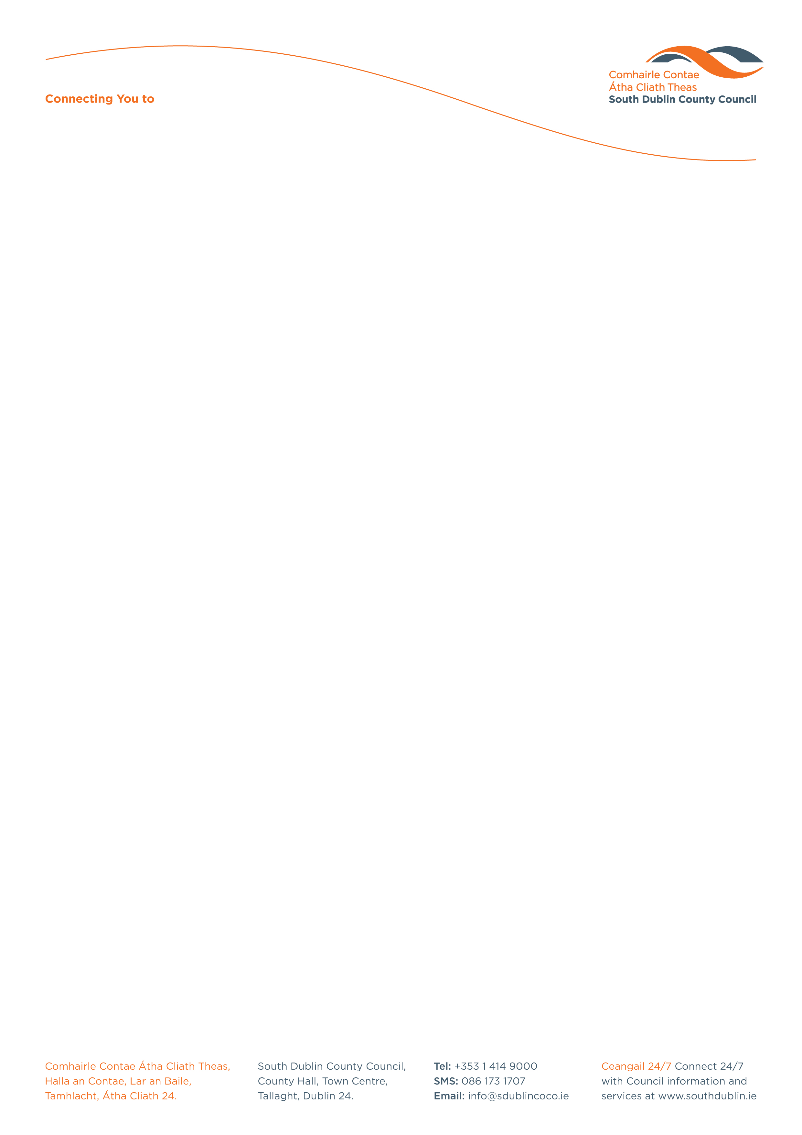

Halla an Chontae, Lár an Bhaile County Hall, Town Centre
Tamhlacht, Baile Átha Cliath 24 Tallaght, Dublin 24
Telefon: 01-4149052 Telephone: 01-4149052

Facs: 01-4149332 Fax: 01-4149332
www.southdublin.ie

Mr.Éamon Ó Cuív
Minister for Community, Rural
and Gaeltacht Affairs
Dún Aimhirgin
43-49 Mespil Road
Dublin 4.

October 7th , 2009

RE: Tallaght Area Committee Meeting (1) – 21st September, 2009

Dear Minister Ó Cuív,

At South Dublin County Council’s Tallaght Area Committee Meeting, held on 21st September, 2009, the following motion was passed:

“That this Committee requests the Minister for Community, Rural and Gaeltacht affairs to give a commitment to maintain the West Tallaght RAPID programme given its outstanding success to date and the potential disastrous consequences to the community it serves if removed.”

I should be obliged if you would let me have a reply on the matter at your earliest convenience.

Thanking you in anticipation.

Yours sincerely,

Allyson Rooney
Senior Staff Officer
Housing Administration

Housing Administration

