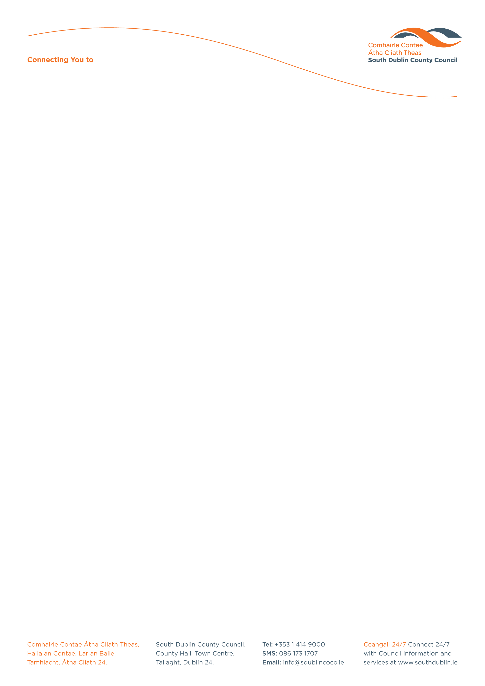

Halla an Chontae, Lár an Bhaile County Hall, Town Centre
Tamhlacht, Baile Átha Cliath 24 Tallaght, Dublin 24
Telefon: 01-4149052 Telephone: 01-4149052

Facs: 01-4149332 Fax: 01-4149332
www.southdublin.ie

Ms Mary Coughlan
An Tanaiste
Minister for Enterprise, Trade
and Employment
23 Kildare Street
Dublin 2
October 7th , 2009

RE: Tallaght Area Committee Meeting (1) – 21st September, 2009

Dear Minister Coughlan,

At South Dublin County Council’s Tallaght Area Committee Meeting, held on 21st September, 2009, the following motion was passed:

“That this Committee condemns any move by the government to abolish JI/CE schemes within Tallaght given the proven immense value of these schemes in terms of community enhancement and development.”

I should be obliged if you would let me have a reply on the matter at your earliest convenience.

Thanking you in anticipation.

Yours sincerely,

Allyson Rooney
Senior Staff Officer
Housing Administration

Housing Administration

