COMHAIRLE CONTAE ÁTHA CLIATH THEAS
SOUTH DUBLIN COUNTY COUNCIL

MEETING OF SOUTH DUBLIN COUNTY COUNCIL
Monday, October 12, 2009
QUESTION NO.15
QUESTION: Councillor C. King
To ask the Manager to state whether the annual junk collections are due to take place this autumn prior to the Halloween period or has financial considerations resulted in the service being cut and can he/she make a statement on the matter?
REPLY:
It has been necessary to impose budgetary constraints on disrectionary areas of expenditure due to the financial situation that this Council is in and accordingly no provision has been made in the Revised Budget 2009 for junk collections. WEEE Ireland and CCRI (Clondalkin Community Recycling Initiative) both offer a collection service to households. These collections have, in the past, been made possible through the employment of temporary staff and in addition to the budgetary constraints there is also a national embargo on such employment. It is however worth noting that there has been an on-going reduction in the level of material collected in the course of this service:-
Junk Collection 2005-2007 | 2008 | 2007 | 2006 | 2005
Total number of houses serviced | 21,450 | 21,500 | 24,511 | 21,285
Total cost | €590,060 | €535,536 | €444,354 | €423,196
Tonnage collected | 1,333 | 1,637 | 1,574 | 1,705
Cost per house | €27.45 | €24.91 | €18.13 | €19.88
WEEE Ireland and CCRI - Clondalkin Community Recycling Initiative both offer a service to households on the collection of electrical goods. It is also worth noting that the Dublin led initiative of Freetrade has seen a considerable growth over recent years
In August 2009 Google Analytics[1] recorded 129,630 visits to the website making it the busiest month of 2009 to date. The monthly figures for June, July and August 2009 are compared to the same time period for 2008.
Website hits to DublinWaste.ie (Source: Google Analytics)
Website hits to DublinWaste.ie (Source: Google Analytics)

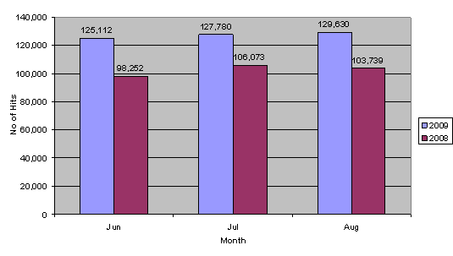

This initiative promotes re-use and reduces the material so is therefore a far more sustainable service to householders and to the region and impacts in reducting the amount of bulk waste which can building up in households and in reducting the material diverting to landfill. Some of the highlights of this website include the following:-
- DublinWaste.ie has had over 4,010,811 million visits since its launch in 2004.
- DublinWaste.ie now has over 30,400 members.
- A total of 22,800 items have been reused through FREE Trade since August 2006.
- PutLitterInItsPlace has received over 2,900 visits since its launch in February 2009.
- DublinWaste.ie has had over 325,000 unique visitors in 2009 to date

