COMHAIRLE CONTAE ATHA CLIATH THEAS

SOUTH DUBLIN COUNTY COUNCIL

MINUTES OF MEETING OF THE TALLAGHT AREA COMMITTEE
(Dealing with Environment, Housing and Community)
HELD ON 27th APRIL, 2009

PRESENT

Councillors | Councillors
Corr M. | King C.
Crowe S. | Maloney E.
Daly J. | Murphy M.
Hannon J. | Neville J.
Jones C. | Warren K.

Councillor E. Maloney presided.

OFFICIALS PRESENT

Director of Community Services | P. Smith
Senior Executive Officers | A. Jacob, M. Fagan,  W. Sheils, J. Quinlivan
Administrative Officer | B. Hynes, T. O’Neill,
Senior Staff Officer | A. Rooney
Staff Officer | E. Conlon

T/230/09 CONFIRMATION AND RE-AFFIRMATION OF MINUTES

Minutes of Tallaght Area Committee Meeting held on 16th March, 2009 which had been circulated, were submitted and APPROVED as a true record and signed.

It was proposed by Councillor E. Maloney, seconded by Councillor K. Warren and RESOLVED:

“That the recommendations contained in the Minutes of the Tallaght Area Committee held on 16th March, 2009 be ADOPTED and APPROVED".

ENVIRONMENT BUSINESS

T/231/09 QUESTIONS

It was proposed by Councillor E. Maloney, seconded by Councillor K. Warren and RESOLVED:

“That pursuant to Standing Order No. 13, Question 1, be ADOPTED and APPROVED."

T/232/09 REMOVAL OF VISIBLE WASTE

QUESTION: Councillor M. Murphy
"Could the Manager confirm that Litter Wardens have the power to ask for waste that is visible from a public place but on private property (in front gardens etc.) be removed?”
REPLY:
The Council’s Anti-Litter Wardens are responsible for the enforcement of the Litter Pollution Act, 1997, as amended, and Section 6 deals with the duty of occupiers, etc., regarding littering. This section places various requirements on occupiers and includes the responsibility to keep any land that is not a public place free of litter that is to any extent visible from a public place. These requirements include the responsibility to keep front gardens clear and Anti-Litter Wardens regularly deal with complaints of this nature and will, in the first instance, generally call out and request that the area in question be cleaned. If this does not resolve the matter, enforcement proceedings are then taken by the Warden.
Bottom of Form

T/233/09 NEW WORKS
It was NOTED there was no business under this heading

T/234/09 CORRESPONDENCE
A (i) Letter dated 25th March, 2009, sent to Roadstone Ltd, regarding a motion passed at the Tallaght Area Committee Meeting of 16th March, 2009, in relation to stones and rubble on the Old Belgard Road.
A (ii) Letter dated 3rd April, 2009, received from Roadstone Ltd, regarding a motion passed at the Tallaght Area Committee Meeting of 16th March, 2009, in relation to stones and rubble on the Old Belgard Road.

T/235/09 CATHAOIRLEACH’S BUSINESS
It was NOTED there was no business under this heading

T/236/09 ILLEGAL DUMPING AT THE NEW INFILL SCHEME AT KILTALOWN

It was proposed by Councillor C. King, seconded by Councillor J. Neville:
"That this Committee calls on the Manager to take additional action to ensure the illegal dumping at the new infill scheme at Kiltalown is stopped as a matter of urgency to ensure that the environmental health and safety of the community are protected as residents new and old are deeply concerned at the current ongoing situation".

The following report by the Manager which had been circulated was READ:
“The Anti-Litter Warden has been actively monitoring the new infill scheme at Kiltalown and has been liaising with the Housing Department as the open space area has not yet been taken in charge.
Residents in the new accommodation have been contacted by the Warden on this issue but sufficient evidence to fine or prosecute residents with regard to illegal dumping has not been forthcoming to date.”

Following a contribution from Councillor C. King, Mr. J Quinlivan, Senior Executive Officer responded to queries raised.
The report was NOTED.

HOUSING BUSINESS

T/237/09 QUESTIONS
It was proposed by Councillor E. Maloney, seconded by Councillor K. Warren and RESOLVED:

“That pursuant to Standing Order No. 13, Question 2, be ADOPTED and APPROVED."

T/238/09 LANDSCAPING AT THE INFILL SCHEME AT KILTALOWN GREEN
QUESTION: Councillor C. King
"To ask the Manager to arrange for the landscaping works at the infill scheme at Kiltalown green to be completed i.e. flattened and seeded as the area is currently in an unsightly and unfinished state?"
REPLY:
The construction and hard landscape works were completed as scheduled by the contractor for the Kiltalown Infill Project. Landscape works were re-scheduled due to poor ground conditions caused by the excessive rain and bad weather over the winter period. The works to complete the outstanding landscape elements, largely comprising grass areas, is now scheduled for the 29th April and will be completed over a three week period.

T/239/09 REPORT ON HOUSING CONSTRUCTION PROGRAMME

The report by the Manager which had been circulated was CONSIDERED:

“2008 COMPLETIONS TO DATE
Avonbeg Phase 3 29 Units
Cushlawn Phase 3 22 Units
Heatherset (Part V) 40 Units
Ard Mor (Part V) 2 Units
Kilcarrig / Drumcairn 34 Units
TOTAL 127 UNITS
2009 COMPLETIONS TO DATE
Kiltalown 27 Units
Fortunestown B Phase 1 26 Units
Kilcarrig Phase 3 20 Units
TOTAL 73 UNITS
SCHEMES ON SITE
Fortunestown B Phase 1 84 Units 2nd Quarter 2009
Kilcarrig Phase 3 25 Units 2nd Quarter 2009
Greenhills Road (Part V) 8 Units 2nd Quarter 2009
Arena Court (Whitestown Way - Part V Fold VHA) 35 units 2nd Quarter 2009
Eaton, Rathcoole (Part V) 4 Units 2nd Quarter 2009
Avonbeg Phase 4 7 Units 3rd Quarter 2010
Fettercairn Phase 2 32 Units 3rd Quarter 2010
Castletymon 32 Units 1st Quarter 2010
Stocking Lane (Part V) 40 Units 4th Quarter 2009
Springfield (RespondV.H. A) 190 Units 3rd Quarter 2010
TOTAL 457 UNITS
TENDER ASSESSMENT
Knockmore 90 Units Approval recieved from DOE. Start date dependant on availability of funding.
Stocking Lane 24 Units Project brief submitted to the DOE for approval.
Deerpark 8 Units Ready to go to tender but this will depend on availability of funding.
Rossfield Old Shop Site 9 Units Ready to go to tender but this will depend on availability of funding.
Fortunestown B Phase 3 & 5 160 Units Proposal being reviewed by Architects Department.
TOTAL 291 UNITS
CONCEPT DESIGN
Suncroft 10 Units

The report was NOTED.

T/240/09 REPORT ON IMPLEMENTATION OF TRAVELLER ACCOMMODATION PROGRAMME

The report by the Manager which had been circulated was CONSIDERED.
“Traveller Accommodation Programme 2009-2013 Report:
Development | No. of Units | Type of Units | Delivery
Stocking Hill | 10 | Bays | Delivered February 2009 – this development is now in the Rathfarnham Electoral Area
Turnpike | 3 | Group Houses | Cost plan being prepared for DOEHLG approval
Belgard Road | 6 | Group Houses | See correspondence received from Tallaght IT Letter from Tallaght IT 25.3.2009
St. Aidans | 10 | Group Houses | Awaiting confirmation from DOEHLG on Capital Allocation (following which meeting will be held with residents in respect of final proposals)

Mr. T. O’Neill, Administrative Officer, summarised the report.

Following a discussion to which Councillors C. King and E. Maloney contributed Mr. T. O’Neill, Administrative Officer, replied to queries raised. The report was NOTED and it was AGREED that the Belgard Road site be prioritised within the Traveller Accomodation Programme and that a Concept Plan for the site would be brought to a future meeting of the Tallaght Area Committee dealing with Housing Business and that a meeting would take place with the residents and local councillors at a future date.

T/241/09 NEW WORKS
It was NOTED there was no business under this heading.

T/242/09 CORRESPONDENCE
A (i) Letter dated 19th December, 2008, sent to IT Tallaght, regarding a Motion passed at the Tallaght Area Committee Meeting of 1st December, 2008, in relation to proposed Residential Caravan Park at the Belgard Road site.
A (ii) Letter dated 25th March, 2009, received from IT Tallaght, regarding a Motion passed at the Tallaght Area Committee Meeting of 1st December, 2008, in relation to proposed Residential Caravan Park at the Belgard Road site.

T/243/09 CATHAOIRLEACH’S BUSINESS
It was NOTED there was no business under this heading.

T/244/09 SAFEGUARDS FOR PUBLIC MONIES INVOLVED IN THE CONSTRUCTION INDUSTRY

The following Motion in the name of Councillor S. Crowe was NOT MOVED:
“This Committee calls on the Manager, in view of the crisis facing many of those involved in the construction industry and in view of the public monies involved, to confirm if there is sufficient safeguards in place to monitor contractors, sub contractors and sub contractors of sub contractors, employed in public housing projects schemes in the County area, that they are tax compliant, pension compliant and also compliant with the industries, registered employment agreement.”

T/245/09 EXCLUSION OF TALLAGHT TOWN CENTRE FROM THE RENT SUPPLEMENT SCHEME

It was proposed by Councillor E. Maloney and seconded by Councillor M. Corr:

“That this Committee urges the Dept. of Environment to sign an Order to exclude the Tallaght Town Centre from the Rent Supplement Scheme, and seeks the support of all elected members of this Council.”

The following report by the Manager which had been circulated was READ:

“The following submission was made to the Minister for the Environment, Heritage and Local Government to have rent supplemented tenancies excluded from the Tallaght Towncentre area:

Application to have Tallaght Towncentre Area declared a Rejuvenation area under Social Welfare and Pensions Act 2007

South Dublin County Council hereby applies in accordance with Section 25 (3B) of the Social Welfare and Pensions Act 2007, to have the Minister for the Environment Heritage and Local Government declare the Tallaght Towncentre area as shown outlined in red on the enclosed map, “as being an area of regeneration for the purpose of providing for greater social integration”.

The purpose of this initiative is to promote good tenure mix and social integration in the subject area in line with Government policy as set out in “Providing Homes- Sustaining Communities”.

Description of the Area

Tallaght Town Centre is defined as the area zoned “To protect, improve and/or improve Town Centre facilities” in the South Dublin County Development Plan 2004 – 2008, see attached map. It fully includes all of the Town Centre area included in the Tallaght Urban Renewal Integrated Area Plan (IAP) 1999 – 2008 and includes most of the Town Centre area included in the recently adopted Tallaght Town Centre Local Area Plan (apart from some land at present zoned for employment and enterprise use north of the Town Centre and included in the LAP in order to indicate South Dublin County Council’s future vision for the area).

Rejuvenation/Generation/Development

In 1999 South Dublin County Council, in partnership with a number of local development groups and following public consultation, produced an Urban Renewal Integrated Area Plan for Tallaght. The Plan was produced in the context of addressing the physical, economic, social and environmental regeneration of the Town Centre.

The intention was that the Tallaght IAP would provide the mechanism to achieve the vision for the town centre as set out in the County Council’s Tallaght Town Centre 2000 Plan published in 1995 (and in the adjoining disadvantaged residential areas in West Tallaght). At that time, the Council, following extensive consultation, launched a new development model for the Town Centre moving away from a car dominated urban form. The vision for the Town Centre was

“Tallaght Town Centre will be a modern town centre with a much increased residential population and workforce with the following characteristics,

- an upgraded urban form,
- people intensive uses,
- much improved accessibility for all and
- Significant environmental improvements”.

The aims of the Tallaght IAP was to attract in private investment by means of tax incentives and to utilise the Council’s IAP Fund and the “Community Linkage Contributions” from the town centre sites to invest in much needed community infrastructure in the disadvantaged areas.

As a result of the IAP, a significant range of tax incentives for qualifying developments on 24 specific sites in Tallaght was approved by the Minister for Housing and Urban Renewal under the Urban Renewal Scheme in 1999, see Map 2. In addition, the whole of the IAP area was designated for residential “owner occupier” status.

Map 2: Tax Designated Site in the Tallaght IAP Area

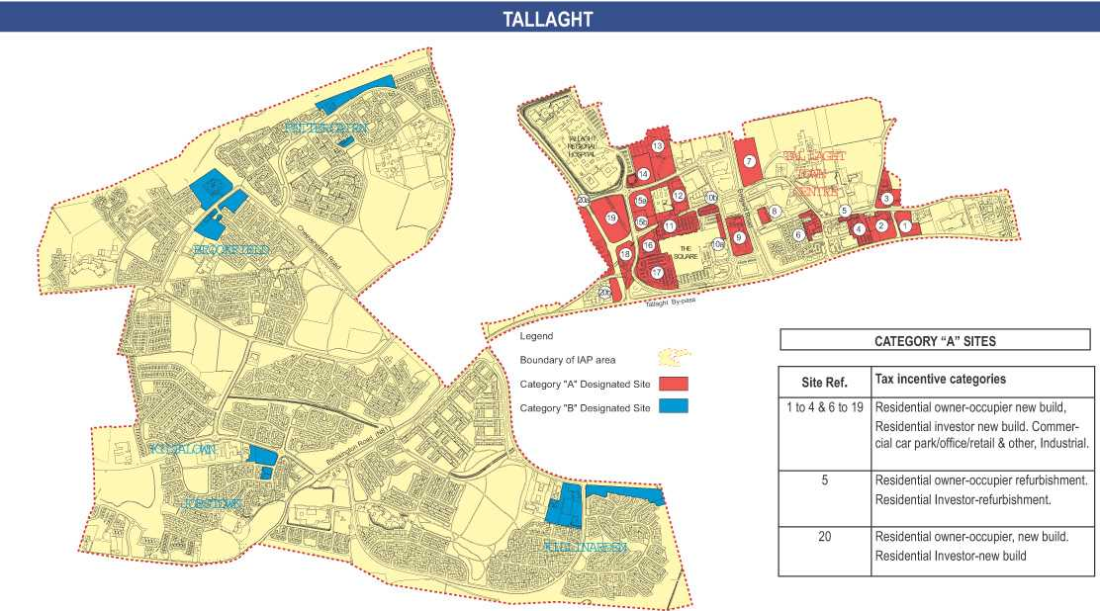

Overall there was a very strong take-up of the Urban Renewal Scheme. A summary of the developments in terms of cost, floor area and residential units is indicated in Table I

Table I – Summary of Development based on cost, floor area and number of units

Tallaght  (All Schemes) | Estimated  Cost | Total Floor Area  Sq.m. | Residential Units
Town Centre | €651,916,641 | 285,170 | 2079
Neighbourhood | € 71,950,000 | 35,449 | 452
Total | €723,866,641 | 320,669 | 2531

State Investment in IAP Scheme

The physical outcome of the Urban Renewal Scheme in terms of commercial floor-space and housing units is detailed in Table III below;

Table III – Summary of Commercial Floor-space and Residential Units

Housing Type | Nos. of Units | Cost per Unit/sq.meter | Floorspace  Sq. metres | Projected Tax Forgone €
Afford. Housing | 312 | 23489 |  | 7328568
Owner Occupied | 139 | 23489 |  | 3264971
Section 23 | 1632 | 66502 |  | 108531264
Total (Housing) | 2083 |  |  | 119,124,803
Total (Commercial) |  | 498 | 113171 | 56.359,158
TOTAL OVERALL |  |  |  | 175,484,961

On the basis of figures provided in the Goodbody Review of Area-Based Tax Incentive Renewal Schemes in 2006, it is possible to determine the tax forgone by the State as a result of the Scheme. The total cost is approx €175,000,000.

Council investment in Tallaght Town Centre

There has been considerable additional Council investment in Tallaght Town Centre during the lifetime of the IAP, including the following; New County Library, new County Arts Centre, South Dublin County Council extension, new Information Office, completion of traffic circulation box in the Town Centre, major public realm additions, infrastructural improvements to Sean Walsh Park (Town Centre Park), installation of 30 camera CCTV system by Dept of Justice. The total investment of the above works exceeds €47.76m.

Future Development/Regeneration Plans

Tallaght Town Centre Masterplan was adopted in October 2006 in order to facilitate the development of Tallaght Town Centre as a vibrant sustainable town centre, where the whole community can avail of the highest standards of housing, employment, services and amenities and to ensure good connectivity and accessibility. One of the main elements throughout the Plan is in providing an attractive built environment focused on creating a place where people can be proud of and where people want to be.

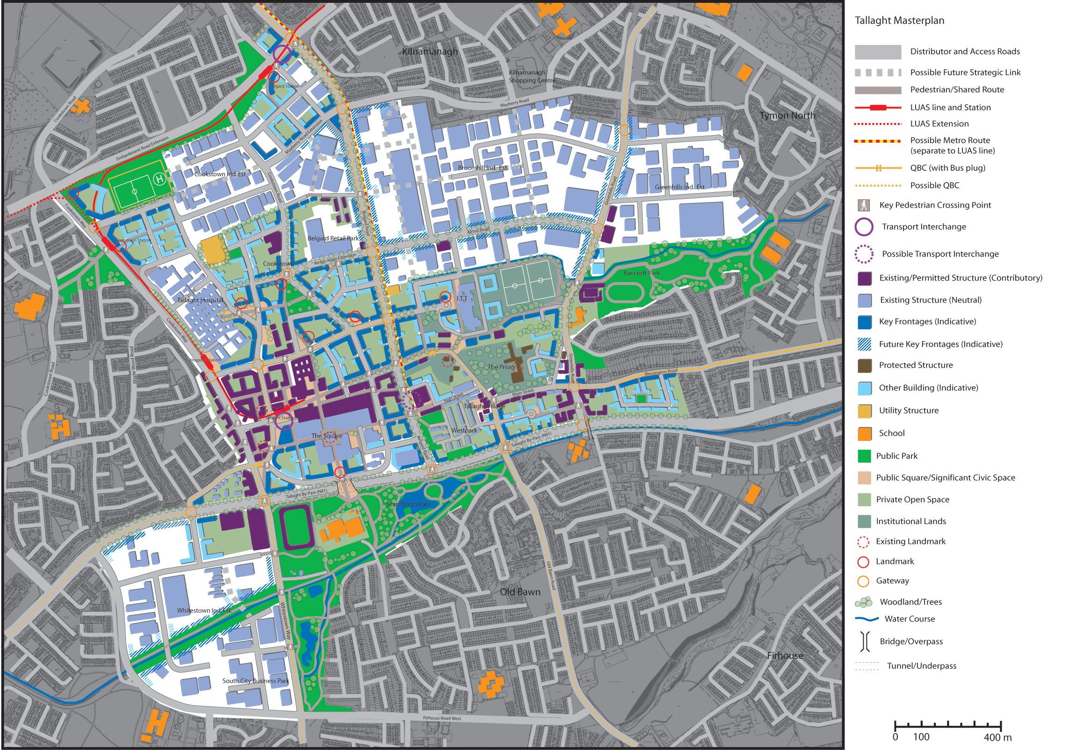

The LAP has as one of its main objectives to “provide for a quality range of new dwellings in the Area in order to promote choice, achieve a diverse social mix and to encourage a greater proportion of units as owner-occupier rather than for short-term lease only”.

The nature of tenure is seen in the LAP as a means of strongly influencing the social mix of housing areas and the stability of residential populations. It is a requirement in the LAP that in new residential schemes:
• The Council shall limit agreements made under the Rental Accommodation Scheme (RAS) to 10% of units, within individual developments and
• A minimum of 60% of residential units in new schemes shall be owner occupied.

A number of key infrastructural requirements were identified in the LAP as being necessary objectives to achieve the proper planning and sustainable development of the Tallaght Town Centre area within the time-scale of the Plan. The schemes include; Community Facilities 9including schools), Parks and Landscaping and Road/Transportation infrastructure. The total investment of the above planned works is approx. €31m.

In summary, the total state investment in the Tallaght Town Centre area (including income foregone as part of the Urban Renewal tax incentive IAP scheme) is €222.76m and the planned state expenditure in the Tallaght Town Centre area is €32m giving an overall state spend of almost 255m Euro.
The Rationale for excluding Rent Supplement from the Tallaght Towncentre Area

The purpose of this initiative is to promote good tenure mix and social integration in the subject area in line with Government policy as set out in “Providing Homes- Sustaining Communities”.

As you will be aware, South Dublin County Council has for years, but particularly since it relocated to the new County Hall in Tallaght in 1994 and even more so since the transfer of the former Dublin Corporation Housing Estates to our management in the late 1998, been using its best efforts allied with those of Government Departments, other State Agencies, the local communities and Local Area Partnerships to improve the physical ,community and social environments of West Tallaght, North Clondalkin and Southwest Clondalkin.

These three areas in the main comprise large tracts of social housing constructed mainly in the 1970s & 1980s

Vast amounts of Council and State funding has been spent over the years in addressing the problems in these estates by way of community development initiatives, upgrades of the physical environments, refurbishment of the housing stock and by targeted and tailored programmes of investment in all State services, particularly educational and health interventions.

The areas have benefited from special State and Council grants for Sports and Community Facilities. They have also qualified for inclusion in various Council, State and EU Initiatives over the years because of their disadvantaged status e.g. CODAN; URBAN; RECITE and the IAP Community Linkage Fund.

Both West Tallaght and North Clondalkin are RAPID areas.

The ongoing concerted efforts of the state agencies have led to very significant improvements but, despite all of the effort and public expenditure, these areas still manifest lower performance in educational achievement, employment levels and health attainment than the national norms and also manifest serious vandalism, ASB, crime and drug problems.

It has been the received wisdom among Housing Practitioners for some time and is now set out as state policy, that the best way of avoiding these issues in the future and the resultant cost to the state, is to promote social integration by way of good tenure mix.

Evidence of this strategy is manifest in the various redevelopment projects in Social housing estates throughout the state e.g. Fatima Mansions and Ballymun and what has now been commenced in Moyross and Southill in Limerick City.

In all cases private, owner occupied units are being introduced in considerable volumes to areas which were previously exclusively council housing estates. This is being done in the interest of good estate management, to create tenure mix, to prevent social stratification and to promote social integration.
In this context, there has been very strong concern for some time, particularly among senior management and the elected members of the Council, that the new apartment complexes currently being constructed in the Tallaght Towncentre Area -- being predominantly investor owned because the Section 23 Tax Incentives which assisted in promoting their development were skewed towards investors rather than owner occupiers--- could potentially become oversaturated by Rent Supplemented/ Social Housing in the near future.

It is feared that if rent supplemented lettings are not subjected to control in the Tallaght Town Centre Area and the new apartment complexes become predominately social housing by way of rent supplement, the Council and the State will then be faced with the need for years to come to repeat the massive effort and the spend of public resources that is still being undertaking in West Tallaght, North and Southwest Clondalkin to retrofix the problems which will inevitably arise.

While the Tallaght Towncentre Area could more accurately be described as a Generation Area rather than a Regeneration Area, the same critical rationale applies as in the cases of Ballymun, Fatima Mansions and the regeneration areas of Limerick City i.e. that there is a glaring need to proactively manage tenure mix to avoid social exclusion and to promote social integration.

While the designation, if granted, would involve the exclusion of all future rent supplemented tenancies from the controlled area, it must be emphasized that it is not our intention to exclude social housing from the area but rather to limit social housing in all its manifestations—pre existing rent supplemented homes; Council rented homes, RAS and Voluntary and Co- Operative Housing to a maximum of 15% of the total quantity of housing in the area with the balancing 85% of homes being privately home owned or privately rented.

The 15% upper threshold for all social housing in the area is deliberately set at the same percentage that developers are required to deliver as social or affordable homes under their Part 5 obligations.

The Council will promote tenure mix and social integration by proactively providing social housing in the designated area by way of existing rent supplemented homes, by transferring existing rent supplemented homes to RAS where eligible, by Part 5 acquisitions, by RAS procurements and by encouraging social housing development by the Voluntary and Co Operative sector.

This approach is based on experience and is considered to be best practice in the interest of good estate management.

Social housing need in the area.

The area forms a part of the Central Tallaght letting zone for which there are 4,503 live applications from social housing applicants who have designated Central Tallaght as their first choice location for accommodation. It should be noted that many of these applicants will also have listed other areas as their lesser preferences.

There are 362 applicants for accommodation in the area who have applied for the Central Tallaght area only

The average waiting time in this letting zone is 4.99 years.

The preferred tenure types would be standard social housing, voluntary housing and RAS.

Capacity of Local Authority to meet the demand for social housing in the area.

It must be emphasised that South Dublin County Council does not seek to exclude social housing from the subject area but, on the contrary, will proactively seek to integrate social homes into the new apartment developments in the area up to a maximum threshold of 15% of the total number of homes by-

Transferring the existing, qualified rent supplement recipients in the area to RAS;

Proactively procuring new homes for RAS;

Procuring Social homes by way of Part 5. This route has the capacity to generate 300 homes.

Particular attention is being paid to vulnerable groups such as the homeless, those with disabilities the elderly and in particular older men. Current examples of this are:

35 homes for the elderly are about to be allocated to elderly social housing applicants –especially elderly single men—as a Part 5 procurement in Arena Court which is within the subject area. These will be managed by the FOLD Housing Association.

A development is currently on site within the subject area for the development of 190 social and affordable homes which are being developed by the St John of Gods and Respond housing associations. 176 of these will be social homes with 30 of these being for special needs clients and the balance of 146 to be used as social homes which will be managed by Cluid.

14 social homes have been procured in a new apartment development at Belgard Square North which will be managed by Cluid.

Three apartments have been procured in the Tallaght Towncentre area through RAS for people exiting homelessness.

The Council will continue to proactively promote social integration in the area by creating tenure mix by procuring social housing up to a maximum threshold of 15% with the balance of homes comprising owner occupied homes and privately rented homes.

The one uncontrollable element in this social integration/tenure mix strategy is the number of rent supplemented rentals (in reality social rentals) that could be created should this designation not be granted especially in the current climate where developers have a very significant overhang of unsold apartments which they may soon release onto the rented market.

Consistency between the proposed designation and South Dublin County Council’s housing policy.

The proposed designation is totally in line with the Council’s housing policy which has as one of its main tenets the promotion of social integration through properly controlled tenure mix.

As set out above, the Council has great experience of managing large continuous tracts of social housing e.g. the large council estates of West Tallaght and North and Southwest Clondalkin and of the social problems that flow from building such concentrations of single tenure social housing.

It is precisely to avoid repeating the mistakes and negative outcomes of the past that we seek to manage the tenure mix in the Tallaght Towncentre area. The exclusion of rent supplement—the one “social housing” stream over which South Dublin County Council as a Housing authority does not control-- is essential to that end.

The worst possible outcome of the development of the Tallaght Towncentre would be for the residential element to become dominated by social housing.

This initiative is also strictly in accordance with Government policy on social integration and tenure mix as set down in the national housing policy document Providing Homes Sustaining Communities.

Any “spillover effect” whereby rent supplemented housing would become over concentrated in the housing estates contiguous to the designated area will be addressed and negated by South Dublin’s policy of limiting all types of social housing within any street, block or estate in the county to 15%. To achieve this it will be necessary to sweat down the number of rent supplemented dwellings in those estates exceeding this threshold by transferring the rent supplement recipients to alternative RAS properties in other estates on transfer to RAS.

Term of Designation
The designation is sought for 10 years.

Consultation
This submission was discussed and agreed by the Housing Strategic Policy Committee of the Council and was approved at a subsequent meeting of the Council.

The Community Welfare Service with responsibility for the Tallaght area was consulted on the proposed submission and was provided with the rationale for the submission. Having had internal discussions on the submission they accept the rational behind the submission and are broadly in favour of same.”

Mr. M. Fagan, Senior Executive Officer summarised the report.

Following a discussion to which Councillors M. Corr, M. Murphy, J. Hannon, S. Crowe, K. Warren, C. King, E. Maloney, J. Neville and J. Daly contributed, Mr. M. Fagan, Senior Executive Officer responded to queries raised.

It was PROPOSED by Councillor E. Maloney, SECONDED by Councillor M. Corr to AMEND the wording of the Motion to state:

“That this Committee urges the Dept of Environment to sign an Order to exclude the Tallaght Town Centre from the Rent Supplement scheme - not to include existing rent supplemented tenancies within the area - and seeks the support of all elected members of this Council.”

On the request of Councillor M. Murphy a Roll Call Vote was taken on the amended Motion with the following results:

For: Councillors C. Jones, E. Maloney, K. Warren, J. Daly, M. Corr, J. Hannon, C. King, S. Crowe and J. Neville

Against: Councillor M. Murphy.

Nine (9) FOR and one (1) AGAINST

The report was PASSED.

T/246/09 REPORT ON THE CURRENT STATUS OF HOUSING GRANTS

It was proposed by Councillor C. King and seconded by Councillor M. Murphy:
"That this Committee, calls on the Manager to provide a report on the current status of the (a) housing adaption grant, (b) Mobility aids grant and (c) housing aid for older persons scheme - in terms of the delivery and funding of the schemes in the Tallaght area with a view to the Committee and the Council using their positions to ensure the schemes remain and the applicants continue to avail of these vital grants".
The following report by the Manager which had been circulated was READ:
With regard to the three Schemes which are the subject of this Motion, the Council is currently continuing to accept applications for all three. Confirmation is awaited from the Department of the Environment, Heritage and Local Government in respect of the level of grant aid which the Council will receive in 2009 and this will determine the level of works which can be approved in 2009.
Please note the Housing Adaptation Grant for People with a Disability replaced the Disabled Persons Grant and the Housing Aid for Older People has replaced the Essential Repairs Grant, since 1st November, 2007. Applications on hand for Housing Adaptation Grant for People with a Disability is 183; and Housing Aid for Older People is 102.
Allocation of funding received from the Department of Environment, Heritage and Local Government for 2008 was €4.1M and we await similar funding for 2009.
With regard to the Council Tenant Disabled Persons Grants we have 30 applications on hand for 2009. Expenditure to date is €232,274.11.
Listed below is a break down of the level of activity countywide, under each of the schemes in 2008.

Type of Grant | No. of Applications Approved 2008 | Expenditure 2008
HAGS | 60 | €544,752.00
MAGS | 12 | € 77,544.00
HOPS | 91 | € 456,365.00
Old Scheme Disabled Person Grant | 241 | €2,371,744.00
Old Scheme Essential Repairs Grant | 144 | € 736,255.00
 | Total | €4,186,660.00

Following a discussion to which Councillors C. King, S. Crowe and E. Maloney contributed, Mr. B. Hynes, Administrative Officer, responded to queries raised.
The report was NOTED.

COMMUNITY BUSINESS

T/247/09 QUESTIONS
It was NOTED there was no business under this heading

T/248/09 APPLICATION FOR GRANTS

The following report by the Manager which had been circulated was CONSIDERED:

“Applications for grants under South Dublin County Council’s Community Grants Scheme have been received from the organisations listed below. Payment of these grants, in accordance with the conditions of the Scheme and in the amounts set out hereunder, is recommended for approval:-

Ref: | Group: | Type of Application | Date of Application | Amount
GF1841 | St Aengus Active Retirement Club | Minor Equipment Grant | 26/03/2009 | €150
GF1840 | St Aengus Active Retirement Club | Running Costs Grant for Community Groups | 26/03/2009 | €200
GF1805 | Tallaght Photographic Society | Minor Equipment Grant | 15/10/2008 | €500
GF1833 | St Kevins Family Resource Centre | Major Equipment Grant | 09/03/2009 | €3,000

GF1828 | St. Muirins House Company Limited | Employment Grant for New or Existing Community Centres | 27/02/2009 | €30,000
GF1846 | Sophia Housing Association Ltd | Community Activity Grant (Including Sport Activity) | 02/03/2009 | €500
GF1849 | Jobstown 6-12 Project | Community Activity Grant (Including Sport Activity) | 27/02/2009 | €500
GF1851 | Glenasmole Community Association | Community Activity Grant (Including Sport Activity) | 20/03/09 | €500
Application for Grant (Arts Act 2003)
Application for a grant under the Council’s Arts Scheme has been received from the organisation listed below. Payment of this grant, in accordance with the conditions of the scheme, in the amount set out hereunder, is recommended for approval.
Ref: | Group: | Type of Application | Date of Application | Amount
Agf 672 | Tallaght Choral Society | Commissioning new musical composition | 3/4/09 | €1000
Arts Contribution
Group: | Type of Application | Date of Application | Amount
Downhill Band | Studio recording production | 22/4/09 | €300

Report on Summer Projects 2009
Summer Projects are aimed at providing a supervised programme of recreational and educational activities for young people over a consecutive number of weeks in the summer period. Emphasis is placed on community involvement and the development of resources and groups within localities. A wide range of activities are encouraged such as arts & crafts, sports, educational trips, drama, films, games etc. The use of available community facilities (schools, community centres, halls, open spaces) is also encouraged.
South Dublin County Council assists Summer Projects in the County area by way of grant-aid, assistance in kind, organised activities and staff support. In 2009 it is estimated that approximately 6,250 young people in the Council’s administrative area will participate in projects.
County Dublin V.E.C has agreed to continue their financial support to Summer Projects for the year 2009. These grants will be complementary to the above resulting in co-ordination between the two authorities, ensuring there is added value from this approach.
Catholic Youth Care provides insurance cover for Summer Projects.
It should be noted that in some cases the necessary insurance cost will be deducted from the grant provided by South Dublin County Council and will be paid directly to Catholic Youth Care.
Name of Project: Duration of Project Grant Amount
Kilnamanagh Summer Project 3 Weeks €1,250
Tallaght Travellers Summer Project 4 Weeks €2,000
Fettercairn Summer Project 4 Weeks €2,000
Killinarden Community Council
Summer Project 4 Weeks €2,000
Citywise 4 Weeks €2,000
Ballycragh Summer Project 3 Weeks €1,500
Brookview Summer Project 3 Weeks €1,500
Little By Little 2 Weeks €850
St. Kevin’s Family Resource 3 Weeks €1,250

Mr. W. Sheils, Senior Executive Officer summarised the report.

It was proposed by Councillor E. Maloney, seconded by Councillor M. Corr and RESOLVED:

“That this Committee recommends that South Dublin County Council approve payment of the above grants recommended in the foregoing report”.

T/249/09 NEW WORKS
It was NOTED there was no business under this heading

T/250/09 CORRESPONDENCE
It was NOTED there was no business under this heading

T/251/09 CATHAOIRLEACH’S BUSINESS
It was NOTED there was no business under this heading

The Meeting concluded at 3.15 p.m.

Siniú: ______________________ Dáta: ________________
An Cathaoirleach

