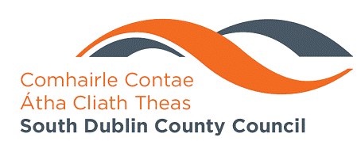
MEETING OF SOUTH DUBLIN COUNTY COUNCIL
Monday , May 11 , 2009
HEADED ITEM NO.

Report from Environmental Services Strategic Policy Committee
30th March 2009.

Attendance:
Councillor Tony McDermott (Chairperson)
Councillor John Lahart
Councillor Mick Murphy
Councillor Guss O’Connell
Councillor Eamonn Walsh
Ms. Connie Kiernan
Mr. Jim Lawler

Ms Philomena Poole
Mr. John Quinlivan
Mr. Leo Magee
Ms. Sorcha O’Brien

The meeting had a single item agenda – Consideration of the Draft Climate Change Strategy for the Council.
A presentation was made on the Strategy by Mr John Quinlivan and on the submissions received and included any comments made at the Area Committees.

A discussion took place to which Councillor McDermott Councillor Lahart, Councillor Murphy, Councillor O’Connell, Councillor Walsh, Ms Kiernan and Mr Jim Lawler contributed. The SPC agreed as follows:- The Environment SPC recommends that the Strategy with the following changes be submitted to the May County Council meeting with their recommendation to the council that the Strategy be adopted.
- The Irish situation - references to the Irish environment to be updated
- Adaptation - a section outlining the Council's commitment to requirement to adapt and to identify adaptation measures as soon as the context of a National Adaptation Strategy is available.
- Agriculture - a section stating the Council's support for climate change measures being taken within the agricultural sector in South Dublin County
- Flora and Fauna - more prominence to be given to the significance of flora and fauna both in terms of impact but also research into climate change
- Emissions trading - a statement defining and identifying emissions trading as a mechanism for climate change control and identifying the major industries where this mechanism is relevant in the county.
- Awareness - the Council's commitment to raising awareness of Climate Change generally and the Strategy particularly through the Council's Environmental Awareness Programmes.

