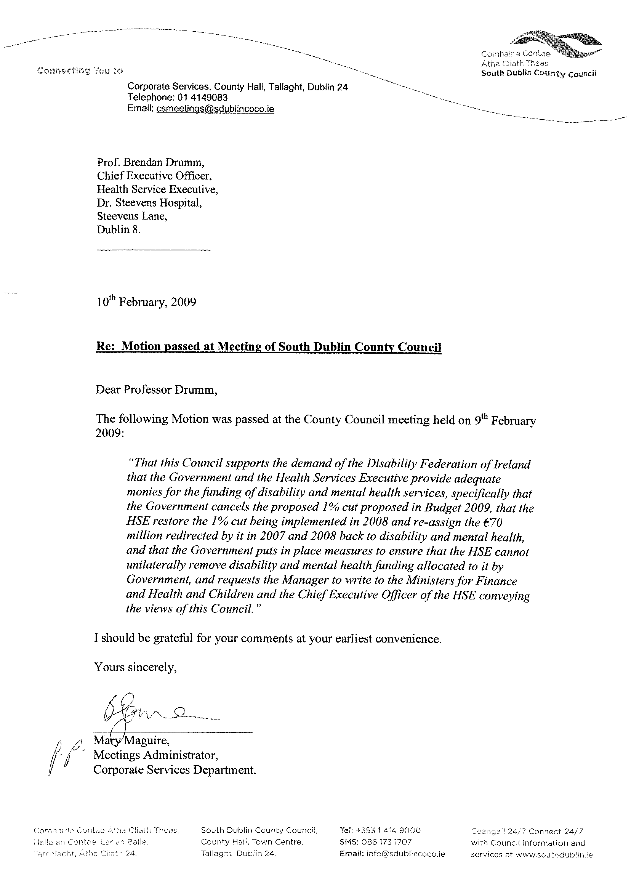Actions List for February Co. Council meeting:

H2 Naming strategy for Tallaght town centre approved (Planning).

H4A Draft Calendar – make changes to current calendar, publish Draft Mar / Apr calendar (CS)

H4b Conferences (CS)

H4c Nominations to CPLN (CS) Write to CPLN.

H7i Disposals of affordable dwellings (Housing)

H7ii Disposal of land to ESB – variation – (Housing)

H8 Part 8 Traffic calming Aylesbury/Cushlawn – (Roads)

H8 TAP adopted (Housing)

M8 moved & re-entered – put on next agenda (CS)
M9 Moved without debate

M3 Write to Mins for Finance, and Health, and also to HSE (3 x letters).

