COMHAIRLE CONTAE ÁTHA CLIATH THEAS
SOUTH DUBLIN COUNTY COUNCIL

MEETING OF TALLAGHT AREA COMMITTEE (1)
Monday, April 27, 2009
MOTION NO. 5
MOTION: Councillor E. Maloney
That this Committee urges the Dept. of Environment to sign an Order to exclude the Tallaght Town Centre from the Rent Supplement Scheme, and seeks the support of all elected members of this Council.
REPORT:
The following submission was made to the Minister for the Environment, Heritage and Local Government to have rent supplemented tenancies excluded from the Tallaght Towncentre area:

Application to have Tallaght Towncentre Area declared a Rejuvenation area under Social Welfare and Pensions Act 2007

South Dublin County Council hereby applies in accordance with Section 25 (3B) of the Social Welfare and Pensions Act 2007, to have the Minister for the Environment Heritage and Local Government declare the Tallaght Towncentre area as shown outlined in red on the enclosed map, “as being an area of regeneration for the purpose of providing for greater social integration”.

The purpose of this initiative is to promote good tenure mix and social integration in the subject area in line with Government policy as set out in “Providing Homes- Sustaining Communities”.

Description of the Area

Tallaght Town Centre is defined as the area zoned “To protect, improve and/or improve Town Centre facilities” in the South Dublin County Development Plan 2004 – 2008, see attached map. It fully includes all of the Town Centre area included in the Tallaght Urban Renewal Integrated Area Plan (IAP) 1999 – 2008 and includes most of the Town Centre area included in the recently adopted Tallaght Town Centre Local Area Plan (apart from some land at present zoned for employment and enterprise use north of the Town Centre and included in the LAP in order to indicate South Dublin County Council’s future vision for the area).

Rejuvenation/Generation/Development

In 1999 South Dublin County Council, in partnership with a number of local development groups and following public consultation, produced an Urban Renewal Integrated Area Plan for Tallaght. The Plan was produced in the context of addressing the physical, economic, social and environmental regeneration of the Town Centre.

The intention was that the Tallaght IAP would provide the mechanism to achieve the vision for the town centre as set out in the County Council’s Tallaght Town Centre 2000 Plan published in 1995 (and in the adjoining disadvantaged residential areas in West Tallaght). At that time, the Council, following extensive consultation, launched a new development model for the Town Centre moving away from a car dominated urban form. The vision for the Town Centre was

“Tallaght Town Centre will be a modern town centre with a much increased residential population and workforce with the following characteristics,

- an upgraded urban form,

- people intensive uses,

- much improved accessibility for all and

- significant environmental improvements”.

The aims of the Tallaght IAP was to attract in private investment by means of tax incentives and to utilise the Council’s IAP Fund and the “Community Linkage Contributions” from the town centre sites to invest in much needed community infrastructure in the disadvantaged areas.

As a result of the IAP, a significant range of tax incentives for qualifying developments on 24 specific sites in Tallaght was approved by the Minister for Housing and Urban Renewal under the Urban Renewal Scheme in 1999, see Map 2. In addition, the whole of the IAP area was designated for residential “owner occupier” status.

Map 2: Tax Designated Site in the Tallaght IAP Area

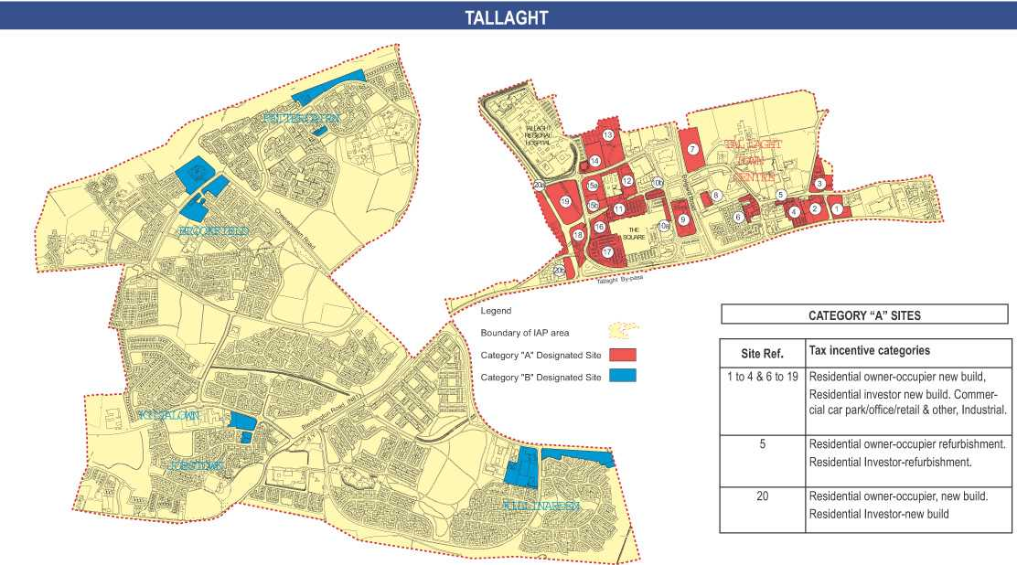

Overall there was a very strong take-up of the Urban Renewal Scheme. A summary of the developments in terms of cost, floor area and residential units is indicated in Table I

Table I – Summary of Development based on cost, floor area and number of units

Tallaght  (All Schemes) | Estimated  Cost | Total Floor Area  Sq.m. | Residential Units
Town Centre | €651,916,641 | 285,170 | 2079
Neighbourhood | € 71,950,000 | 35,449 | 452
Total | €723,866,641 | 320,669 | 2531

State Investment in IAP Scheme

The physical outcome of the Urban Renewal Scheme in terms of commercial floor-space and housing units is detailed in Table III below;

Table III – Summary of Commercial Floor-space and Residential Units

Housing Type | Nos. of Units | Cost per Unit/sq.meter | Floorspace  Sq. metres | Projected Tax Forgone €
Afford. Housing | 312 | 23489 |  | 7328568
Owner Occupied | 139 | 23489 |  | 3264971
Section 23 | 1632 | 66502 |  | 108531264
Total (Housing) | 2083 |  |  | 119,124,803
Total (Commercial) |  | 498 | 113171 | 56.359,158
TOTAL OVERALL |  |  |  | 175,484,961

On the basis of figures provided in the Goodbody Review of Area-Based Tax Incentive Renewal Schemes in 2006, it is possible to determine the tax forgone by the State as a result of the Scheme. The total cost is approx €175,000,000.

Council investment in Tallaght Town Centre

There has been considerable additional Council investment in Tallaght Town Centre during the lifetime of the IAP, including the following; New County Library, new County Arts Centre, South Dublin County Council extension, new Information Office, completion of traffic circulation box in the Town Centre, major public realm additions, infrastructural improvements to Sean Walsh Park (Town Centre Park), installation of 30 camera CCTV system by Dept of Justice. The total investment of the above works exceeds €47.76m.

Future Development/Regeneration Plans

Tallaght Town Centre Masterplan was adopted in October 2006 in order to facilitate the development of Tallaght Town Centre as a vibrant sustainable town centre, where the whole community can avail of the highest standards of housing, employment, services and amenities and to ensure good connectivity and accessibility. One of the main elements throughout the Plan is in providing an attractive built environment focused on creating a place where people can be proud of and where people want to be.

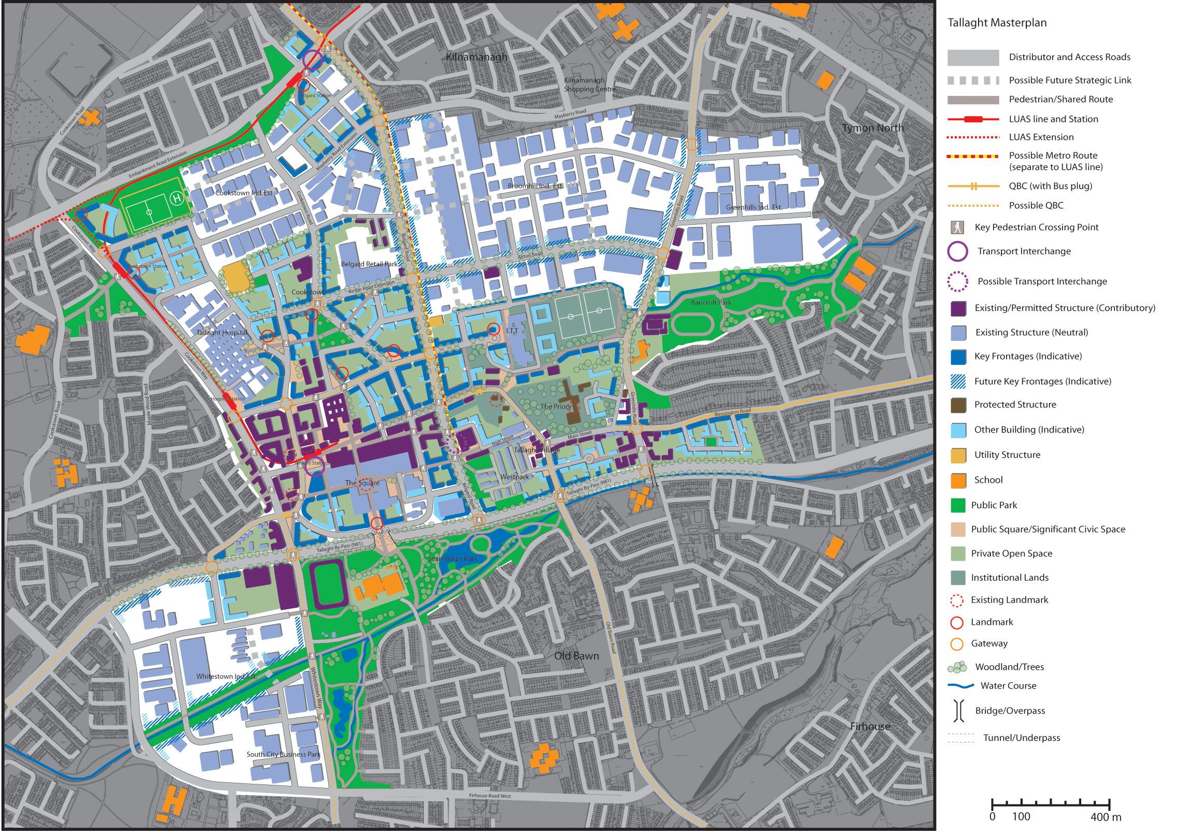

The LAP has as one of its main objectives to “provide for a quality range of new dwellings in the Area in order to promote choice, achieve a diverse social mix and to encourage a greater proportion of units as owner-occupier rather than for short-term lease only”.

The nature of tenure is seen in the LAP as a means of strongly influencing the social mix of housing areas and the stability of residential populations. It is a requirement in the LAP that in new residential schemes:
• The Council shall limit agreements made under the Rental Accommodation Scheme (RAS) to 10% of units, within individual developments and
• A minimum of 60% of residential units in new schemes shall be owner occupied.

A number of key infrastructural requirements were identified in the LAP as being necessary objectives to achieve the proper planning and sustainable development of the Tallaght Town Centre area within the time-scale of the Plan. The schemes include; Community Facilities 9including schools), Parks and Landscaping and Road/Transportation infrastructure. . The total investment of the above planned works is approx. €31m.

In summary, the total state investment in the Tallaght Town Centre area (including income foregone as part of the Urban Renewal tax incentive IAP scheme) is €222.76m and the planned state expenditure in the Tallaght Town Centre area is €32m giving an overall state spend of almost 255m eoro.
The Rationale for excluding Rent Supplement from the Tallaght Towncentre Area

The purpose of this initiative is to promote good tenure mix and social integration in the subject area in line with Government policy as set out in “Providing Homes- Sustaining Communities”.

As you will be aware, South Dublin County Council has for years, but particularly since it relocated to the new County Hall in Tallaght in 1994 and even more so since the transfer of the former Dublin Corporation Housing Estates to our management in the late 1998, been using its best efforts allied with those of Government Departments, other State Agencies, the local communities and Local Area Partnerships to improve the physical ,community and social environments of West Tallaght, North Clondalkin and Southwest Clondalkin.

These three areas in the main comprise large tracts of social housing constructed mainly in the 1970s & 1980s

Vast amounts of Council and State funding has been spent over the years in addressing the problems in these estates by way of community development initiatives, upgrades of the physical environments, refurbishment of the housing stock and by targeted and tailored programmes of investment in all State services, particularly educational and health interventions.

The areas have benefited from special State and Council grants for Sports and Community Facilities. They have also qualified for inclusion in various Council, State and EU Initiatives over the years because of their disadvantaged status eg CODAN; URBAN; RECITE and the IAP Community Linkage Fund.

Both West Tallaght and North Clondalkin are RAPID areas.

The ongoing concerted efforts of the state agencies have led to very significant improvements but, despite all of the effort and public expenditure, these areas still manifest lower performance in educational achievement, employment levels and health attainment than the national norms and also manifest serious vandalism, ASB, crime and drug problems.

It has been the received wisdom among Housing Practitioners for some time and is now set out as state policy, that the best way of avoiding these issues in the future and the resultant cost to the state, is to promote social integration by way of good tenure mix.

Evidence of this strategy is manifest in the various redevelopment projects in Social housing estates throughout the state eg Fatima Mansions and Ballymun and what has now been commenced in Moyross and Southill in Limerick City.

In all cases private, owner occupied units are being introduced in considerable volumes to areas which were previously exclusively council housing estates. This is being done in the interest of good estate management, to create tenure mix, to prevent social stratification and to promote social integration.
In this context, there has been very strong concern for some time, particularly among senior management and the elected members of the Council, that the new apartment complexes currently being constructed in the Tallaght Towncentre Area -- being predominantly investor owned because the Section 23 Tax Incentives which assisted in promoting their development were skewed towards investors rather than owner occupiers--- could potentially become oversaturated by Rent Supplemented/ Social Housing in the near future.

It is feared that if rent supplemented lettings are not subjected to control in the Tallaght Town Centre Area and the new apartment complexes become predominately social housing by way of rent supplement, the Council and the State will then be faced with the need for years to come to repeat the massive effort and the spend of public resources that is still being undertaking in West Tallaght, North and Southwest Clondalkin to retrofix the problems which will inevitably arise.

While the Tallaght Towncentre Area could more accurately be described as a Generation Area rather than a Regeneration Area, the same critical rationale applies as in the cases of Ballymun, Fatima Mansions and the regeneration areas of Limerick City ie that there is a glaring need to proactively manage tenure mix to avoid social exclusion and to promote social integration.

While the designation, if granted, would involve the exclusion of all future rent supplemented tenancies from the controlled area, it must be emphasized that it is not our intention to exclude social housing from the area but rather to limit social housing in all its manifestations—pre existing rent supplemented homes; Council rented homes, RAS and Voluntary and Co- Operative Housing to a maximum of 15% of the total quantity of housing in the area with the balancing 85% of homes being privately home owned or privately rented.

The 15% upper threshold for all social housing in the area is deliberately set at the same percentage that developers are required to deliver as social or affordable homes under their Part 5 obligations.

The Council will promote tenure mix and social integration by proactively providing social housing in the designated area by way of existing rent supplemented homes, by transferring existing rent supplemented homes to RAS where eligible, by Part 5 acquisitions, by RAS procurements and by encouraging social housing development by the Voluntary and Co Operative sector.

This approach is based on experience and is considered to be best practice in the interest of good estate management.

Social housing need in the area.

The area forms a part of the Central Tallaght letting zone for which there are 4,503 live applications from social housing applicants who have designated Central Tallaght as their first choice location for accommodation. It should be noted that many of these applicants will also have listed other areas as their lesser preferences.

There are 362 applicants for accommodation in the area who have applied for the Central Tallaght area only

The average waiting time in this letting zone is 4.99 years.

The preferred tenure types would be standard social housing, voluntary housing and RAS.

Capacity of Local Authority to meet the demand for social housing in the area.

It must be emphasised that South Dublin County Council does not seek to exclude social housing from the subject area but, on the contrary, will proactively seek to integrate social homes into the new apartment developments in the area up to a maximum threshold of 15% of the total number of homes by-

Transferring the existing, qualified rent supplement recipients in the area to RAS;

Proactively procuring new homes for RAS;

Procuring Social homes by way of Part 5. This route has the capacity to generate 300 homes.

Particular attention is being paid to vulnerable groups such as the homeless, those with disabilities the elderly and in particular older men. Current examples of this are:

35 homes for the elderly are about to be allocated to elderly social housing applicants –especially elderly single men—as a Part 5 procurement in Arena Court which is within the subject area. These will be managed by the FOLD Housing Association.

A development is currently on site within the subject area for the development of 190 social and affordable homes which are being developed by the St John of Gods and Respond housing associations. 176 of these will be social homes with 30 of these being for special needs clients and the balance of 146 to be used as social homes which will be managed by Cluid.

14 social homes have been procured in a new apartment development at Belgard Square North which will be managed by Cluid.

Three apartments have been procured in the Tallaght Towncentre area through RAS for people exiting homelessness.

The council will continue to proactively promote social integration in the area by creating tenure mix by procuring social housing up to a maximum threshold of 15% with the balance of homes comprising owner occupied homes and privately rented homes.

The one uncontrollable element in this social integration/tenure mix strategy is the number of rent supplemented rentals (in reality social rentals) that could be created should this designation not be granted especially in the current climate where developers have a very significant overhang of unsold apartments which they may soon release onto the rented market.

Consistency between the proposed designation and South Dublin County Council’s housing policy.

The proposed designation is totally in line with the Council’s housing policy which has as one of its main tenets the the promotion of social integration through properly controlled tenure mix.

As set out above, the Council has great experience of managing large continuous tracts of social housing eg the large council estates of West Tallaght and North and Southwest Clondalkin and of the social problems that flow from building such concentrations of single tenure social housing.

It is precisely to avoid repeating the mistakes and negative outcomes of the past that we seek to manage the tenure mix in the Tallaght Towncentre area. The exclusion of rent supplement—the one “social housing” stream over which South Dublin County Council as a Housing authority does not control-- is essential to that end.

The worst possible outcome of the development of the Tallaght Towncentre would be for the residential element to become dominated by social housing.

This initiative is also strictly in accordance with Government policy on social integration and tenure mix as set down in the national housing policy document Providing Homes Sustaining Communities.

Any “spillover effect” whereby rent supplemented housing would become over concentrated in the housing estates contiguous to the designated area will be addressed and negated by South Dublin’s policy of limiting all types of social housing within any street, block or estate in the county to 15%. To achieve this it will be necessary to sweat down the number of rent supplemented dwellings in those estates exceeding this threshold by transferring the rent supplement recipients to alternative RAS properties in other estates on transfer to RAS.

Term of Designation
The designation is sought for 10 years.

Consultation
This submission was discussed and agreed by the Housing Strategic Policy Committee of the Council and was approved at a subsequent meeting of the Council.

The Community Welfare Service with responsibility for the Tallaght area was consulted on the proposed submission and was provided with the rationale for the submission. Having had internal discussions on the submission they accept the rational behind the submission and are broadly in favour of same.

