Comhairle Baile na Sionna
Shannon Town Council
Town Hall, Shannon, Co. Clare.

(Cléireach an Bhaile – Tomás Mac Cormaic Guthán 061 478081)

(email shannontclerk@eircom.net)

March 6th 2009

To each Local Authority

A Chara,

At the March monthly meeting of the Shannon Town Council the following resolution was adopted:

“that this Council calls on the Government to maintain investment in Primary Education to avoid increasing class sizes at primary level and to ensure the educational opportunities of our children are protected in these difficult times and that this resolution be forwarded to An Taoiseach, the Minister for Education and each local authority.”

The members of Shannon Town Council would appreciate your support for this resolution.

Is muse, le meas,

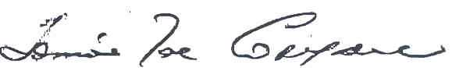
Cleireach an Bhaile

