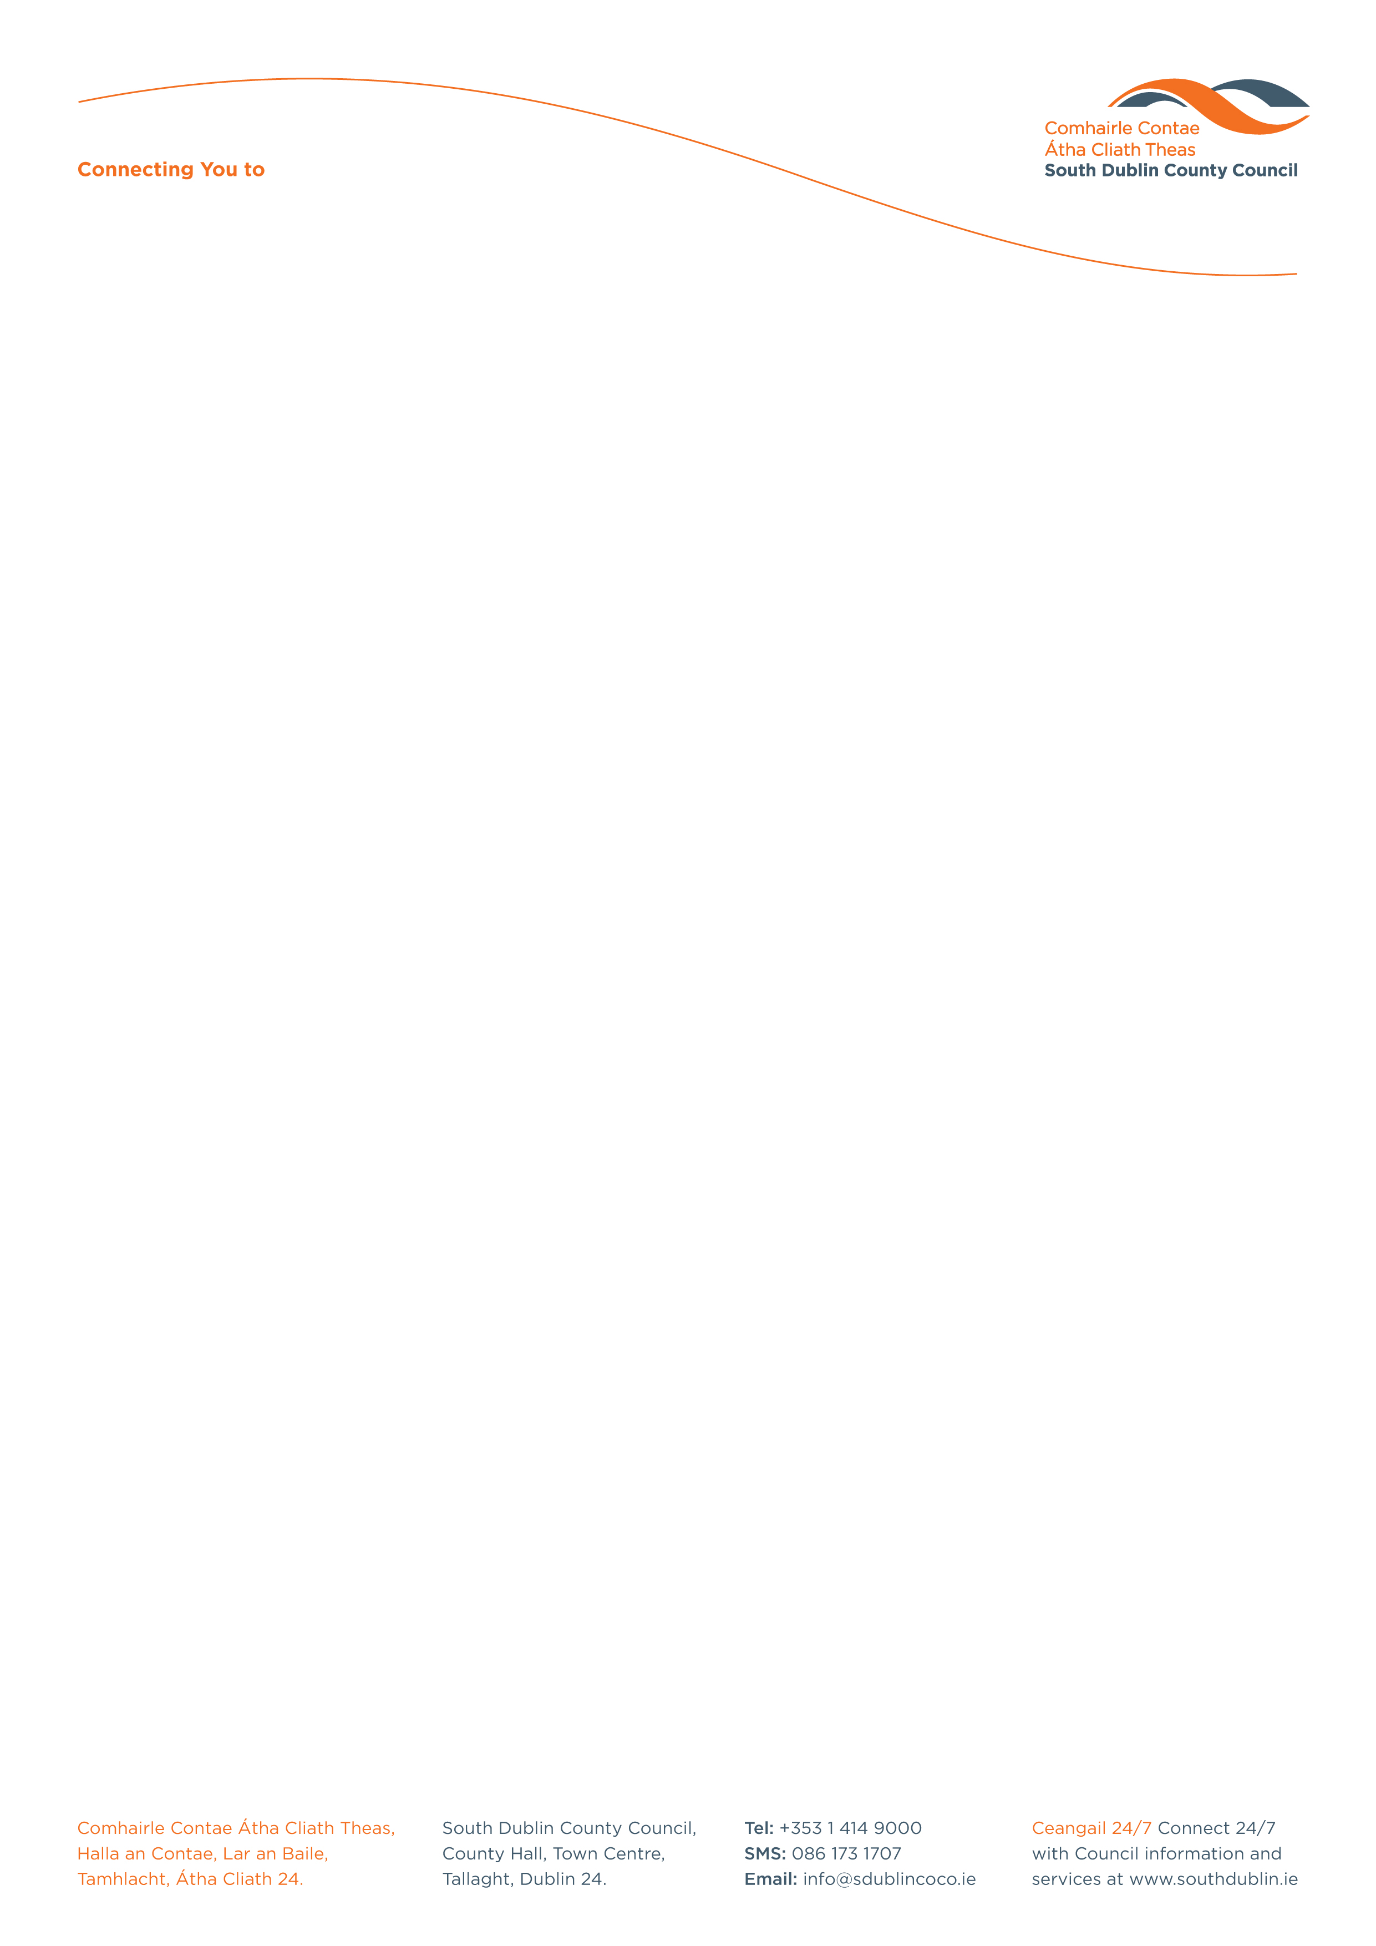

Halla an Chontae, Lár an Bhaile County Hall, Town Centre
Tamhlacht, Baile Átha Cliath 24 Tallaght, Dublin 24
Telefon: 01-4149052 Telephone: 01-4149052

Facs: 01-4149332 Fax: 01-4149332
www.southdublin.ie

Mr Jim Farrell
Managing Director
Roadstone
Fortunestown
Tallaght
Dublin 24
March 25th, 2009

RE: Tallaght Area Committee Meeting (1) – 16th March, 2009

Dear Mr. Farrell,

At South Dublin County Council’s Tallaght Area Committee Meeting, held on 16th March, 2009, the following motion was passed:

“In view of the visible build of stones and rubble on the old Belgard Road and the obvious dangerous implications for pedestrians and other road users that appears to be coming from lorries leaving Roadstone that the Committee write to Roadstone asking them to take action against drivers and look for financial support for the clean up bill until the situation is resolved.”

I should be obliged if you would let me have a reply on the matter at your earliest convenience.

Thanking you in anticipation.

Yours sincerely,

Allyson Rooney,
SENIOR STAFF OFFICER,
HOUSING ADMINISTRATION.

Housing Administration

