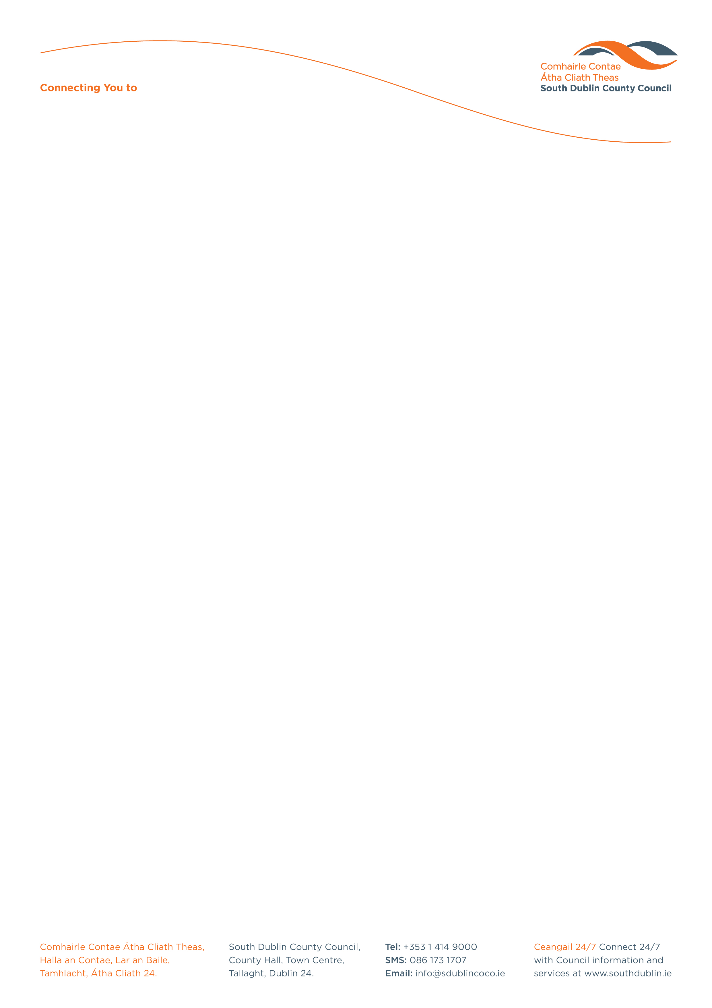

Halla an Chontae, Lár an Bhaile County Hall, Town Centre
Tamhlacht, Baile Átha Cliath 24 Tallaght, Dublin 24
Telefon: 01-4149052 Telephone: 01-4149052

Facs: 01-4149332 Fax: 01-4149332
www.southdublin.ie

Mr Noel Dempsey, T..D.
Dail Eireann
Merrion Street
Dublin 2.

March 3, 2009

RE: Tallaght Area Committee Meeting – 23rd February, 2009

Dear Sir/Madam,

The following Motion, submitted by Councillor E. Maloney, was passed at the Tallaght(2) Area Committee meeting, which took place on 23rd February 2009:
"That this Committee condemns the proposed reduction of the bus service in Tallaght as announced by Dublin Bus, and the loss of employment, and that this be conveyed to the company, and the Minister for Transport."

I should be obliged if you would let me have a reply on this matter at your earliest convenience.

Thanking you in anticipation.

Yours sincerely,

ALLYSON ROONEY,
SENIOR STAFF OFFICER,
HOUSING ADMINISTRATION.

Housing Administration

