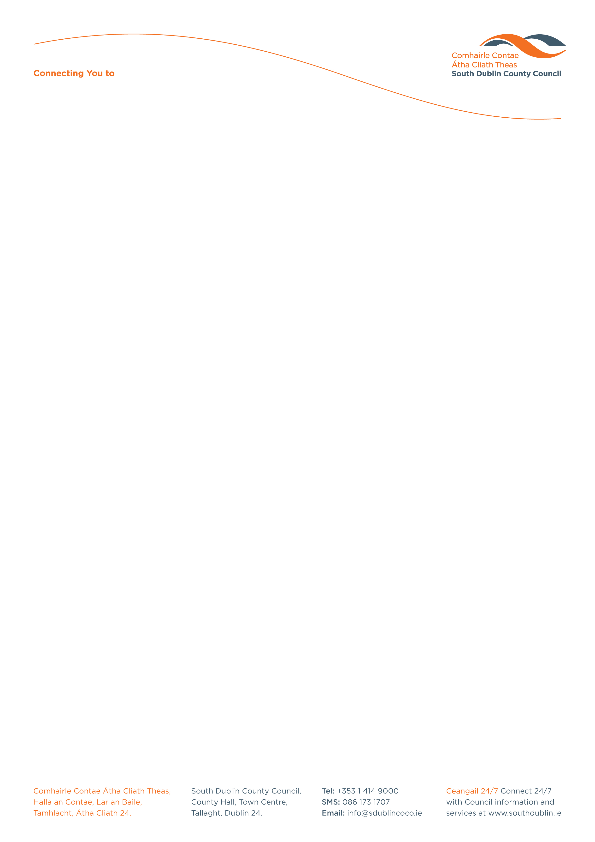

Halla an Chontae, Lár an Bhaile County Hall, Town Centre
Tamhlacht, Baile Átha Cliath 24 Tallaght, Dublin 24
Telefon: 01-4149052 Telephone: 01-4149052

Facs: 01-4149332 Fax: 01-4149332
www.southdublin.ie

Railway Procurement Agency
Parkgate Business Centre
Parkgate Street
Dublin 8.

March 3, 2009

RE: Tallaght Area Committee Meeting – 23rd February, 2009

Dear Sir/Madam,

The following question was submitted by Councillor M. Corr, in the order of business of the Tallaght(2) Area Committee meeting, which took place on 23rd February 2009:
"To ask the Manager to write to the RPA requesting an indication of the realistic delivery
date of the extension of the LUAS A1 line to Citywest given residents in the area have been
long awaiting its arrival?"

I should be obliged if you would let me have a reply on this matter at your earliest convenience.

Thanking you in anticipation.

Yours sincerely,

ALLYSON ROONEY,
SENIOR STAFF OFFICER,
HOUSING ADMINISTRATION.

Housing Administration

