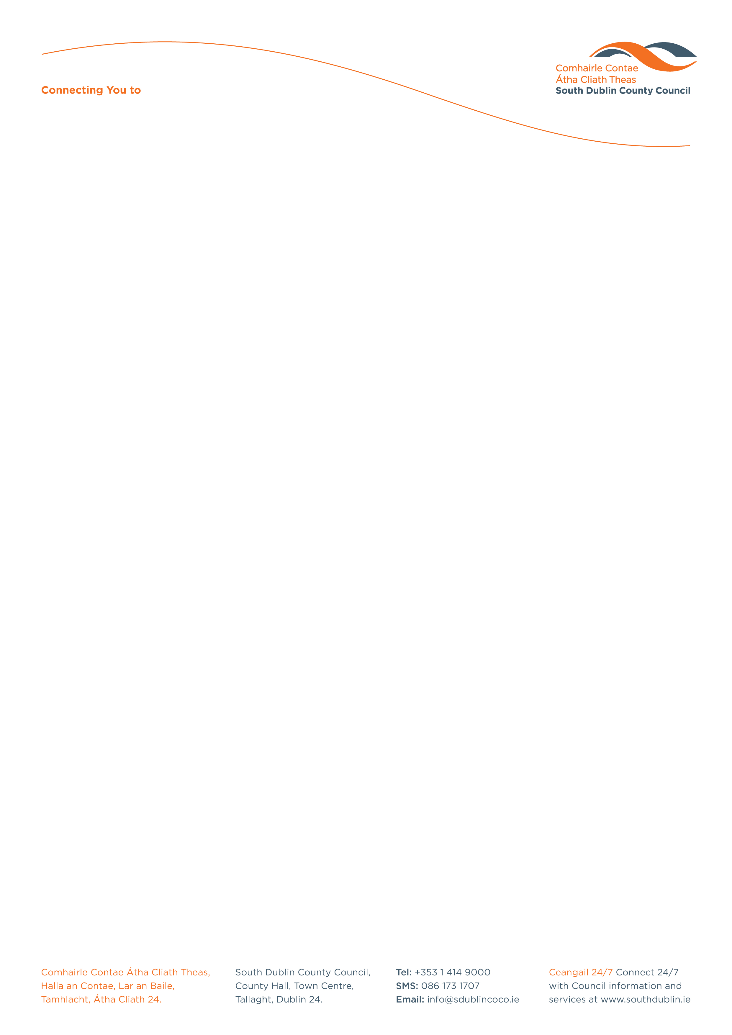

Halla an Chontae, Lár an Bhaile County Hall, Town Centre
Tamhlacht, Baile Átha Cliath 24 Tallaght, Dublin 24
Telefon: 01-4149052 Telephone: 01-4149052

Facs: 01-4149332 Fax: 01-4149332
www.southdublin.ie

Ms. Coughlan,
Minister for Enterprise,
Trade & Employment,
Dail Eireann,
Merrion Street,
Dublin 2.

February 3, 2009

RE: Tallaght Area Committee Meeting – 26th January 2009

Dear Sir/Madam,

At the Tallaght Area Committee Meeting of 26th January, 2009, the following motion was passed:

“That the members of this Committee support a request to the Minister for Enterprise, Trade and Employment, Ms. Coughlan, for a meeting to outline the need for new industries for Tallaght, given the recent loss of employment in the area.”

I should be obliged if you would let me have a reply on this matter at your earliest convenience.

Thanking you in anticipation.

Yours sincerely,

ALLYSON ROONEY,
SENIOR STAFF OFFICER,
HOUSING ADMINISTRATION.

Housing Administration

