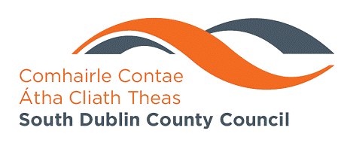
MEETING OF ENVIRONMENT SPC
Wednesday, February 4th 2009
HEADED ITEM NO 4
Climate Change Strategy – updated report following workshop held on 13th January.

It was noted at the meeting of the Committee held on the 12th November 2008 that the Draft Climate Change Strategy would be available for referral to the SPC working Group early in 2009.

The Draft Strategy was forwarded to the members of the Working Group on the 9th January last. A meeting of the Working Group was held on the 13th January at which the Draft Strategy was discussed.

Following the meeting, changes agreed by the Group were inserted into the document and the revised version was circulated to the members of the SPC in advance of this meeting. It is proposed to embark on a public consultation process for one month commencing on the 11th February. Members of the SPC may also make further submissions or observations on the Draft Strategy during the public consultation period.

The proposed revised timeline for the completion of the Strategy is as shown below.

SDCC Climate Change strategy draft revised timeline.

- 4th February – report for SPC meeting

- 11th February - 11th March – Public Consultation

- Revised draft to SDCC Climate Change strategy Working Group

- 30th March – Special SPC - (Subject to approval of the Organisation ,Procedure and Finance Committee.)

- April - presentation to Area Committees

- 11th May - Council meeting for adoption

