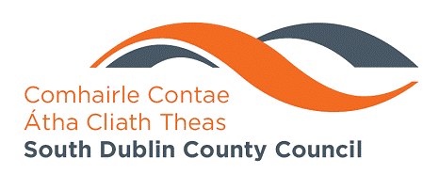
MEETING OF ENVIRONMENT SPC
Wednesday, February 4th 2009
HEADED ITEM NO 5

Report on: Air Quality Management Plan

A Regional Draft Air Quality Management plan was prepared and presented to a joint meeting of the relevant Strategic Policy Committees of the four Dublin Local Authorities on 16th December 2008 during which detailed discussions took place. Following on from these discussions the next stage in the Statutory Process is to arrange Public Consultation on the Draft Plan. Accordingly it is proposed to commence the Statutory Consultation process this month. The Public Consultation will continue for one month.

At the meeting of the Council held on the 12th January last it was agreed that the draft plan should also be presented at the meetings of the three Area Committees. This is currently in progress.

Following completion of the consultation process the revised Draft Plan will be presented to the next full meeting of the Council for adoption. The adoption of the Air Quality Management Plan is a reserved function of the elected Council.

A summary PowerPoint presentation on the Plan is being made at this meeting.

