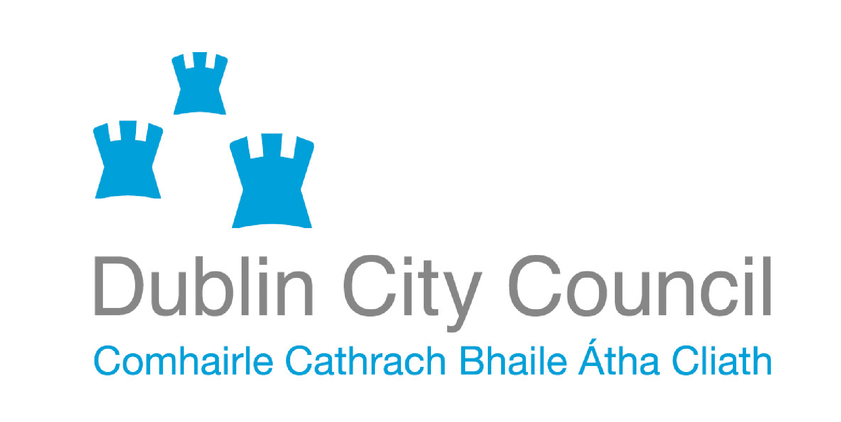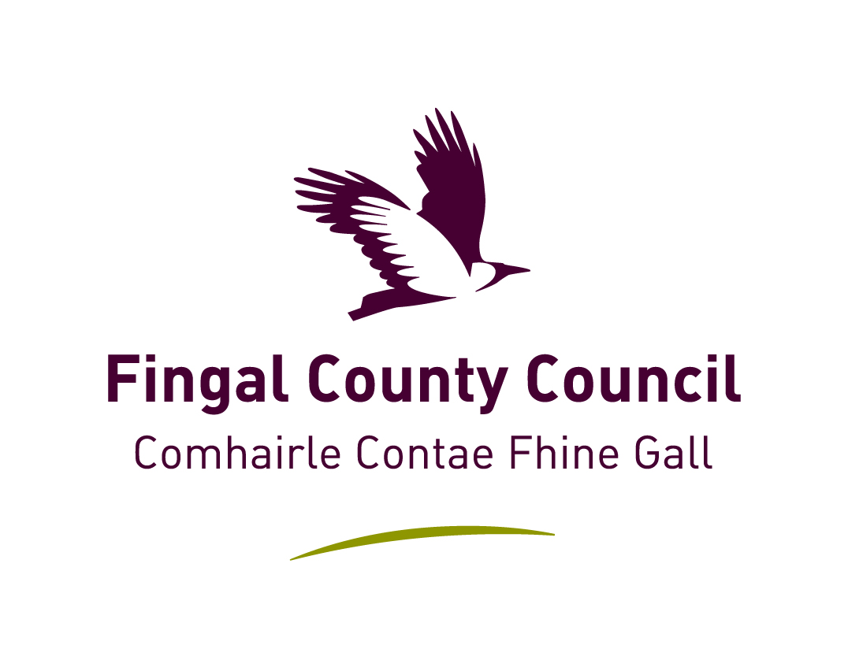

Dublin Regional
Air Quality Management Plan.

2008-2012

DRAFT
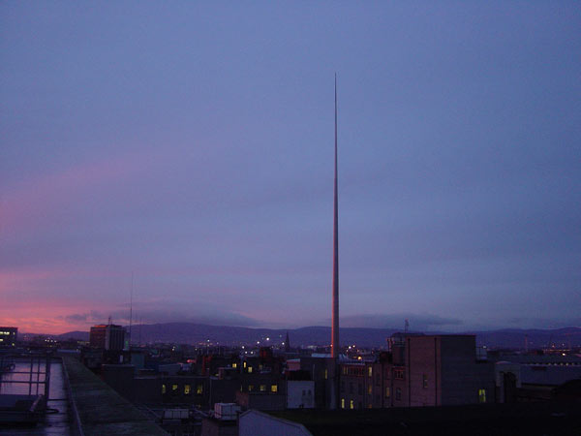

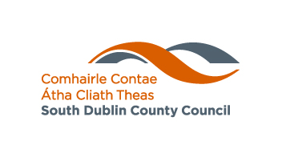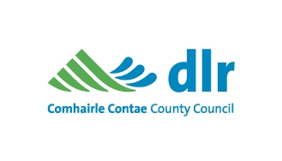
List of contents | Page

Chapter 1 Background

Setting the scene | 3
What is an Air Quality Management Plan and why have one in the Dublin region? | 4
Sources of air pollution in the Dublin region | 6
What are the common air pollutants? | 7
1.5 What are the pollutants of most concern? | 10
Description of Region. | 11
What was in the initial Air Quality Management Plan 1999? | 12
1.8 What was achieved and what remains to be achieved from the 1999 Plan | 12

Chapter 2 Current situation

2.1 Legislative framework | 15
2.2 Historical perspective on air quality in Dublin since the mid 1980’s | 16
2.3 Specific air quality data and commentary - 1999 to the present | 17

Chapter 3 Challenges and threats to future air quality

3.1 Existing and ongoing challenges | 24
3.2 Emerging challenges | 28
3.3 Summary conclusions | 31

Chapter 4 The Way Forward

4.1 Setting the context | 32
4.2 Time frame for change | 33
Appendix 1: Dublin Regional Air Quality Management Plan 1999 | 36
Appendix 2: Department of the Environment memo 1979 | 48
References | 49

Chapter 1 Background

  - Setting the scene

The well-known photograph below gives another twist to the refrain – “Dublin in the Rare Ould Times”. It is a photograph taken in the early afternoon in Dublin city centre in January 1982, and starkly illustrates the dense smog that all too frequently enveloped Dublin during the 1970’s and 1980’s in cold winter months.
The bleak scene depicted mirrors the difficult economic times, when unemployment was high, emigration commonplace, and times were generally tough.

A common sight on the quaysides of the Dublin docks were the large shiploads of bituminous coal from Poland and America which provided the fuel for domestic heating in inner city Dublin and in the burgeoning new suburban estates around the north and west of the city. As a consequence of policies to utilise solids fuels, rather than more expensive and sometimes scarce oil supplies, air quality in the Dublin region was poor.

When Ireland joined the EEC in 1973, it was its poorest member. Present day Dublin, in 2008 is a very different place from that of three decades ago, not withstanding current economic challenges.

With change can come positive improvements and negative impacts. Many of the traditional work practices and social customs have gone forever. Modern Dublin now has an all day-every day vibrancy, and communication technologies have more people working from their homes or while in transit. Dublin today is a modern, eclectic city with a huge influx of international residents eager to set up home here. Public transport infrastructure has seen the construction and current extensions of the LUAS electric tram system, the construction of the Port Tunnel, and the extension of the DART rail network.

One of the less desirable impacts of our increased prosperity has been the traffic congestion resulting from the large increase in car ownership,
The number of vehicles on Irish roads more than doubled over the period 1990 to 2006. Over this period the total increased by 118% (5% per annum on average) to reach 2,138,680 vehicles in 2006. (1)

Increasing traffic volumes have resulted in increased congestion in the past few years, and major roads such as the N4, N7 and M50 have all been widened to accommodate extra traffic lanes.

The traditional semi-detached suburban house was generally the starting rung of the property ladder for young couples setting up home. Escalating land prices in the recent boom times resulted in many people purchasing their house in the adjoining counties to Dublin.

  - What is an Air Quality Management Plan and why have one in the Dublin region

Under the Air Pollution Act 1987, [zza6y1987s46]46 a local authority may make a plan for the preservation or the improvement of air quality in their functional area.
Two or more local authorities may also jointly make an air quality management plan. The adoption of such a plan is a reserved function i.e. a function of the elected Members of the Councils.

An air quality management plan must contain such objectives as seem to the local authority (or authorities) concerned to be reasonable and necessary for the prevention or limitation of air pollution or the preservation or improvement of air quality in their area.
[zza6y1987s47]47 [zza6y1987s48]48 Where a local authority propose to make, vary or replace an air quality management plan, they must publish their intent in at least one newspaper circulating in their functional area.
Representations in relation to a proposed plan must be taken into consideration before the making of the plan, and when the local authority have considered any representations made to them within a stated period, they may vary or replace the plan with or without amendment.

A local authority, having made an air quality management plan, must transmit a copy of the plan to the Minister of Environment Heritage and Local Government and to such other persons as prescribed in the Act.
In 1999 the four local authorities in the Dublin region took the initiative to produce a regional air quality management plan. This plan identified a range of strategies and actions for rollout over a five-year period.

While there has been significant slippage in terms of the review period, there have been notable successes in the implementation of the 1999 plan. Equally there are some issues where progress has been disappointing.

This Plan for 2008-2012 is primarily directed at protecting the valuable asset of good air quality in the region and particularly of ensuring that adverse air quality does not impact on the most vulnerable of the population whether their vulnerability is due to occupation, age, existing health conditions or other factors.

It is intended that this plan be presented in such a format to allow the report to be read and understood by all sections of society including citizens, elected representatives, environmentalists and the medical community.

The quality of Air in Dublin is good!

In the past 20 years Dublin’s air quality has shown significant improvement in the levels of black smoke, lead, sulphur dioxide (SO₂), benzene, and carbon monoxide (CO). This is due largely to the success of the regulatory ban on the sale of bituminous coal in the Dublin region and the elimination/reduction of other substances in vehicle fuels. A fuller description of these pollutants is dealt with further on in this Chapter.

The legislation dealing with banning sales of bituminous coal has been so successful that its application has now been further extended to cover another 15 cities and large towns around Ireland.

Major health studies of air quality in Dublin on morbidity and mortality such as that led by Dr Luke Clancy, St James’s Hospital Dublin, reveal encouraging findings. The “Clancy Study” (2) estimated that 359 deaths were prevented in Dublin each year since 1990 because of the introduction of the ban on the sale of bituminous coal products.

This figure equates to almost one life saved for every single day in the past 18 years in the Dublin area .

More recent studies (3) indicated that Dublin compares extremely favourably when compared to 26 European cities surveyed.

The large natural gas finds off the Cork coast were also a vital contributor in providing an alternative fuel source and in the subsequent reduction of smoke levels, as the gas grid is now widespread throughout the greater Dublin region.

Another progressive initiative has been the agreement between the Solid Fuel Trade Group and the Minister for the Environment, Heritage and Local Government. This agreement concerns (1) the reduction in the sulphur content of bituminous coal and petroleum coke and (2) the extension of the ban on the marketing, sale and distribution of solid fuels into most large towns. (4)
  - Sources of air pollution in the Dublin region

Dublin’s smogs of the 1980s are now a thing of the past and most of the capital’s younger citizens or more recent arrivals have not experienced what it was like to have a blanket of pollution blocking out the sun’s rays for over two weeks. Now, two decades on, it is the protection of our air quality as a valuable resource that is the concern for local authorities and other statutory bodies.

The main sources of pollution that we now face are:

Road vehicle emissions to ambient air

The contribution of road traffic to the levels of various air pollutants can vary dramatically in urban areas. The 2003 London Atmospheric Emissions Inventory (5) estimated that road traffic accounts for over 51% of nitrous oxides and 73% particulate matter (PM₁₀) levels. As a rule the closer people are to traffic, the more pollution they inhale. At pollution “hot spots” such as very busy roads, levels can be much higher than the urban average.

Emissions from motor vehicle exhaust fumes are universally recognised as being damaging to human health. These emissions can cause early deaths amongst people who are most at risk, especially those who already have heart or respiratory problems. Such pollution can develop into chronic disease and exacerbate existing symptoms. It impacts on the overall quality of life, through minor irritations such as coughs, colds and sore throats. Thus, it has the potential to cause the loss of thousands of working days through sickness, or the losing of concentration and productivity difficulties in educational and work environments

Inside the Motor Vehicle

While frequently overlooked, one of the most prevalent of all the known “hot spots” for poor air quality is the inside of a motor vehicle. In cars for instance, levels of nitrogen dioxide can be up to ten times higher than ambient levels on the street outside. (6) This is not surprising when one considers the proximity of exhaust pipes from vehicles in traffic which pump out their emissions into the air intake points of the motor vehicle directly behind.

Other sources

While the transport sector is recognised as having the major impact on air quality in the Dublin region, there are a number of other sources that all contribute to overall pollution burden. These include:

- Other energy sources
- Construction activities
- Uncontrolled burning

These are discussed in more detail in Chapter 3.

  - What are the common air pollutants?

The Air Quality Standards Regulations 2002 sets out legislative standards for the air pollutants listed below. These regulations consolidate the various EU Directives dealing with air quality into one national legal instrument. These standards have been set with regard to scientific and medical evidence on the effects of the particular pollutant on health, or, in the appropriate context, on the wider environment.

The main pollutants covered by these regulations are:

- Sulphur dioxide (SO₂)

- Nitrogen dioxide (NO₂) and oxides of nitrogen (NO_{x})

- Particulate matter (PM₁₀)

- Benzene (C₆H₆)

- Carbon monoxide (CO)

- Black smoke

- Lead (Pb)

The source and associated health effects of each of these pollutants can be summarised as follows:

SULPHUR DIOXIDE (SO₂)

SO₂ is formed when fuel (mainly coal and oil) containing sulphur is burned at power generating plants, industrial processes or homes.

High concentrations of SO₂ can result in temporary breathing impairment for asthmatics that are active outdoors. Other effects that have been associated with longer-term exposures to high concentrations of SO_{2,} in conjunction with high levels of particulate matter, include aggravation of existing cardiovascular disease, respiratory illness and alterations in the lungs’ defences. Together, SO₂ and oxides of nitrogen (NO_{X}) are the major precursors to acidic deposition (acid rain), which is associated with the acidification of soils, lakes and streams and the accelerated corrosion of buildings and monuments.

NITROGEN DIOXIDE (NO₂) AND OXIDES OF NITROGEN (NO_{x})

NO_{x} includes the two pollutants nitric oxide (NO) and nitrogen dioxide (NO₂).
Power-generation plants and motor vehicles are the principal sources of NO_{x}, through high temperature combustion. NO_{x} contributes to the formation of acid rain and is also a recognised ozone precursor.

Short-term exposure to NO₂ is associated with reduced lung function and airway responsiveness and increased reactivity to natural allergens. Long-term exposure is associated with increased risk of respiratory infection in children.

PARTICULATE MATTER (PM₁₀)

PM₁₀ are very small particles in the air that can penetrate deep into the respiratory tract. Inhalation of these particles can increase the risk, frequency and severity of respiratory and cardiopulmonary disorders. PM₁₀ found in the atmosphere can result from direct emissions (primary PM₁₀) or can subsequently be formed by the interaction of other chemical compounds (secondary PM₁₀).

The main sources of PM₁₀ are the combustion of solid fuels and road traffic emissions, in particular from diesel engines. Other particulates include dust from roads, industrial emissions and natural substances such as windblown sea salt.

BENZENE (C₆H₆)

Road traffic is the major source of benzene in Ireland. Benzene is also found in the air from the emissions of burning coal and oil, from petrol service stations and from motor-vehicle exhaust and cigarette smoke.

The primary health concern with benzene is that it is a known carcinogen.
Acute (short-term) inhalation exposure of humans to benzene may cause drowsiness, dizziness, headaches, as well as eye, skin and respiratory tract irritation and, at high levels, unconsciousness.

Chronic (long-term) inhalation exposure has caused various disorders in the blood, including reduced numbers of red blood cells and anaemia in occupational settings.

CARBON MONOXIDE (CO)

CO is a colourless and odourless gas, formed when carbon in fuel is not burned completely. It is a component of motor-vehicle exhaust, which accounts for most of the CO emissions nationwide. Consequently, CO concentrations are generally higher in areas with heavy traffic congestion.

CO enters the bloodstream through the lungs and reduces oxygen delivery to the body’s organs and tissue. The health threat from levels of CO sometimes found in the ambient air is most serious for those who suffer from cardiovascular disease such as angina. At much higher levels of exposure not commonly found in ambient air, CO can be poisonous, and even healthy individuals may be affected. Visual impairment, reduced work capacity, reduced manual dexterity; poor learning ability and difficulty in performing complex tasks are all associated with exposure to elevated CO levels.
In indoor environments poisoning or death from inhalation of carbon monoxide occur each year caused primarily by poorly maintained or poorly ventilated gas oil or solid fuel burners.

BLACK SMOKE

Black smoke consists of fine particulates suspended in air that mainly arise from the incomplete burning of fossil fuels, such as coal, oil and peat, in the domestic, industrial or transport sectors. Open fires in dwelling houses are a major source of much of the particulate material emitted to air as smoke.

The main health concern associated with these particulates is their potential effect on human health, notably the respiratory system, as particles of small size can be inhaled into and deposited in the respiratory system and remains there for long periods of time.

LEAD (Pb)

Airborne lead levels have dramatically reduced since the introduction of lead-free petrol in the 1980s. The decrease is readily apparent from the trend in annual mean concentrations of airborne lead at city-centre and suburban roadside stations in Dublin and Cork.

Excessive exposure to lead may cause neurological impairments such as seizures, mental retardation and behavioural disorders. Even at low doses, lead exposure is associated with damage to the nervous system of foetuses and young children. Recent studies also show that lead may be a factor in high blood pressure and subsequent heart disease. Lead can also be deposited on the leaves of plants, presenting a hazard, through ingestion, to grazing animals and, thence, to humans.

What are the pollutants of most concern?

The two pollutants which are of most concern for air quality in this Plan are:

- Nitrogen Dioxide, (NO₂) and
- Particulate Matter, less than 10 microns in diameter, (PM₁₀).

The reason for this is that we have not seen the levels of these pollutants decrease over recent years in the same way that has been observed for other air pollutants. In this respect the experience in the Dublin region is similar to cities throughout Europe and beyond.

Nitrogen Dioxide.

Currently in Dublin, the levels of NO₂ are within the legal parameters, but changing patterns in energy demand may give rise to situations where we approach the annual mean limit of 40μg/m³. Although NO₂ emissions from individual vehicles continue to fall as a result of technological advances and cleaner fuel, improvements to date have been offset largely by the significant increase in the number of vehicles on the road. The achievement of NO₂ standards in Dublin and other urban areas will largely depend of effective traffic management measures and on the degree to which a modal shift from private cars to high quality public transport can be achieved (7).

Particulate Matter (PM10)

The key challenge in relation to PM₁₀ is to ensure compliance with the daily and annual limit values. Levels have approached the limit values in recent years and there is a risk that limit values could be exceeded in the Dublin area. Traffic is the main source of this pollutant and once again effective traffic management is the key management measure.

A significant amount of research (8) has been done on the short term effect of variations in fine particle concentrations on mortality, with the conclusion:

“ that for every 10 micrograms per cubic metre increase in fine particles there is a corresponding 1% increase in the death rate”

Both of these pollutants will be further explored in Chapters 2 and 3 of this plan.

1.6 Description of Region.

Area

This Plan covers the administrative areas of Dublin City Council, Dun Laoghaire/Rathdown, Fingal County, Dublin City and South Dublin, which extends to over about 925km².

Population:

The population figures at last census in 2006 for the Dublin City Council area alone was 505,738. At the same census the Greater Dublin Area had a population of 1,661,185 and is estimated by the Central statistics Office to reach 2.1 million by the year 2021(9).

Last year, it was estimated that 40% of the total population of Ireland live within 100 km (60 miles) of Dublin. According to research from the University College Dublin (UCD) School of Geography, Planning and Environmental Policy (10) the outward growth of the commuter belt of Dublin now extends to over 100km from Dublin City through Leinster and into South Ulster.

Climate.

The climate of the region plays a major role in the levels of air pollutants measured. The prevailing wind is from South–Southwest direction with an average annual speed of about 5.2 metres/second. For most of the year emissions are easily dispersed and periods of elevated pollution levels are relatively infrequent. The frequency of the famous smogs of the 1980s was largely determined by the occurrence of low wind speeds, the stability of the lower atmosphere near to the ground, and restricted air movement, thereby causing levels of air pollution to increase. The direction of the wind is also important since easterly winds associated with trans-boundary air pollution and episodes of ozone and acidic aerosols along the east coast of Ireland were observed during such episodes. The coastal location of Dublin ensures that even during warm summer days the local on-shore sea breeze over the area prevents high air pollution levels forming within the inner city. Annual rates of precipitation in the Dublin region are about 750 mm with the maximum amounts occurring during the winter months with about 125-135 rain-days per year when amounts of 1mm or more is recorded over a day. This is lower than the national average of between 150-200 days when rainfall is recorded.

There are two synoptic meteorological stations within 15km of Dublin City centre that provide hourly wind direction/wind speed, cloud cover and cloud height. This type of data is important in undertaking air quality dispersion modelling studies for Dublin and the surrounding areas.

1.7 What was in the initial Air Quality Management Plan 1999?

The initial Plan set out fourteen (14) policies with associated strategies. These were outlined in the plan describing the measures to be adopted to control air-polluting emissions from both stationary and transport sources through sustainable development. Annex 1 contains the full text of the 1999 Plan.

These 14 policies may be categorised into four broad areas.

- Enforcement of legislative controls

- Transport policies.

- Control of development.

- Review of implementation and educational programmes.

1.8 What was achieved and what remains to be achieved from the 1999 Plan

(1) Effective Enforcement Controls

The Air Pollution Act 1987 and associated Regulations is the main legislative instrument by which the local authorities have powers to control air pollution emissions. A rigorous policy of enforcement in the region has been successful in controlling emissions over the period of the Plan.

Under the Air Pollution Act 1987, air emissions have been controlled as a result of monitoring and investigation of complaints from the public. Some examples where action is taken are,

- Illegal burning

- Excessive emissions from industry

- Dust emissions from construction activity

Compliance is achieved by a combination of advice given to offenders, informal warnings, legal notices and where necessary by instituting legal proceedings. The policy for controlling of the burning of gorse and stubble on agricultural land and the policy for controlling the spreading of slurry had no practical application in Dublin City Council. In the other three Councils the implementation of these policies on gorse burning and the spreading of slurry have not been necessary as there are other effective control measures available.

- Transport policies.

The previous Plan identified a number of policies and strategies to control the level of emissions from vehicular traffic with the encouragement of modal change from private car use towards the use of public transport. The reliance on private cars has been identified as the major contributor to air pollution. Many of these measures have been addressed in other strategic initiatives in the region and their implementation is still ongoing.

Examples of these include:

- The introduction and ongoing expansion of the LUAS light rail network

- The continued expansion of Quality Bus corridors

- The restriction on heavy goods vehicles in Dublin City Centre

- The banning of private motor vehicles travelling from North to South on the capital’s primary thoroughfare-O’Connell Street

- Traffic calming in residential areas.

- Provision of cycle ways

- Provision of park and ride facilities adjacent to public transport

- Completion of the port tunnel providing priority routes for heavy goods vehicles entering and exiting the port.

- The large increase in pay and display for on-street parking in Dublin City and into suburban commercial areas.

3. Control of development.

In addition to the above, strategic initiatives have been introduced by local authorities through their city and county development plans that contribute towards protecting air quality in the region. These include:

In order to reduce the reliance on private cars for commuting to and from work the Local Authorities in the region are granting permissions to developments with higher occupancy density where they are close to public transport routes.

Where Environmental Impact Assessment and Statements are required for planning permission for larger developments the assessment of the possible effects on air quality is an integral element of the process.

However, there has not been any major progress to develop strategies to encourage “home-based” economic activity

4. Review of implementation and educational programmes.

This is the policy area that has shown the least level of success.

One of the main strengths of any working plan is that a steering group of appropriate and relevant people within the air quality sectors of local authorities be set up to monitor it’s progress. Such a steering committee/group was not put in place arising from the last plan and this was one of the major reasons why more progress was not achieved.

Subsequently there has no mechanism to systematically implement the review of the requirement:

- for additional ambient air quality monitoring,
- updating emission inventories,
- urban air quality modelling, or
- proposing changes in air quality standards in legislation and
- evaluation of hot spots.

Some educational activities within the region to disseminate information on air quality have been operated on an ad-hoc basis. They are, however limited in scope, and should be reassessed with a view to employing the most up to date educational techniques and informational technologies to disseminate information.

Chapter 2 Current situation

2.1 Legislative framework

The Air Quality Standards Regulations 2002, (S.I.271/2002) transposed the Air Quality Framework Directive (96/62/EC 1996) and the first two daughter directives on air quality into Irish law.

These established the air quality standards for sulphur dioxide, nitrogen dioxide, lead, PM10, carbon monoxide CO and benzene. There are additional air quality regulations with regard to ozone which are dealt with directly by the Environmental Protection Agency

The various regulations specify the dates by which the limit values or target values for each of the pollutants must be achieved and also the reference methods for sampling, analysis and, measurement. There are also specific requirements in relation to providing the public with information on ambient air quality.

The Air Framework Directive requires that member states divide their territory into zones for the assessment and management of air quality. The zones adopted in Ireland are shown in Figure 1. The Dublin region is classified as Zone A.
Figure 1: Zones for assessment of air quality

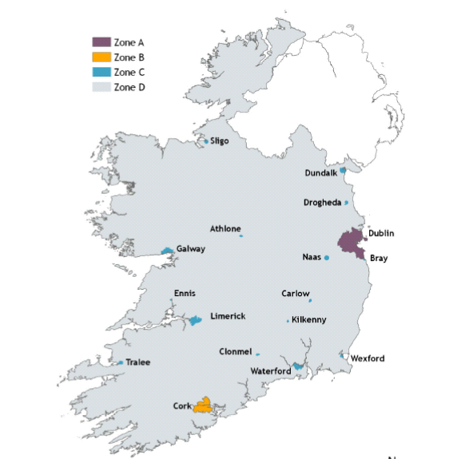

The air quality in each zone is assessed and classified with respect to upper and lower assessment thresholds based on the measurements over the previous five years. Upper and lower assessment thresholds are prescribed in the Regulations for each pollutant. The number of monitoring locations
required is dependent on population size and whether ambient air quality concentrations exceed the upper assessment threshold, are between the upper and lower assessment thresholds, or are below the lower assessment threshold as defined in Schedule 9 of the Air Quality Regulations 2002.

The Clean Air for Europe (CAFÉ) Directive was published in 2008.
This Directive introduced a limit value for PM_{2.5}, also known as fine particulate matter. PM_{2.5} has similar effects on health as PM10; however,
PM _{2.5} is a better indicator of anthropogenic (man-made) emissions than PM₁₀.

A further set of directives are pending that will deal with arsenic, cadmium, nickel and polycyclic aromatic hydrocarbons (measured as benzo[a]pyrene) and mercury in ambient air.

2.2 Historical perspective on air quality in Dublin since the mid 1980’s

In the 1980’s the greater Dublin area was frequently subjected to episodes of smog, largely attributed to incomplete burning of fossil fuels (mainly bituminous coal) in domestic fireplaces. One major contributory factor was government policy in response to the fuel crises of 1970’s which in the 1980’s required new houses to be fitted with open fires and provided incentives to existing households to convert for oil fired heating to systems burning solid fuels- see Appendix 2. This led to an increase in the quantity of solid fuel (mainly bituminous coal) utilised for domestic heating, which in turn gave rise to repeated incidences of extremely high concentrations of black smoke during the winter months.

On one day in early 1982 the daily concentrations of black smoke exceeded 1700 μg/m³ . At the time the legal limit value was 250 μg/m³ (over 3 days).
As a result the Air Pollution (Marketing, Sale and Distribution of Fuel) Regulations were enacted in 1990 that effectively banned the sale of bituminous fuels in the Greater Dublin area. This lead to an immediate dramatic and sustained reduction in smoke levels. These levels subsequently reduced from being close or exceeding legal limit values to a point that are almost one tenth of the legal standard of 250 μg/m³. The Directive on black smoke was revoked in 2005 and replaced by the Directive on PM_{10.}

Airborne lead was a pollutant of concern up to the mid 1990’s, as it is a cumulative toxin that is stored in body tissue, with particular risk of possible health effects due to long-term exposure in children. The major contributor to airborne lead pollution was the combustion of leaded petrol. Since leaded petrol was phased out and then completely eliminated in 1999 and replaced by lead free petrol, airborne lead concentrations have shown a major reduction. The correlation between the phasing of leaded petrol and the reduction in annual mean lead concentration is evident, and is not now regarded as an air pollutant of major significance.

Sulphur dioxide levels have reduced in the region since the early 1990’s and concentrations overall are low. Factors that influenced this reduction include the switching to fuel oils with lower sulphur content, the introduction of the ban on the sale of bituminous coal accompanied by more stringent standards for sulphur content in smokeless solid fuels, and the switch by many households to natural gas for heating.

Oxides of nitrogen continues be a pollutant of concern in the region. During the 1990’s nitrogen dioxide levels were exceeded. While the current results are in compliance with the annual limit value the levels are sufficiently high to be of concern in relation to compliance in the future.

PM₁₀ concentration levels have decreased with broadly similar levels measured at city centre and suburban sites in the Dublin region. Nonetheless
there remains a threat of exceeding the limit value (35 days greater than 50
μg/m3) at some locations should a combination of factors I(including unfavorable weather conditions and traffic emissions) occur. It should be noted though that from a national perspective the highest PM₁₀ levels during 2007 was recorded in Ennis, Waterford and Navan.

2.3 Specific air quality data and commentary - 1999 to the present

The key criteria in assessing the success or otherwise of the Air Quality Management Plan 1999-2005 is to examine to what extent air quality has improved or deteriorated over the lifetime of the plan.

On the basis of this criteria there are positive indications that air quality in the Dublin region has improve in many respects. As has been highlighted throughout this report, this is not a basis for complacency, but rather a vindication for continued vigilance and action.

National trends in air quality can be tracked through the “Air Quality in Ireland” reports published each year by the Environmental Protection Agency.
These reports integrate the air monitoring activities during each year by both the Agency and all the local authorities in Ireland.

The “Air Quality in Ireland 2007 – Key Indicators of Ambient Air Quality” (11) report provides a definite picture of air quality tend in the Dublin region over recent years and indicates how this compares to air quality and levels of specific pollutants in other regions of the country.

The following data is abstracted from that report.

Sulphur dioxide (SO₂)

Sulphur dioxide concentrations have been consistently low as shown in Figure 2 for the period 2002 to 2007. Factors that influenced this sustained reduction includes the switching to fuel oils with lower sulphur content, the ban on the sale of bituminous coal, and lower sulphur content in smokeless solid fuels and the switch by many households to natural gas for heating.
Figure 2: National trends in sulphur dioxide levels in ambient air
2002 to 2007

Carbon monoxide

Carbon monoxide levels have historically been low with no discernible
trend in the changes. All levels recorded are well within the limit value that came into force on 1 January 2005 (see Figure 3).

Figure 3: National trends in carbon monoxide levels in ambient air
1998 to 2007

Benzene

Annual mean benzene concentrations have been measured in Dublin and Cork from 2001 to 2007. The levels recorded (see Figure 4) have decreased significantly since 2001 when the mean level recorded at Winetavern Street, Dublin, was close to the 5 μg/m³ limit value. The levels recorded at both stations in
the past three years were much lower and well within the limit value which comes into force in 2010. Benzene concentrations in petrol have reduced in recent years. In Europe, the average benzene concentration in petrol is approximately 0.7 per cent while the EU limit is 1 per cent.
Figure 4: National trends in benzene levels in ambient air
2001 to 2007

Nitrogen dioxide (NO₂)
NO₂ concentrations measured in Dublin have been broadly consistent over a number of years in that there were no exceedances of the hourly limit. It is noteworthy that the highest annual mean level of 39 μg/m³, recorded at Coleraine Street, (see Figure 5) was below the annual limit value of 40 μg/m³. This indicates nitrogen dioxide is a pollutant of significant concern and will require vigilance in order to ensure continued compliance with required standards, and where possible achieve reductions in concentration levels.

Figure 5: National trends in nitrogen dioxide levels in ambient air
2001 to 2007

LEAD
Lead concentrations recorded in 2007 are similar to values recorded since leaded petrol was phased out in 2000. The decrease in ambient lead levels resulting from this initiative is readily apparent (see Figure 6) from the trend in annual mean concentrations of airborne lead at city-centre and suburban roadside stations in Dublin for the period 1988 through to 2007.

Figure 6: Trends in lead levels in ambient air in Dublin
1988 to 2007

BLACK SMOKE
Black smoke has been measured in Ireland for over 20 years and is valuable for observing trends in air quality in towns and cities. For many years it was the central element of air monitoring in Ireland. With the advent of new directives and improvements in monitoring technology it has been largely superseded and there is no longer a strict legal requirement to continue this type of monitoring. That said, the EPA encourages local authorities to continue measuring black smoke, and they have indicated that they will continue to report the results in the Annual Air Quality Indicators report. Smoke levels have dramatically reduced since the 1990s (see Figure 7) and have stabilized at very acceptable values. This reduction underlines the effectiveness of smoke-control legislation introduced in the Dublin area in 1990.

Figure 7: National trends in black smoke levels in ambient air
1985 to 2007

PM₁₀
Nationally, PM₁₀ is monitored at 18 stations (see Figure 8) across the country. All stations were compliant with the 2005 limit value which permits no more than 35 exceedances greater than 50 μg/m³. The highest PM₁₀ levels were recorded in Ennis, Waterford and Navan. This is most likely due to burning of coal and other solid fuel in addition to emissions from traffic.

Figure 8: National trends in PM₁₀ levels in ambient air 2007

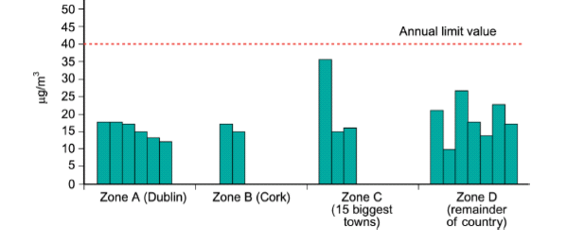
PM₁₀ has been monitored in Dublin for a considerable number of years and the historical trends are interesting in that they indicate that levels have stabilised in recent years (see Figure 9). Levels of PM₁₀ have been of considerable concern across the EU region in recent years. In response the new directive on PM _{2.5} is intended to be a more sensitive indicator of man-made particulate emissions.
Figure 8: Trends in PM₁₀ levels in ambient air in Dublin 1998 to 2007

From reviewing the data above it is encouraging that air quality in the Dublin Region continues to comply with national and international air quality standards. For a number of air pollutants the degree of compliance is very significant (lead, benzene, black smoke, carbon monoxide and sulphur dioxide). The overall downward trends in pollution levels are grounds for continued optimism. In relation to other pollutants (nitrogen dioxide and particulates) present gains must be managed proactively to ensure continued compliance with legal standards.

Chapter 3

Challenges and threats to future air quality

According to the National Development Plan the key challenges in relation to air quality are Nitrogen Oxides (NO_{x}) and Particulate Matter (PM₁₀) (12). As previously stated the major sources of these pollutants are transport and energy production sectors.

3.1 Existing and ongoing challenges

Transport

The biggest threat now facing our air quality is emissions from the transport sector. The main challenge to air quality now stems from rising vehicle emissions.

While progressively stricter emission standards and improved fuel economy of new cars are reducing emissions per vehicle, individual vehicle gains are counter balanced by the increasing numbers of vehicles.

“Emissions of air pollutants, particularly PM10 and NOX, from road traffic remain the main threat to air quality in urban areas. While new standards for car emissions and the resultant cleaner technology have curbed emissions from individual vehicles, this has been offset by
the increasing number and bigger engine sizes of vehicles on Ireland’s roads. Air quality issues must therefore be an integral part of traffic management and planning processes, and there needs to be a modal shift from the private car to high-quality public transport. .” (13).

There is a universal acceptance that tackling the transport problem is the key to improving air quality in the Dublin Region. Tackling the traffic management challenges of the Dublin region rests with several agencies and while it is not within the remit of the Air Quality Management Plan to be the primary motivating force on this matter, it is proper that the linkages between traffic policy and air quality continue to be emphasised.

The establishment of an Air Quality Steering Committee for the Dublin Region would hopefully mainstream air quality management into all major policy areas including traffic strategies.

The Greater Dublin Area Travel Demand Management Study published in October 2004 by the Dublin Transport Office (14) clearly lays out some of the underlying causes as to why transport has become the primary focus for air quality improvements:

- Demand for travel in the Greater Dublin Area (GDA) increased rapidly as a result of increased economic activity and prosperity, reflected in a growing population and workforce;
- Irish GDP grew from €36,300 million in 1990 to €129,3000 million in 2002; (GDP Data in ch 1 was 2004). Population of the Greater Dublin Area (GDA) grew from 1,405,000 in 1996 to 1,535,000 in 2002.
- The number of residents of the GDA in employment grew from 511,000 in 1996 to 680,000 in 2002;
- Population has become more dispersed resulting in less sustainable settlement patterns that are reflected in a high mode share for car use – over 80% of trips made outside the M50 between 8.00a.m. and 9.00 a.m. are by car;
- The percentage share of trips to school and work made by car is increasing;
- The absolute number of trips to work by car is increasing;
- In 2002, 50% of all those travelling to work (150,000 people) in the Dublin City Council area did so by car.

The irony is that over the past years individual vehicle performances have improved in terms of emissions to the atmosphere, and measures including emission testing of cars on an ongoing basis have seen very effective.

The key challenge in relation to air quality is to ensure compliance with the daily and annual limit values for particulate matter (PM₁₀). Levels have approached legal limit values in recent years and there is a risk that limits could be exceeded in urban areas. PM₁₀ levels vary significantly depending on meteorological conditions. As such, average levels need to be well below the limit to ensure that compliance is maintained.

Measures that help reduce congestion, promote fuel efficiency and the ongoing investment in public transport are of major assistance in addressing any potential air quality problems in the future. Existing or proposed measures which will assist in maintaining our high standards of air quality include:

- National Car testing
- Vehicle emission standards,
- Fuel efficiency in vehicles,
- Modal shift (LUAS, DART, Metro, quality bus corridors, cycle lanes etc.),
- Demand management (large infrastructural projects such as the M50 upgrade, the Dublin Port Tunnel and general measures to help relieve traffic congestion etc.),
- Restructuring of vehicle registration tax and motor tax in favour of more fuel efficient cars, and
- Excise relief on bio fuels

Energy

Energy use in Ireland increased by 0.9% in 2006 to reach 15,910 ktoe while energy related carbon dioxide (CO2) emissions increased by 0.4% for a total of 46,910 kt CO2.
Primary energy usage in 2006 was 67% higher than 1990 levels while energy-relatedCO2 emissions increased by 54% over the same period.
From 1990 to 2006 final energy usage in industry grew by 56% while industrial
output as measured by value added (constant prices) grew by 234%.
Final energy use in the transport sector increased by 167% between 1990 and 2006,the fastest growth rate of all sectors.
Over the period 1990 to 2006 final energy use in the residential sector increased by32%. Despite this its share of the total energy use fell from 31% in 1990 to 23% in
2006. Over the same period the number of permanently occupied dwellings
increased by 145% to 1,462,296. (15)

Electricity generation and transport continue to be the key sectors influencing energy demand in Ireland. Currently the bulk of this energy demand is being met through a combination of non-renewable resources. All such resources are associated with significant emissions of air pollutants.

The Dublin region, as the primary focus of much of the economic activity of the country will continue to bear a significant burden in term of atmospheric emissions. The positive aspect to this is that any progress that can be made on reducing and conserving energy will also have benefits in terms of air quality.

The Action Plan on Energy for Dublin (16) is being developed as a strategy that aims to create a coherent set of clear energy guidelines for the ongoing planning and development of Dublin. It will contribute to the sustainable development of Dublin through good energy management, which will benefit the environment and contribute to the quality of life for the people who live and work in Dublin.

Local authorities in the region can lead by example with the introduction of measures related to their activities that will reduce emissions. A good example is Fingal County Council’s initiative to ensure that new housing developments will be built to energy efficient standards that are 60% above the national standard. Sustainable building requirements have been implemented into the Cappagh Local Area Plan and the response so far has been very positive.

Major infrastructural projects

Major infrastructural projects carried out in the Dublin region over the past number of years can contribute to maintaining air quality in the region. The evolving role of private and public partnerships has also meant that local authorities are increasingly a driving force behind such projects.

All major projects attract attention to a range of environmental considerations. In recent years a number of such projects have required careful consideration of potential impacts on regional air quality: These include:

- Dublin Port Tunnel
- Upgrading of M50
- Proposed Waste to Energy Plant in Ringsend
- Redevelopment of Dublin Airport
- Ongoing national road network expansion

Construction and development

The Greater Dublin region has seen very significant levels of construction activity in the past decade. The benefit of this regeneration has been very significant, but the level of sustained public concern regarding air quality problems associated with this cannot be ignored. The construction sector continues to be a major source of public complaint. There needs to be consistency across the region requiring developers to produce a documented plan to reduce dust and airborne emissions during building and demolition.
Uncontrolled burning
Dioxin, which is particular pollutant that can occur when some substances are burned at low temperatures, has generated considerable interest in recent years. Uncontrolled burning of waste material contributes to over 50% of all dioxin emissions in Ireland. It is a growing problem nationwide with 80% of local authorities identifying it as a significant issue. According to an EPA survey (17) on Irish people’s attitudes on environmental issues, one in ten adults admit to burning household waste. This problem continues to grow even though 80% of adults are aware of the environmental and health risks associated with Backyard Burning and 40% are aware that Backyard Burning is the greatest source of dioxins in Ireland. Two findings from the survey that are especially worrying is that 15% of adults believe backyard burning is an acceptable method of disposing of waste and half of those that admitted to burning did so in the knowledge of the public health implications due to the associated release of dioxins.
Tackling uncontrolled burning of waste in the Dublin region must be prioritised. A regional public information campaign on the health and environmental risks associated with Halloween bonfires should be developed.

3.2 Emerging challenges
Climate change
Concerns about climate change have led to an unprecedented awareness of the need to limit emissions and for responsibility to be taken for individual and collective behaviour. This is an awareness that should be fostered and harnessed. By anticipating change it may be possible to minimise adverse impacts and to maximise positive impacts of global climate change.

The Fourth Assessment Report of the IPCC (18) on climate change gives examples of major projected impacts by sector including:

- Reduced energy demand for heating
- Increased demand for cooling
- Declining air quality in cities
- Reduced disruption to transport due to snow and ice
- Disruption of settlements, commerce, transport and societies due to flooding
- Pressures on urban and rural infrastructures
- Reduced hydropower generation potentials

The report outlines the adaptation strategies required for each sector, the underlying policy framework and the key constraints and opportunities to implementation. It also outlines key sectoral mitigation technologies, and the policies, measures and instruments shown to be environmentally effective and the key constraints and opportunities.

It is critical that climate change remedies dovetail with AQMP objectives. It is also important that research studies about the major impacts of climate change that can be expected to occur will be undertaken with reference to the Greater Dublin Region. Research and policy should take an integrated approach to tackling both air quality and climate change. Carefully designed solutions to one problem may also be an efficient solution to the other.

The National Climate Change Strategy 2007-2012 builds on the commitment to sustainable development set out in towards 2016 and the National Development Plan 2007-2013 and is one of a number of inter-related government initiatives that will address energy and climate change issues. These include the White Paper on Energy, the Bio-Energy Action Plan and the Sustainable Transport Action Plan.

Improving the knowledge base

There has been the progress in monitoring air quality across the region in recent years. The expansion of the air monitoring network and the introduction of more sophisticated means of monitoring for a wider range of pollutants has improved our knowledge of air quality the region. There is though little in the way of integration of this monitoring data at regional level, and decision on siting of monitoring locations are made on local rather than strategic regional basis.

Similarly there is la lack of integration on the range and contribution of emission sources across the region. While much useful work has been done in terms of major emergency planning to map major potential sources there is a dearth of information currently available on the full range of emission sources that exist. This has major implications in terms of developing strategies for air quality management.

Integration of air quality management into other sectoral plans

In the course of this review to date, a range of regional plans were identified that specifically address air quality issues in the Dublin Region.
These include:

- Dublin City Development Board. Dublin – A City of Possibilities 2002-2012
- Waste Management Plan for the Dublin Region 2005-2010
- Dublin Transportation Office - A Platform for Change – Summary Report
- Strategic Planning Guidelines for the Greater Dublin Area
- Statement Of Strategy 2005-2007 Dept of the Environment, Heritage & Local Government
- Local Agenda 21

It is noteworthy that in each of these regional plans that while air quality is addressed to varying degrees, none of them make reference to the AQMP.
It is also noteworthy that there appears to be little in the way of cross-reference between the plans in relation to air quality.

In addition to the above, each local authority has their own range of plans that refer to air quality management. These include:

- Corporate Plans
- Regional plans for waste management
- City and County Development Plans
- Various departmental Business Plans

The County Development Plan 2004-2010 Dun Laoghaire/Rathdown County Council states:

- “It is the policy of DLRCC that the principles of sustainable development will inform all objectives, policies, decisions and actions of the County Council for the period of the Plan….. Protection of the built and natural environment is a fundamental element of sustainability…

- It is Council policy to ensure that all economic activity in County operates in accordance with current European and National environmental legislation. The Council has a role in advising, monitoring and enforcement of environmental considerations including emissions to air. When considering proposals for employment provision the Council shall take into account the interaction between such development and the receiving environment. Aspects for consideration will include the effect of industrial processes on air quality.

- It is the Council’s policy to facilitate the implementation of the objectives set out in the DTO Strategy…

- It is Council policy to implement the provision of air pollution abatement in accordance with National and EU Directives and legislative requirements in conjunction with other agencies as appropriate.

- The Council has established a network of air pollution monitoring stations which will be extended as required.

- The Council will have regard to the Local Government (Planning and Development) General Policy Directive 1988 (as amended) relating to air quality standards nationally, and to the Air Quality Management Plan for the Dublin Region in considering applications for planning permissions and such other relevant legislation as may be enacted…

- To accord with the principles of sustainable development……it is the vision of this Plan to encourage and support energy efficiency, conservation and generation from renewable resources……….”

The establishment of an Air Quality Steering Committee would help to ensure that the Air Quality Management Plan is integrated with EU and national policies. The emphasis should be on mainstreaming the AQMP into Development Plan and Strategic Environmental Assessment processes as well as energy conservation and management plans.

Targeting enforcement

The Air Pollution Act 1987 and associated Regulations is the main legislative instrument by which the local authorities have powers to control air pollution emissions. A rigorous policy of enforcement in the region has been successful in controlling emissions over the period of the last AQMP.

Local authorities must prioritise tackling uncontrolled burning of waste in the Dublin region. Co-ordination of enforcement activities under the Waste Management Acts 1996-2005 and the Air Pollution Act 1987 is required to maximise the positive impact on air quality.

Continued enforcement of the Marketing Sale and Distribution of Fuels Regulations 1992 of bituminous throughout the period of the last plan was effective in maintaining air quality standards and assisted in the promotion lower polluting fuels such as natural gas electricity and low sulphur gas oil.
Local authorities must develop a coordinated regional implementation plan for continued enforcement of the ban on the marketing, sale, and distribution of bituminous fuel.

3.3 Summary conclusions

- Ireland must achieve new EU air quality standards for a variety of pollutants in the period 2005 – 2010. This may be a challenge to achieve for new standards for oxides of nitrogen and particulate matter, in heavily trafficked urban hotspots. This is because although emissions from individual vehicles continue to fall as a result of technological advances and cleaner fuel, improvements to date have been largely offset by the significant increase in the number of vehicles on the road.

- Emissions from the transport sector are the main, but not the only threat to air quality in the Dublin region. Other issues include the construction industry, uncontrolled burning of waste and localised emissions from a small number of industries. Specific strategies along the lines of those included in the original AQMP must be carried through in the revised version, but this time on a priority and time bound basis.

- Standardised complaints and inspections procedures must be developed and implemented throughout the region. These can be along the lines of the Recommended Minimum Criteria for Environmental Inspections (RMCEI) framework developed by the Environmental Protection Agency.

- Energy consumption and energy security has become and will remain a focus of concern for Irish society. The Governments White Paper on Energy is clear evidence of this. Ironically, this situation provides an opportunity to highlight the relationship between energy conservation and reducing emissions across a whole range of sectors. The new AQMP should take on board this development and use it a positive driver to facilitate change. Integration of climate change and air quality strategies and research must also form part of the new plan.

Chapter 4

The Way Forward

4.1 Setting the context

Good air quality contributes significantly to the health and quality of life of the population of the Dublin region. While air quality in the Dublin region is good, sustained efforts are required to protect this valuable natural resource.
The use and enjoyment of many other natural resources, such as our green spaces is also further enhanced by having clean air, and the attractiveness of the region to inward investment and visitors is underpinned by having a strong commitment to environmental management.

Although air quality in the Dublin Region currently complies with European Union standards, there is no room for complacency. Experience to date clearly demonstrates that as our knowledge of the effect of various pollutants increases, the legal permissible levels for these substances invariably decreases. As the debate at European Union level continues as to new standards for air quality to be adopted, it is clear that achieving further and continued improvements will challenge all Member States.

On the positive side, the well-founded concerns about climate change have led to an unprecedented awareness of the need to limit emissions and for responsibility to be taken for individual and collective behaviour. This is an awareness that should be fostered and harnessed.

Many of the issues that lead to increases or decreases in specific levels of some pollutants being emitted may lie beyond the direct control of local authorities. This however should not be a deterrent to taking action, or being an advocate or facilitator of change. Local authorities have a unique role in civil society in influencing other organisations and in being a facilitator of change. Local authorities also have the potential to be models of best practice that in turn can influence other bodies.

The specific elements of an Air Quality Management Plan for the Dublin Region for Dublin therefore should be clear, and ideally follow the SMART approach, i.e. Specific; Measurable; Achievable; Realistic; and Timed.

It should be stressed that these objectives specifically address those areas where the four local authorities will act in unison. Each local authority may wish to pursue priority initiatives or activities within their own functional area.

The main strategies that the local authorities in the region should consider are as follow:

- Improve coordination of our efforts and build on the good work done to date

- Mainstream air quality management into all major policy areas

- Strengthen evidence based decision making by improving how we share information on air quality

- Lead by example with measures related to local authority activities that will reduce emissions.

- Identify and priorities tackling main potential threats to air quality.

- Provide clear time- bound criteria for the achievement of objectives.

Time frame for change

The specific actions to be carried out are as follows:

Strategy 1: Improve co-ordination of our efforts and build on the good work done to date

Within one month of the adoption of the Plan:

Establish an Air Quality Steering Committee comprising of managerial and technical members of each of the local authorities to periodically review and report on the implementation of the AQMP. The emphasis should be to ensure it is integrated with EU and national polices and mainstreamed into both Development Plan and SEA processes.

Within three months of the adoption of the Plan:

Develop and implement a regional Standard Operational Procedure for responding to public complaint about air pollution incidents in line with best practice and equity throughout the Dublin region. The Local Authority Management System (LAMS) initiative by the Environmental Protection Agency provides a framework to ensure this level of service is developed and enhanced.

Within six months of the adoption of the Plan:

Develop a coordinated regional implementation plan for continued enforcement of the ban on the marketing, sale, and distribution of bituminous fuel.

Strategy 2: Mainstream air quality management into all major policy areas

Within twelve months of the adoption of the Plan and as necessary thereafter.

- The Air Quality Steering Committee will appraise major existing sectoral plans (e.g. Waste Management Plans, Traffic Strategy) with a view to ensuring elements of air quality are addressed.

- Develop in conjunction with the respective Planning Departments of each local authority, an agreed set of planning conditions that address air quality issues and best practice. Specifically these should include a requirement for developers to produce a documented plan to reduce dust and airborne emissions during building and demolition

Strategy 3: Strengthen evidence-based decision-making by improving how we share information on air quality

Within twelve months of the adoption of the Plan:

- Develop a system to share and pool of air quality monitoring data between the local authorities.

Within 18 months of the adoption of the Plan

- Develop a mechanism for dissemination of this air quality information to the public in a readily understandable and timely manner. Internet based systems and/or public media such as teletext services should be considered.

Within 24 months of the adoption of the Plan

- Develop a common pool of knowledge on emission sources within the Dublin region. An air quality prediction model hosted by the four local authorities that can predict the cumulative effects of major projects and developments in the Dublin Region require sustained support in terms of resources and time. The level of support required is in the region of Euro 50,000 per local authority per year.

- Develop a partnership programme on research activities with other bodies (such as third level institutions) with a view to increasing the evidence base for making informed decisions on air quality.

Strategy 4: Lead by example with measures related to local authority activities that will reduce emissions

Within six months of the adoption of the Plan:

- The Air Quality Steering Committee will appraise energy conservation and energy management plans currently being produced by local authorities in the region with a view to assessing if all elements of air quality management are included.

Within 18 months of the adoption of the Plan

- Report on the feasibility of the conversion of local authority fleet to alternative fuels (initial work has commenced on this area).

Strategy 5 identifies and prioritizes tackling main potential threats to air quality.

Within 6 months of the adoption of the Plan
  - Prioritise tackling uncontrolled burning of waste in the Dublin region, with particular emphasis on metal recovery by cable burning.

Within 24 months of the adoption of the Plan

- Develop a public information campaign on best environmental practices in the area of air quality. Practical examples could include having an awareness campaign on the issues of Halloween bonfires, construction site management.

Within 36 months of the adoption of the Plan

- Encourage measures to allow private or public companies introduce benefit in kind schemes for public transport, car-pooling and improved facilities for cyclists.

Appendix 1: Dublin Regional Air Quality Management Plan 1999

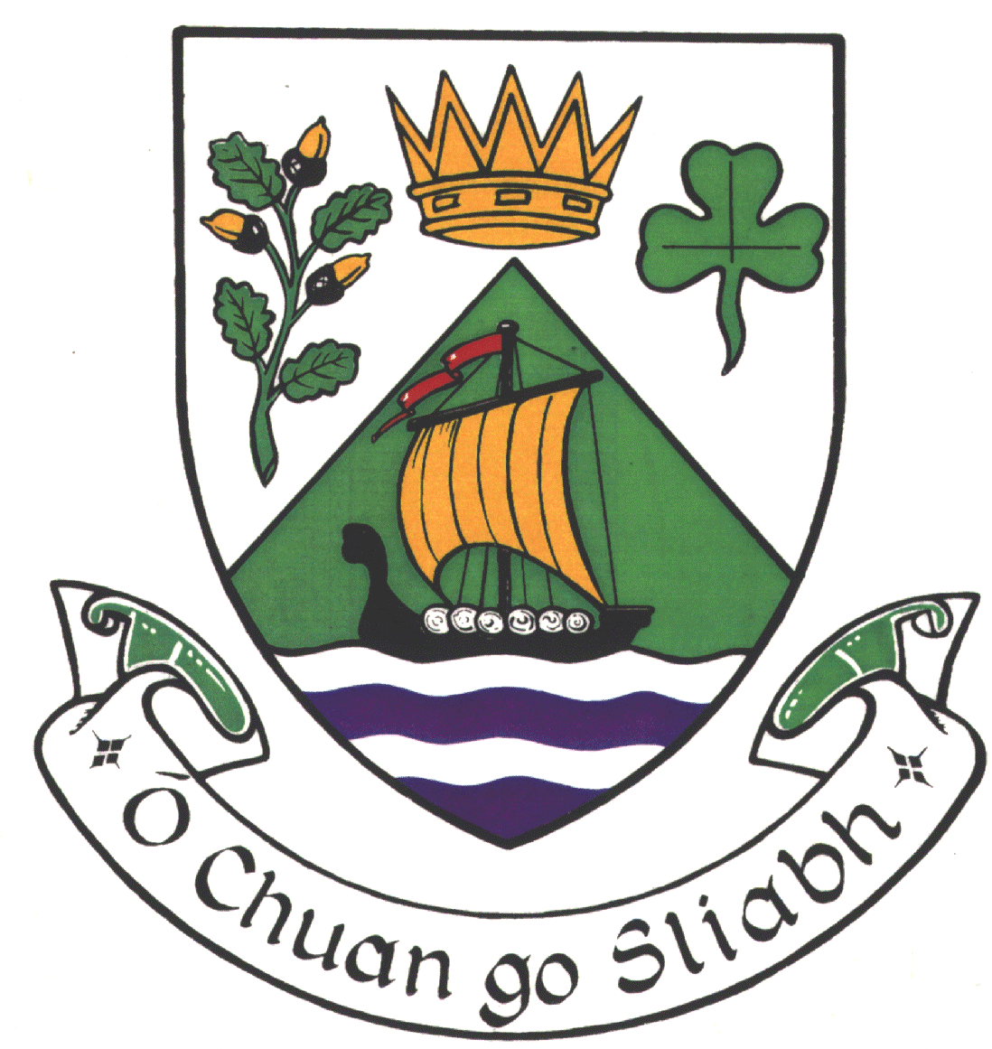


Dublin Regional Air Quality
Management Plan
Dublin Corporation
Fingal
South Dublin
Dun-Laoghaire/Rathdown

DRAFT DUBLIN REGIONAL AIR QUALITY MANAGEMENT PLAN

VISION STATEMENT

The vision statement of the Air Quality Management Plan for the Dublin Region is:-

“To improve the health and quality of life of the citizens of Dublin and protect the environment by the provision of a co-ordinated approach to the control of air pollution and to the sustainable development of the built environment and transportation within the region”.

OBJECTIVE OF THE PLAN

The principal objective of the Dublin Regional Air Quality Management Plan is to develop policies and strategies so that measured levels of air pollutant concentrations within the functional areas of the Local Authorities in the Region comply with air quality target values by 2001. The Plan establishes a number of measures to control and reduce air polluting emissions from both stationary and road transport sources. Local transport policies play an important part in the operation of the Plan with the dominance of pollutants from road vehicles exhaust emissions affecting ambient air quality. Other aspects of the Plan relate to educational and promotional programmes, establishment of a Steering Committee to assess the effectiveness of the Plan and general development and regional planning issues.

There are certain emission reduction measures that are determined by National Government through the European Union and so are beyond the legislative powers of the Local Authorities. These relate to the various recent Directives and corresponding National Legislation regarding emission limits for road transport; including both private motor cars and commercial goods vehicles. The increasingly stringent emission control measures introduced by the European Union will make a substantial impact on the volume of emissions from road transport in the area of the Plan. The Local Authorities fully support measures aimed at controlling and reducing vehicle exhaust emissions by setting tighter limits for new vehicles. However, as the introduction of such legislation is a matter for National Government and is outside the remit of the Local Authority decision making process this aspect of controlling air quality is not covered in the list of policies given in the Plan.

The recommended target values for the different air pollutants commonly found in the urban environment are set out in Table 1. The target concentrations shown in the table are based on current and proposed European Union Air Quality Directives that have been developed to protect the health of the general population.

Table 1
Air Quality Target Values for the Dublin Region

Pollutant | Averaging Period | Target Value
Sulphur Dioxide | 10 minute mean | 500 (μg/m³)
 | 1 hour mean (1) | 350 (μg/m³)
 | 24 hour mean (2) | 125 (μg/m³)
 | Annual mean | 60 (μg/m³)
Nitrogen Dioxide | 1 hour mean (3) | 200 (μg/m3)
 | Annual mean | 40 (μg/m3)
Black smoke | 24 hour mean | 150 (μg/m3)
 | Annual mean | 60 (μg/m3)
Particulate ( PM10) | 24 hour mean (4) | 50 (μg/m3)
 | Annual mean | 30 (μg/m3)
Benzene | Annual mean | 5 (μg/m3)
Carbon Monoxide | 8-hour mean (5) | 10 (mg/m3)
Ozone | 8 hour mean (6) | 120 (μg/m3)
Lead | Annual mean | 0.5 (μg/m3)

Note: The air quality target values are interpreted as follows:-
(1) 350 (μg/m3) hourly mean not to be exceeded more than 8 times per year
(2) 125(μg/m3) daily mean not to be exceeded more than 3 times per year
(3) 200 (μg/m3) hourly mean not to be exceeded more than 8 times per year
(4) 50 (μg/m3) daily mean not be exceeded more than 25 times per year
(5) 10 (mg/m3) as a running 8-hour mean
(6) 120 (μg/m3) as the highest running 8-hour mean within one day not to be exceeded on more than 20 days per year

Overall, the air quality in the Dublin Region is good. However, there are certain urban areas of the Region where levels of air pollution may occasionally give rise to concern. From the detailed studies carried out under the AQMP programme the pollutants warranting reduction strategies for 2001 are nitrogen dioxide, particulate matter (PM10) and benzene. Black smoke has been included in Table 1 as it is included in the National Air Quality Standards regulations. However, this pollutant is likely to be discontinued as a monitoring parameter by 2001, to be replaced by continuous PM10 sampling that is recognised as a more reliable and accurate measurement of airborne particulate matter. For the other pollutants given in Table 1, sulphur dioxide, carbon monoxide, ozone and lead, monitoring results obtained in recent years indicate that current ambient concentrations are expected to comply with the proposed air quality target values. As a result of the trends in ambient levels for these pollutants no specific emission abatement strategies are required.

The air quality target values are considered on a pollutant-by-pollutant basis. There is no evidence that at the concentrations normally experienced in the urban environment the combined health effects are synergistic; even in the case of air pollution episodes.

Levels of air quality should be compared with the target values specified in the Plan at outdoor locations, excluding the workplace, where human exposure over the appropriate averaging time is significant.

The locations where the highest concentrations occur, such as at the kerb edge, may not be appropriate for evaluating the risk to the citizen as the duration of the exposure to high levels from the vehicle exhaust would be very short.

Ambient air quality monitoring should be undertaken at locations removed from the direct influence of emission sources to provide measurements typical of normal community exposure. This is in line with the appropriate E.U. Directives. These could include sites adjacent to major roadways, such as at the back of the pavement and also at residential or background locations within the Region.

POLICIES AND STRATEGIES
The following policies and associated strategies are the measures that are required to meet the objectives of the Plan so as to be able to fulfil the vision statement.

POLICY 1
It is the policy of the Local Authorities to control and reduce air emissions from domestic, commercial and industrial premises within their functional areas.

STRATEGY:
a) Residential /Domestic

(i) The Local Authorities shall continue to promote the use of cleaner, low-polluting fuels and switching from coal and other solid fuels to natural gas, electricity and low-sulphur gas-oil will be encouraged.

(ii) The Local Authorities shall continue to enforce the ban on the sale of bituminous coal and where necessary take legal action against traders who continue to supply coal within the control area.

(iii) The Local Authorities shall continue to provide a complaint investigation and resolution service for the citizens of their functional areas.

b) Commercial/Industrial

(i) The Local Authorities shall encourage sustainable industrial development within their functional areas through the use of cleaner technologies and production techniques, reduction in waste production, conservation and recycling of materials.

(ii) The Local Authorities shall continue to limit and reduce emissions from industries through the statutory powers of the 1987 Air Pollution Act.

(iii) The Local Authorities shall encourage conversion to low-sulphur gas oil where commercial or industrial premises use oil as their main source of fuel.

(iv) The Local Authorities shall continue to enforce measures to control and recover the petroleum vapour emissions resulting from the storage at a terminal and transport of petrol by road tanker between the terminal and the storage tanks at the service station.

POLICY 2
It is the policy of the Local Authorities to control development within their functional areas to provide efficient use of land and infrastructure, thereby controlling and limiting air emissions.

STRATEGY:
(i) The Local Authorities shall examine all matters relating to major new developments to ensure that any emissions to atmosphere from the development do not result in a change in air quality likely to exceed the target values specified in the Plan for 2001.

(ii) The Local Authorities shall require that planning proposals for development of suburban or green-field sites requiring an environmental impact statement shall address the local impact of alterations in traffic flows on air quality.

(iii) The Local Authorities shall require that adequate information on the air quality impact of new developments is submitted as part of the environmental assessment procedure under the requirements of the E.U. Legislation on Environmental Impact Assessments and in accordance with the provisions of the Local Government
( Planning and Development) Acts 1963-98 and any subsequent legislation.

(iv) The Local Authorities shall encourage the development of public and private residential housing close to public transport routes to reduce reliance on private cars for commuting to and from work.

(v) The Local Authorities shall encourage ‘home-based’ economic activities where, by virtue of their nature and scale, they can be accommodated without detriment to the amenities of the residential areas.

(vi) The Local Authorities shall encourage the relocation of business premises in residential areas that seriously detract from residential zoning objectives.

POLICY 3
It is the policy of the Local Authorities to take such measures as deemed appropriate to prevent a nuisance from dust emissions occurring during building/demolition activities within their functional areas.

STRATEGY:
(i) The Local Authorities shall require, when necessary that a documented plan is submitted indicating measures to prevent and reduce dust and airborne particulate emissions prior to carrying out activities that may result in a nuisance.

POLICY 4
It is the policy of the Local Authorities to restrict gorse, straw and cereal crop stubble burning activities on agricultural lands where a nuisance is likely.

STRATEGY:
(i) The Local Authorities shall require when necessary that a plan of intention to carry out open burning on agricultural lands is submitted to the environment section prior to the burning of gorse, stubble and other cereals to prevent smoke generated by this activity creating a local community nuisance or a danger to road users. The size of area to be burnt, measures to control burning and fire safety precautions in addition to the proposed schedule for burning should be given.

(ii) The Local Authorities shall require that on completion of straw and cereal crop stubble burning ash remaining should be incorporated into the soil to prevent a local dust nuisance.

POLICY 5
It is the policy of the Local Authorities to prohibit the spreading of agricultural slurry on agricultural lands in a manner likely to create an odour nuisance within the community

STRATEGY:
(i) The Local Authorities shall require that a plan be submitted to the environment section of the Local Authority prior to undertaking slurry spreading on lands. Measures should be adopted during land spreading which minimise the generation of malodours from such activities likely to result in a nuisance.

(ii) The Local Authorities will require, where deemed practical, that animal slurry is applied on lands by band spreading or even surface injection in sensitive areas in preference to splash-plate spreading equipment.

(iii) The Local Authorities may restrict spreading of animal slurry on lands during climatological conditions likely to cause strong malodours in the area following the spreading.

POLICY 6
It is the policy of the Local Authorities to encourage a modal change from private car use towards other types of travel and to promote the use of public transport to reduce vehicle emissions and improve air quality within their functional areas.

STRATEGY:
(i) The Local Authorities will promote and encourage cycling facilities within residential areas to enable safe cycling routes to and from local schools and shops. The emphasis will be on encouraging the use of cycles that would reduce the volume of private cars travelling during the peak morning traffic period.

(ii) The Local Authorities will implement the Dublin Transportation Initiative plan for a network of strategic cycle ways and recreational cycle routes. This plan includes safer cycling conditions, improvements in cycle parking and suitable lock-up facilities between cycling and other modes of travel.

(iii) The Local Authorities shall continue to promote and encourage safe and convenient routes for walking to and from schools and shops in residential areas with an emphasis on providing alternative ‘safe’ routes for short-trips of typically less than 1-2km in length.

(iv) The Local Authorities shall support and encourage the rapid introduction of Park and Ride Facilities close to public transport nodes within their functional areas in accordance with the Dublin Transportation Initiative strategy as an alternative means of transport for private motorists entering Dublin city.

(v) The Local Authorities shall support and encourage the rapid implementation of Quality Bus Corridors and other bus priority measures along the routes identified in the Dublin Transportation Initiative strategy within their functional areas. As part of the implementation programme due regard shall be made to appropriate traffic calming measures in residential areas adjacent to the route to prevent a deterioration in air quality due to commuters using alternative roads.

(vi) The Local Authorities shall encourage Coras Iompair Eireann and its subsidiaries to provide inter-bus service facilities, feeder links to the DART and ARROW suburban rail services to facilitate movement of commuters to and from work.

POLICY 7
It is the policy of the Local Authorities to manage and control traffic flows within their functional areas to reduce congestion and queuing times at road junctions and in urban areas, thereby improving air quality at these locations.

STRATEGY:
(i) The Local Authorities will continue to address proposals on traffic calming measures within their functional areas to limit the volume of traffic passing through residential areas in the vicinity of, or as a means of avoiding major road junctions.

(ii) The Local Authorities will promote plans for the introduction of environmental traffic cells (ETC) in urban centres. Monitoring of the traffic flows in adjacent zones will be undertaken to ensure that no adverse impact on air quality takes place.

(iii) The Local Authorities will consider proposals to extend the Urban Traffic Control systems currently used within Dublin city centre to suburban locations on major radial routes in an effort to improve traffic flow at junctions and reduce high vehicle emissions as a result of stop-start driving conditions.

(iv) The Local Authorities will evaluate the introduction of traffic management strategies as a means to prevent a further deterioration in air quality at traffic ‘hot-spots’.

POLICY 8
It is the policy of the Local Authorities to control and reduce exhaust emissions from public service vehicles within their functional areas.

STRATEGY:
(i) The Local Authorities will require verification of regular vehicle engine/emission testing of the Coras Iompair Eireann and its subsidiary Company’s bus and coach fleet to limit and reduce emissions of particulates and other air pollutants.

(ii) The Local Authorities will support proposals from Coras Iompair Eireann to National Government to reduce the time-scale for the replacement of older vehicle stock in their Fleet.

(iii) The Local Authorities will encourage programmes for converting existing diesel engine vehicles in the fleet of Coras Iompair Eireann and its subsidiary companies to LPG or CNG.

(iv) The Local Authorities will require verification that buses operating on the routes designated as Quality Bus Corridors meet current vehicle emission limits.

(v) The Local Authorities shall have due regard to regulating and limiting emissions from buses and coaches operated by private companies in the event of proposals being submitted for de-regulation of certain routes within their functional areas.

POLICY 9
It is the policy of the Local Authorities to develop a short-term management strategy for commercial vehicles within their functional areas.

STRATEGY:
(i) The Local Authorities shall examine proposals to regulate the movement of Heavy Goods Vehicles through residential and retail areas.

(ii) The Local Authorities will introduce priority routes for such vehicles travelling to and from Ports of access.

(ii) The Local Authorities may, where deemed necessary, restrict the locations and periods during the weekday when loading/unloading will be permitted in order to reduce traffic congestion within the urban centres.

POLICY 10
It is the policy of the Local Authorities to encourage, where practicable, businesses within their functional areas to reduce the reliance on private cars by their employees.

STRATEGY:
(i) The Local Authorities shall consider the introduction of planning control measures to regulate the number of car-parking spaces permitted in new developments.

(ii) The Local Authorities will encourage any measures that would allow private and public companies to introduce alternative benefit in kind payment schemes for public transport, car pooling and improve facilities for cyclists.

(iii) The Local Authorities may require new major commercial/industrial developments to submit plans that encourage a transfer from private cars to public transport.

POLICY 11
It is the policy of the Local Authorities to limit and reduce the level of on-street and off-street parking provided in the urban centres within their functional areas to reduce traffic volumes and vehicle emissions.

STRATEGY:
(i) The Local Authorities shall promote parking restraint in Dublin City centre, Dun Laoghaire and other town centres to reduce congestion caused by private cars and associated vehicle emissions. Measures proposed may include raising on-street parking costs, enforcement of parking restriction regulations, tow-away zones within the city centre and discouraging all-day street parking.

(ii) The Local Authorities shall consider the removal of ‘free’ on-street parking within their urban central business districts and in adjacent areas where all-day commuter parking is evident.

POLICY 12
It is a policy of the Local Authorities to undertake a programme to evaluate the various measures available to control and reduce emissions from their own vehicle fleet

STRATEGY:
(i) The Local Authorities shall examine the cost-effectiveness of converting existing petrol and diesel engine vehicles to other alternative fuels including LPG, CNG, electricity and bio-fuels. They shall also investigate the opportunities available for purchasing new vehicle stock, which operate on alternative fuels.

(ii) The Local Authorities shall introduce procedures to monitor vehicle kilometres travelled, fuel consumption rates and vehicle maintenance programmes to improve performance of their vehicles and so lower exhaust emissions.

POLICY 13
It is the policy of Local Authorities to periodically review air quality within their functional areas to identify changes that could result in zones where deterioration in air quality may take place.

STRATEGY:
(i) The Local Authorities will put in place a steering committee, composed of managerial and technical members, which will meet periodically to undertake a review of air quality trends and make recommendations in relation to:-

the effectiveness of policies and strategies specified within the Air Quality Management Plan

additional requirements for ambient air monitoring

updating emission inventories

urban air quality dispersion modelling

assessing the impact on existing air quality of future changes in National and International legislation.

evaluation of air quality trends at traffic ‘hot-spots’ within the urban centres.

POLICY 14
It is the policy of the Local Authorities to promote educational programmes on matters relating to controlling and reducing air emissions to improve air quality within their functional areas.

STRATEGY:
(i) The Local Authorities will undertake promotional and educational programmes within their functional areas aimed at the individual and schools. Their roles in helping to improve the ambient air quality within the area of the Plan will be emphasised through the use of public information leaflets and items on the radio and television. Issues which would be covered in such programmes would include changing from solid fuel to cleaner low-polluting fuels, energy conservation in the home, using alternative modes of transport to the private car, campaigns to encourage better maintenance of cars and adopting better driving techniques to reduce vehicle emissions.
(ii) The Local Authorities will publish air pollution monitoring data from their respective networks to be available to the general public through the media, Aertel and the Internet. In the event of poor air quality in the region information shall be available as regular news up-dates to local radio services.

(iii) The Local Authorities will promote local campaigns in residential areas to reduce the dependence on cars as a means of travelling to school and encourage cycling and walking as alternative modes of transport.

(iv) The Local Authorities will encourage and promote involvement of local initiatives and partnerships under Agenda 21 to improve air quality in their region.

(v) The Local Authorities will reinforce the objectives of the Healthy Cities Project in their areas through the adoption of the strategies of the Plan.

Appendix 2:

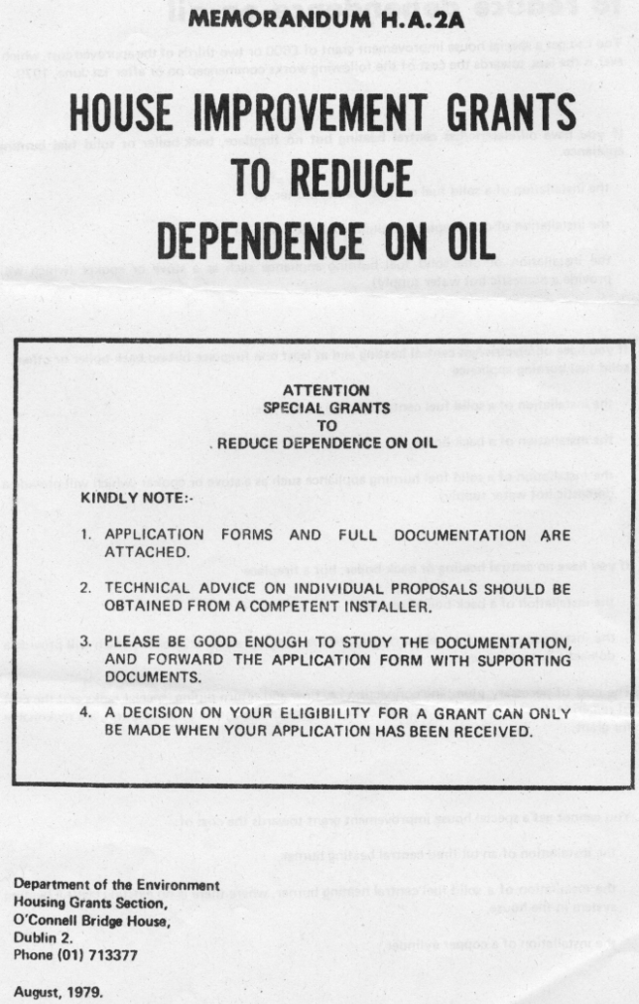

References

1. | Energy in Transport. 2007 Report. M. Howley, F. O’ Leary, B. Ó Gallachóir. December 2007. Sustainable Energy Ireland. Energy Policy Statistical Support Unit. 59pp.
2. | Clancy L., Goodman P., Sinclair H. et al. Effect of air pollution control on death rates, Dublin Ireland. Lancet 2002: 360 p.1210-4.
3. | Health Impact Assessment on the Benefits of Reducing PM2.5 in 26 European Cities (Summary) . 18 September 2006. APHEIS: Air Pollution and Health: A European Information System. S. Medina (InVS, France) on behalf of the Apheis network. 3pp.
4. | 2008-2011Agreement Maintaining Low Levels in the Sulphur Emissions of Bituminous Coal and Petcoke and the Maintenance of Existing Limitations through Smokeless Zones on the Marketing, Sale and Distribution of Solid Fuels between The Solid Fuel Trade Group Limited and The Minister of State at the Department of the Environment, Heritage and Local Government. Department of the Environment, Heritage and Local Government .5pp
5. | London Atmospheric Emissions Inventory 2003.Second Annual Report. Greater London Authority. August 2006. 145pp.
6. | Environmental Health Perspectives. September 2001. 109:9. Don’t Breathe and Drive? United States' National Institute of Environmental Health Sciences. A422-A427.
7. | Ireland Environment 2008. 4th State of the Environment Report. Environmental Protection Agency. Ireland 268pp.
8. | WHO Air quality guidelines for particulate matter, ozone, nitrogen  dioxide and sulfur dioxide, Global update 2005. Summary of risk assessment. World Health Organization. 2006.
9. | Regional Population Projections 2006-2021 25 May 2005. Central Statistics s Office. Dublin.
10. | Williams, B., Hughes B, and Shiels (2007) Urban Sprawl and market fragmentation. Society of Chartered Surveyors Housing Study
11. | Air Quality in Ireland 2007 – Key Indicators of Ambient Air Quality.2008. Environmental Protection Agency. Ireland. Matter,
12. | National Development Plan -2007-2013. Transforming Ireland -  A Better Quality Of Life For All. Government Publications Office.
13. | See 7
14. | Greater Dublin Area Travel Demand Management Study. Dublin, October 2004. Dublin Transport Office
15. | Energy in Ireland - KEY STATISTICS. F.l O’Leary, M. Howley,  B. Ó Gallachóir. March 2008. Sustainable Energy Ireland.
16. | The Action Plan on Energy for Dublin. (in production).  CODEMA
17. | Public Perceptions, Attitudes and Values on the Environment –  A National Survey. 2005. Strategic Policy Research Unit.  Environmental Protection Agency
18 | Climate Change 2007 – Synthesis Report the Fourth Assessment Report of the IPCC. International Panel on Climate Change

