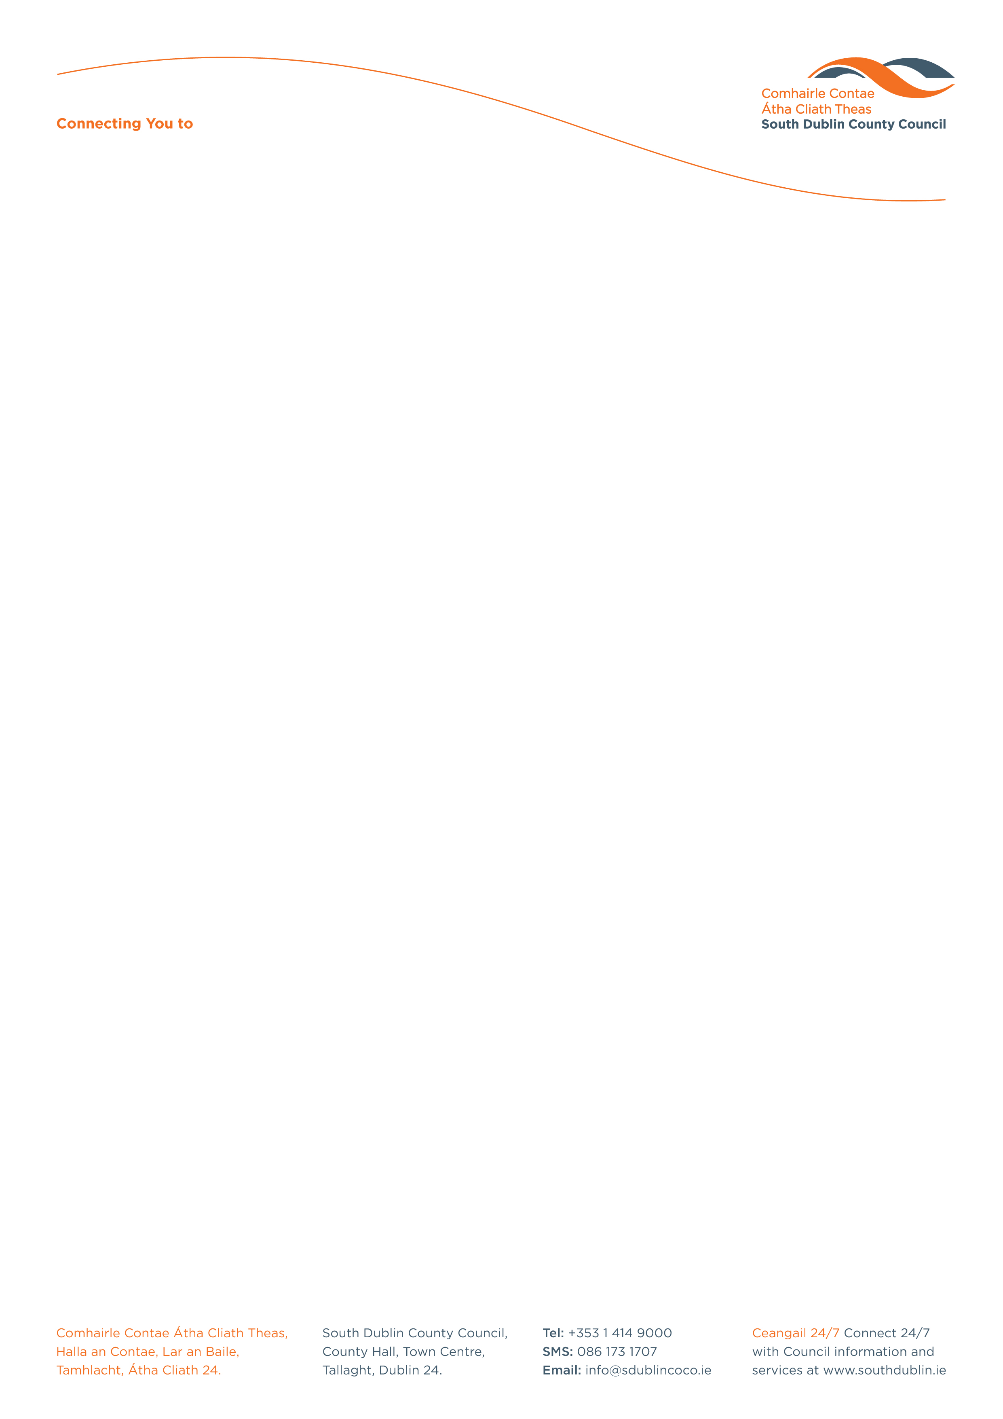

Halla an Chontae, Lár an Bhaile County Hall, Town Centre
Tamhlacht, Baile Átha Cliath 24 Tallaght, Dublin 24
Telefon: 01-4149052 Telephone: 01-4149052

Facs: 01-4149332 Fax: 01-4149332
www.southdublin.ie

Mr B. O’Keeffe TD
Minister for Education & Sport
Dail Eireann
Merrion Street
Dublin 1.

27th November, 2008

RE: Tallaght Area Committee Meeting – 24th November, 2008

Dear Sir/Madam,

At the Tallaght Area Committee Meeting of 24th November , 2008 the following motion was passed:

“That this Committee condemns the cuts in funding to the schools in Tallaght, as announced in Budget 2008, and requests Corporate Services to convey to the Minister for Education, the opposition of the elected local Councillors to the reduction in funding”.
I should be obliged if you would let me have a reply on this matter at your earliest convenience.

Thanking you in anticipation.

Yours sincerely,

ALLYSON ROONEY,
SENIOR STAFF OFFICER,
HOUSING ADMINISTRATION.

Housing Administration

