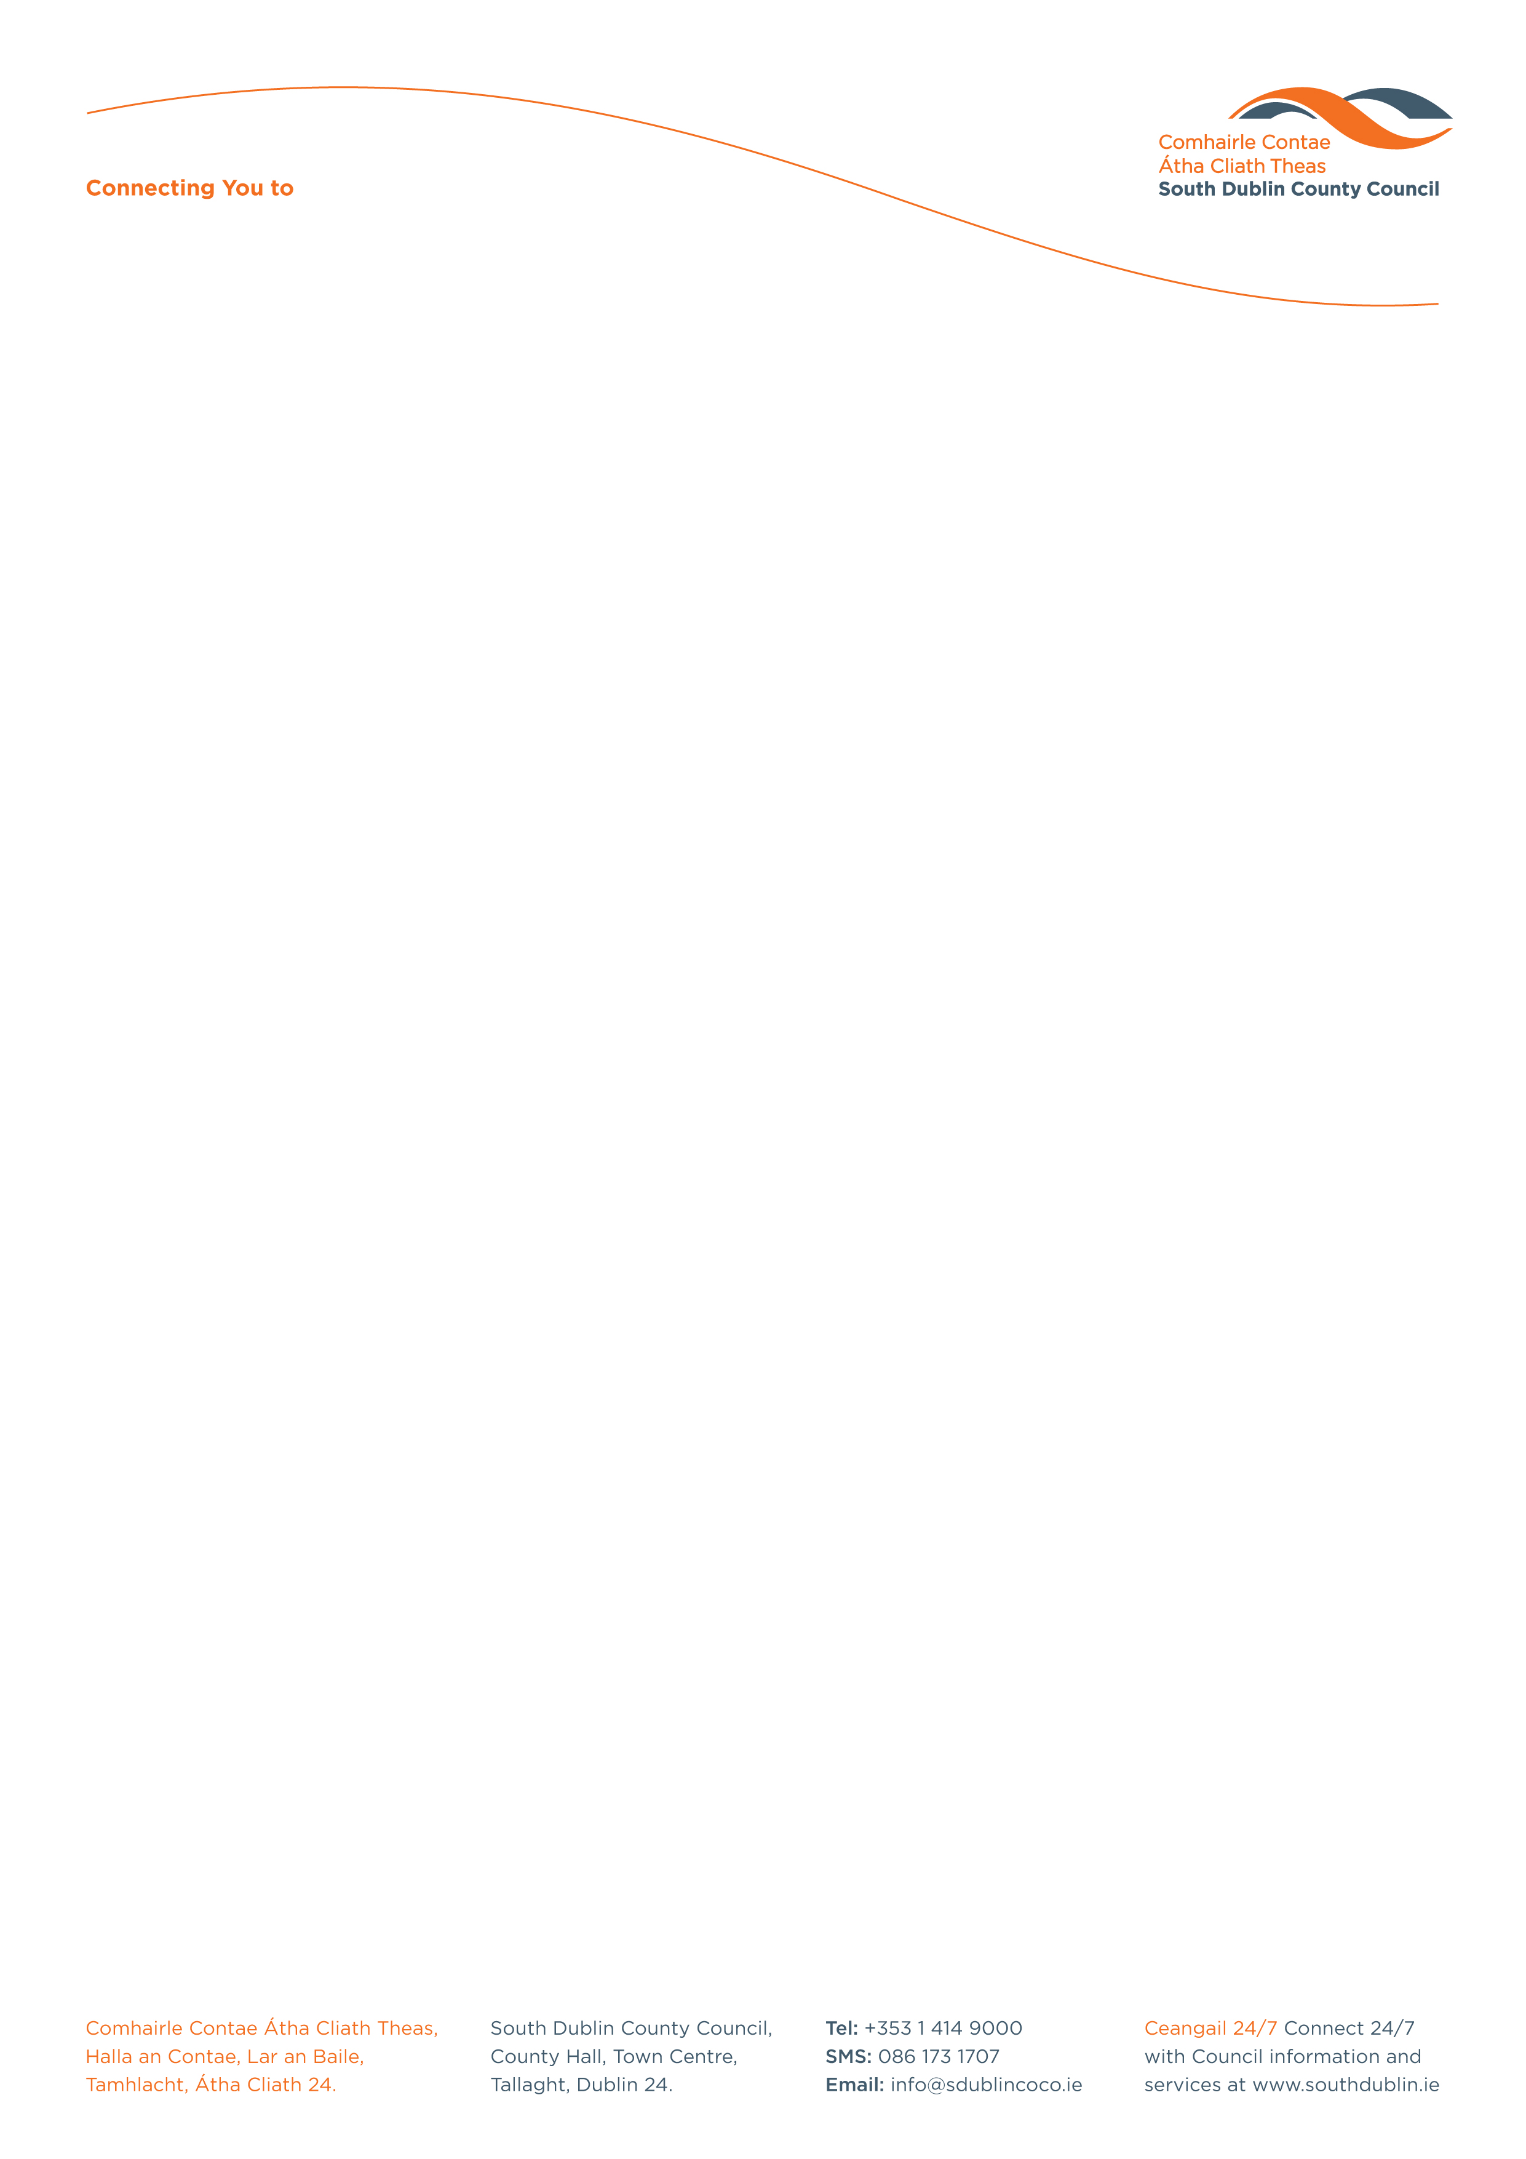

Halla an Chontae, Lár an Bhaile County Hall, Town Centre
Tamhlacht, Baile Átha Cliath 24 Tallaght, Dublin 24
Telefon: 01-4149052 Telephone: 01-4149052

Facs: 01-4149332 Fax: 01-4149332
www.southdublin.ie

Manager
Dublin Bus
59 Upper O’Connell Street
Dublin 1.

27th November, 2008

RE: Tallaght Area Committee Meeting – 24th November, 2008

Dear Sir/Madam,

At the Tallaght Area Committee Meeting of 24th November , 2008 the following motion was passed:

"That this committee calls on the Manager to write to Dublin Bus requesting an alternative bus stop to be placed in the vicinity of the recently controversially removed stop opposite the main entrance to the De Selby estate on the Blessington Road as a matter of urgency - the removal of this stop is causing enormous hardship to residents of the De Selby and surrounding areas who are dependent on Dublin Bus as their primary mode of transport, particularly at this time of year given bad weather, low visibility at night etc".
I should be obliged if you would let me have a reply on this matter at your earliest convenience.

Thanking you in anticipation.

Yours sincerely,

ALLYSON ROONEY,
SENIOR STAFF OFFICER,
HOUSING ADMINISTRATION.

Housing Administration

