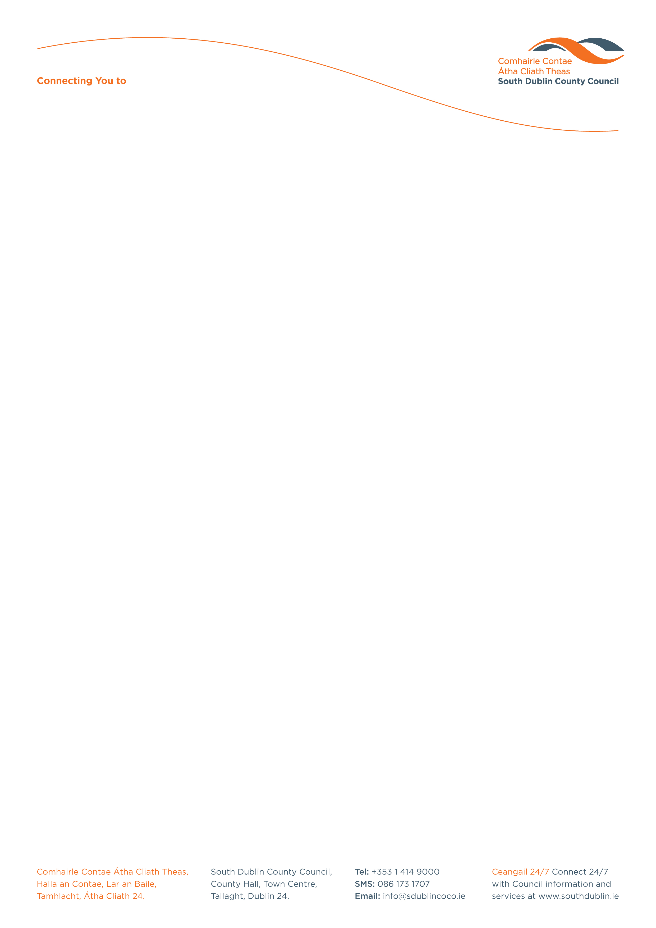

Halla an Chontae, Lár an Bhaile County Hall, Town Centre
Tamhlacht, Baile Átha Cliath 24 Tallaght, Dublin 24
Telefon: 01-4149052 Telephone: 01-4149052

Facs: 01-4149332 Fax: 01-4149332
www.southdublin.ie

Manager
Bus Atha Cliath
59 Upper O’Connell Street
Dublin 1.

27th November, 2008

RE: Tallaght Area Committee Meeting – 24th November, 2008

Dear Sir/Madam,

At the Tallaght Area Committee Meeting of 24th November , 2008 the following motion was passed:

"That this Council Committee concerned at the difficulties being experienced by students attending the local IT in Tallaght, their lack of any shelter at the bus stop on the Old Blessington Road opposite St Maelruans Church and at the long and unnescessary delay in the erection of any shelter at this site, agrees to call on the manager to immediately contact Bus Atha Cliath to resolve this issue as a matter of urgency".
I should be obliged if you would let me have a reply on this matter at your earliest convenience.

Thanking you in anticipation.

Yours sincerely,

ALLYSON ROONEY,
SENIOR STAFF OFFICER,
HOUSING ADMINISTRATION.

Housing Administration

