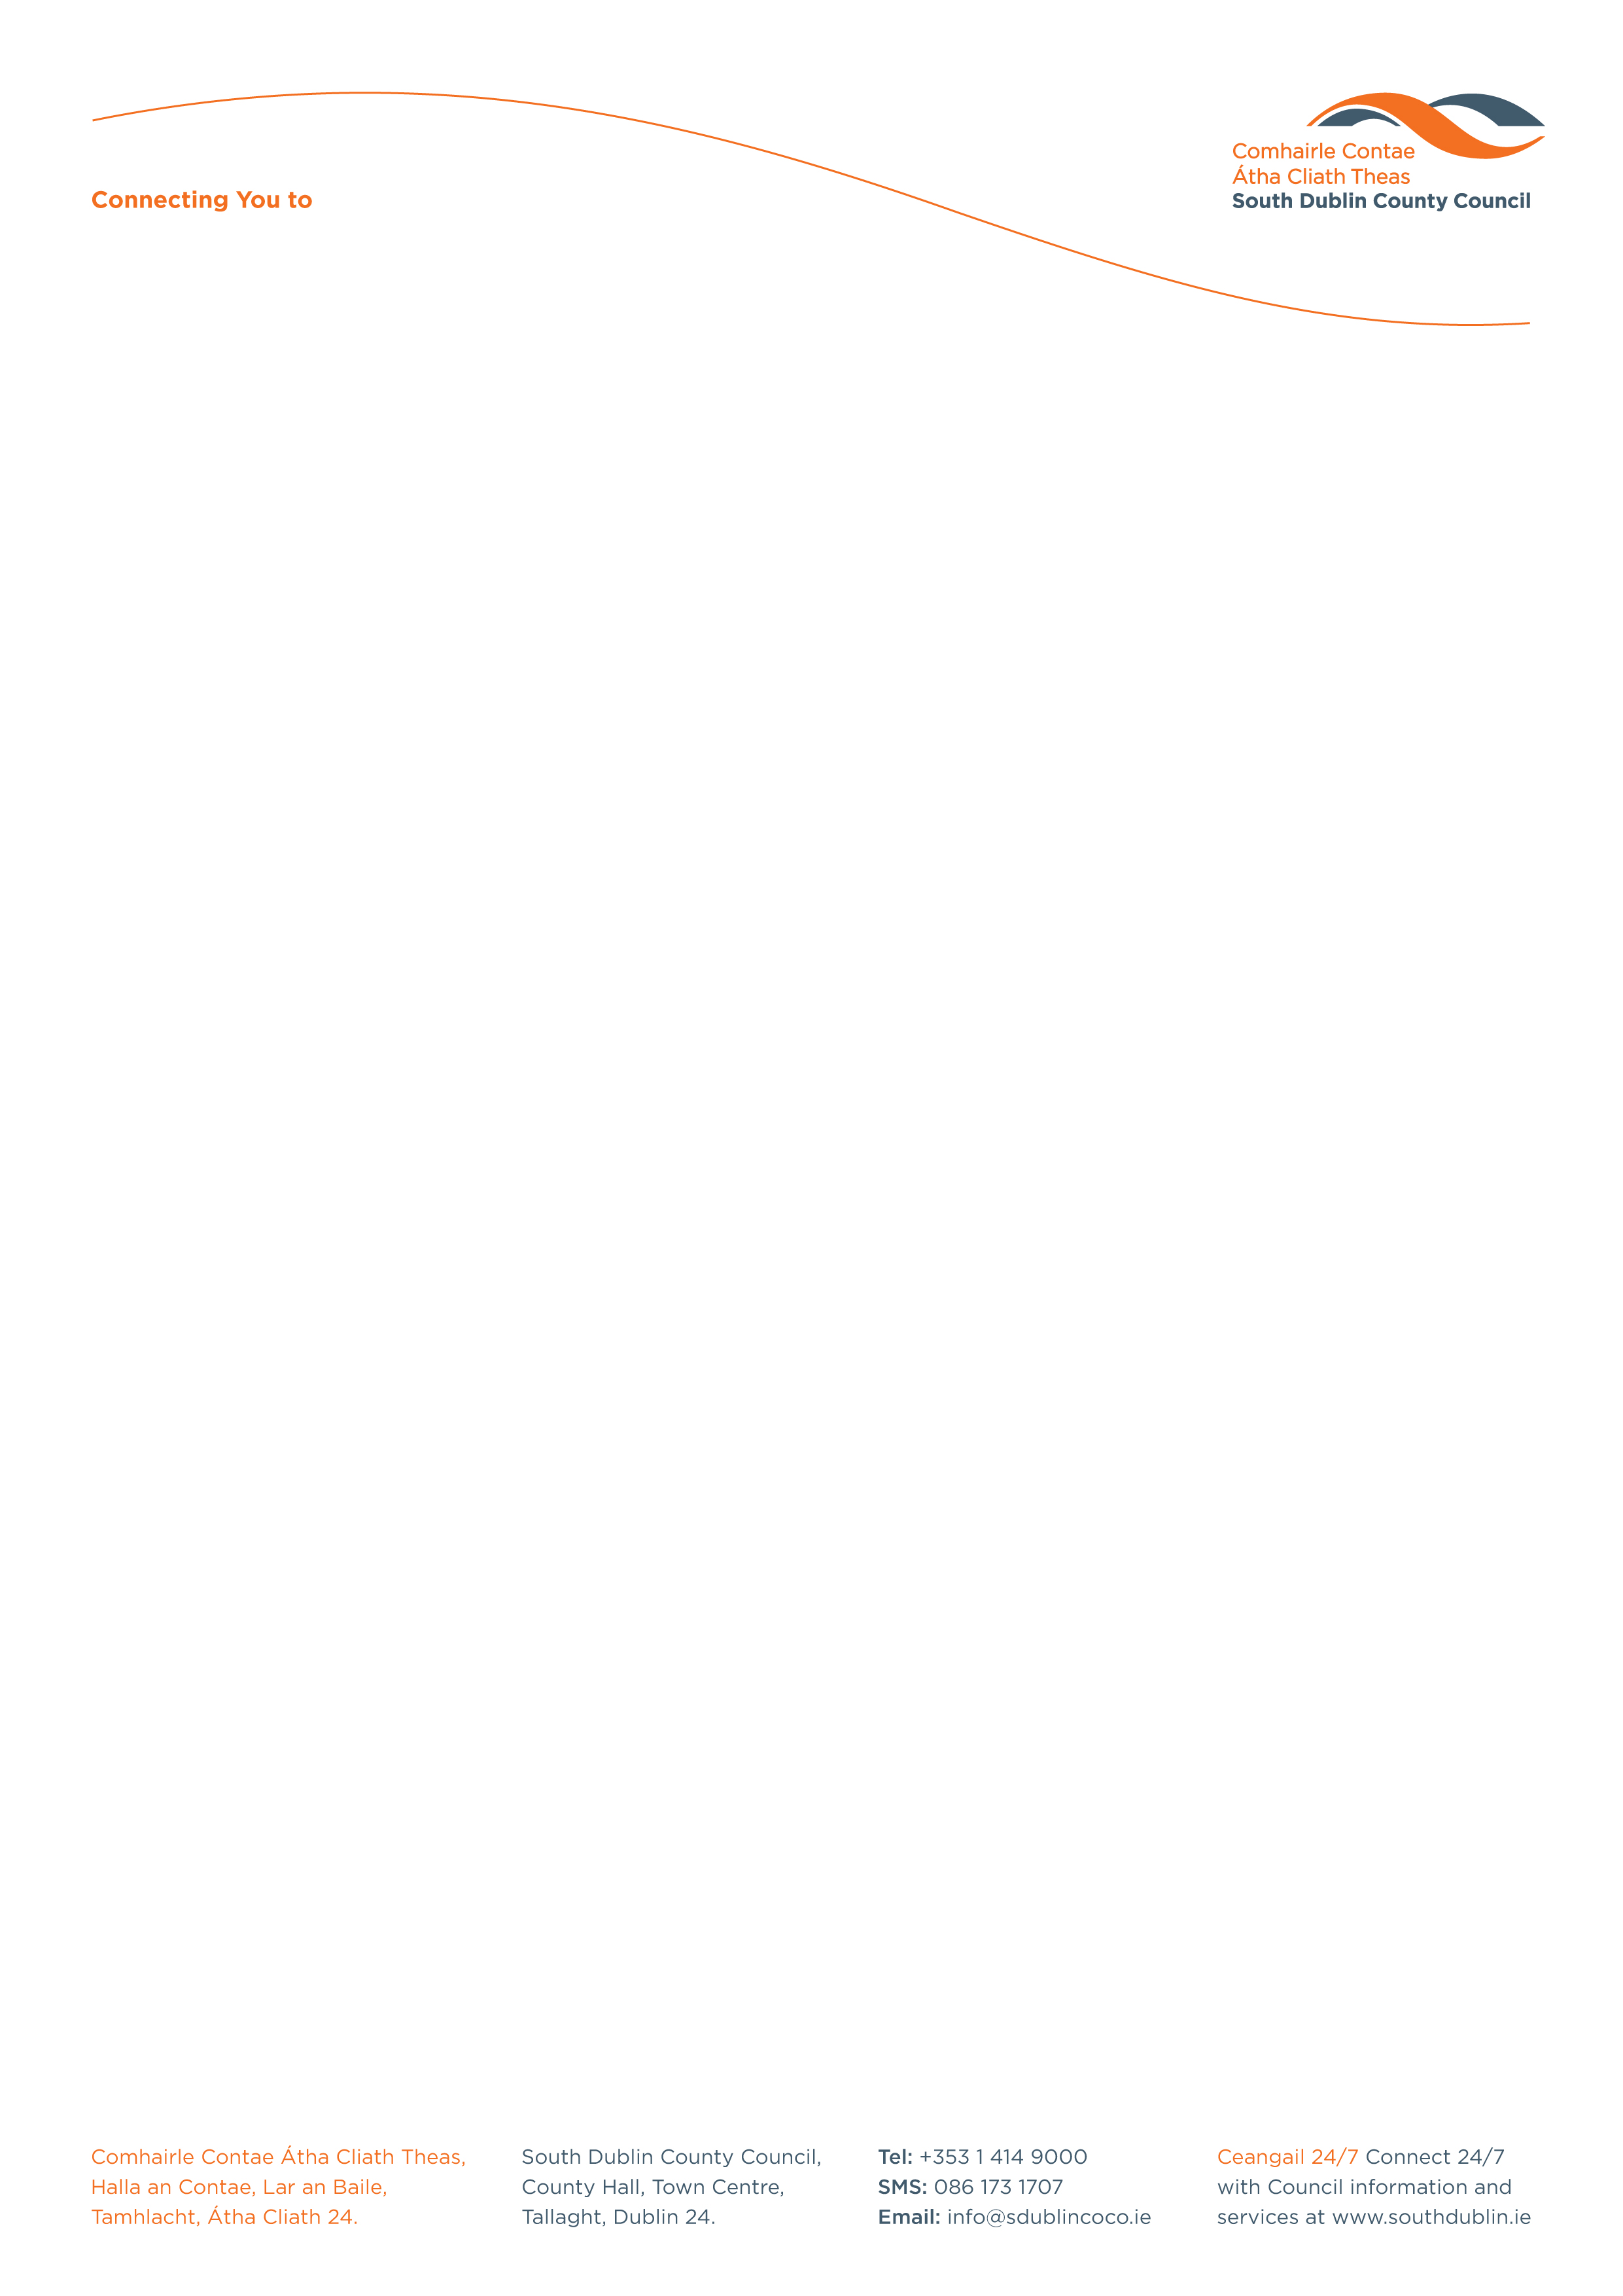

Halla an Chontae, Lár an Bhaile County Hall, Town Centre
Tamhlacht, Baile Átha Cliath 24 Tallaght, Dublin 24
Telefon: 01-4149052 Telephone: 01-4149052

Facs: 01-4149332 Fax: 01-4149332
www.southdublin.ie

Clock Tower Public House
Kingswood Shopping Centre
Tallaght
Dublin 24.

10th November, 2008

RE: Tallaght Area Committee Meeting – 28th October, 2008

Dear Sir/Madam,

At the Tallaght Area Committee Meeting of 28th October , 2008 the following motion was passed:

“This committee calls on the manager to write to the owners of Kingswood Shopping centre to express the urgent need for improvement in the areas of lighting, car park surfacing and in litter cleansing”.

I should be obliged if you would let me have a reply on this matter at your earliest convenience.

Thanking you in anticipation.

Yours sincerely,

ALISON ROONEY,
SENIOR STAFF OFFICER,
HOUSING ADMINISTRATION.

Housing Administration

