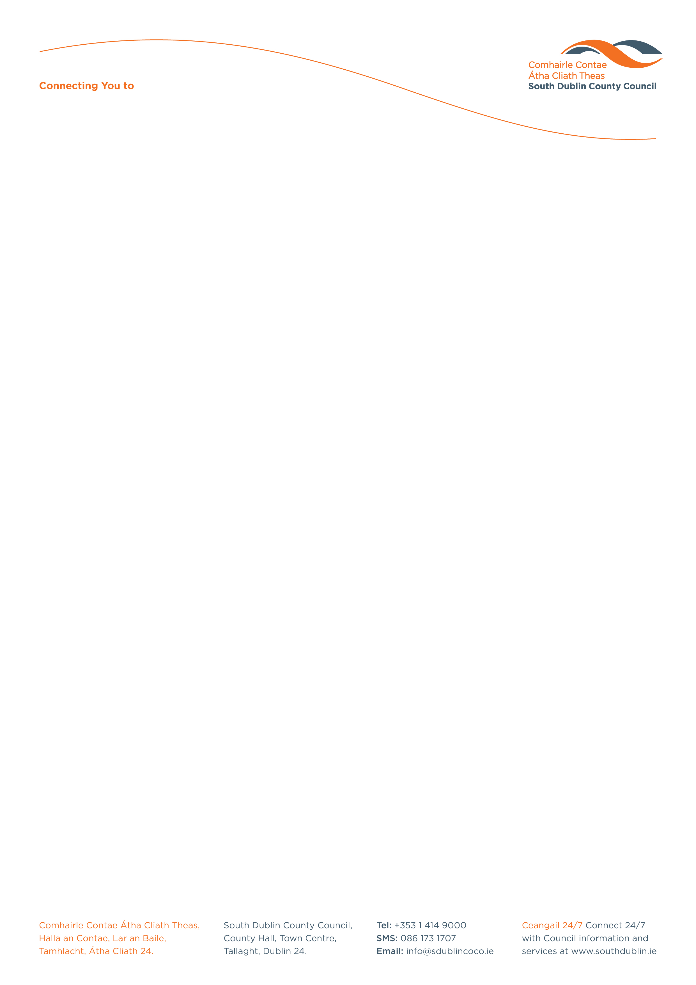

Halla an Chontae, Lár an Bhaile County Hall, Town Centre
Tamhlacht, Baile Átha Cliath 24 Tallaght, Dublin 24
Telefon: 01-4149052 Telephone: 01-4149052

Facs: 01-4149332 Fax: 01-4149332
www.southdublin.ie

The Lilliput Press
62-63 Sitric Road
Arbour Hill
Dublin 7.

3rd November, 2008

RE: Tallaght Area Committee Meeting – 28th October, 2008

Dear Sir/Madam,

At the Tallaght Area Committee Meeting of 28th October , 2008 the following motion was passed:

“This committee condemns the fictional use, by an author, of a Tallaght place name, to depict actual criminal events that took place outside of this County. Further, this committee resolves write to the author in question to communicate this condemnation and the negative implications of the author's action.”
(The book referred to is “Bad Day in Blackrock” by Kevin Power)

I should be obliged if you would let me have a reply on this matter at your earliest convenience.

Thanking you in anticipation.

Yours sincerely,

JOAN KELLY,
SENIOR STAFF OFFICER,
HOUSING ADMINISTRATION.

Housing Administration

