COMHAIRLE CONTAE ATHA CLIATH THEAS

SOUTH DUBLIN COUNTY COUNCIL

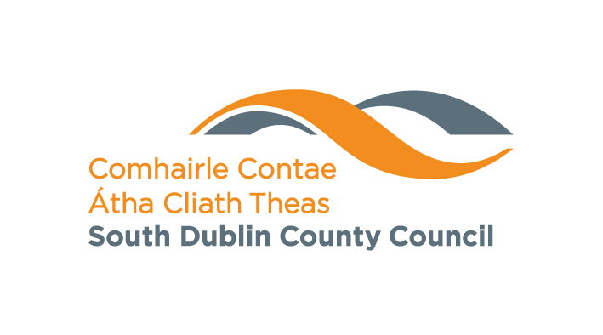

MONDAY 15th SEPTEMBER 2008

TALLAGHT AREA COMMITTEE (1)

ITEM NO: H-I (11)

LIBRARY EVENTS

September 2008
Branch | Events |  | Date
Castletymon | Exhibition - History of Printing from the National Print Museum | Month of September
 | Display of Adult Education and Evening Class Information | Month of September
 | English for Foreign Nationals. All Welcome. | Resumes Monday 15th September at 10am
 | Improvers Irish Conversation Class. Booking Necessary | Resumes Tuesday 30th September at 10am
 | Book Club  All Welcome. | Resumes Tuesday 30th September at 11am
 | Computer Class  Booking Necessary. | Wednesdays from 10am – 12pm.
 | Spanish Conversation Group. All Welcome. | Resumes in September Fridays at 10am
 | Junior Book Club for 7 – 10 year olds. All welcome. | Tuesday 9th & 23rd September at 3.30pm
 | Story time for 3-6 year olds.  All Welcome. | Wednesdays at 3.30pm
 | Arts and Crafts with Sinead for 8 – 12 year olds.  Booking Necessary | Thursdays at 3.30pm
 | Tour of Library and Storytime. Booking necessary | Thursday Mornings.

September 2008
Branch | Events | Date
Tallaght | Oidhreacht 2008 Heritage Photographic Competition: Digital display of winning photos in Tallaght library. | Month of September
 | Art Exhibition - Philipina | September 1st - 29th
 | Irish Conversation  Booking essential | Mondays at 10.30am
 | Spanish Conversation  Booking essential | Tuesdays at 6.30pm
 | Computer Classes  Booking essential | Tuesdays 7pm - 9pm
 | Computer Classes  Booking essential | Wednesdays 11am-1pm
 | English Conversation  Booking essential | Wednesdays  Beginners 5pm  Intermediate 6.30pm
 | Tracing your Family Roots  A day long workshop with Ruth Lawlor. Booking essential | Saturday 6th September from 10.30am - 4pm
 | Exhibition - Irish Life and Lore | 8th – 30th September
 | Launch of “Drinking the colour Blue” By Eileen Casey This will be launched by Dermot Bolger | Tuesday 9th September at 7pm
 | Launch of Audio version of  “If those trees could speak” Followed by a talk with Frank Tracy | Thursday 11th September at 7.30pm
 | Lunchtime Salsa Dance class with Hilary Clarke 6 week course. Booking essential | Begins Wednesday 17th September at 1pm
 | History & Heritage Month Book Launch: Bumps in the Fields and Crumbling walls: Field Archaeology for Sunday Afternoons by Jermann Geissel. All welcome! | Wednesday 24th September at 7.30pm
 | Digital Photography Course with Podge Kelly.  Booking essential | Begins Thursday 25th September at 6.30pm
 | Exhibitions - 100 Years of St. Endas | August 25th – 30th September

 | Polish for beginners  Booking essential | Fridays at 10.30am

