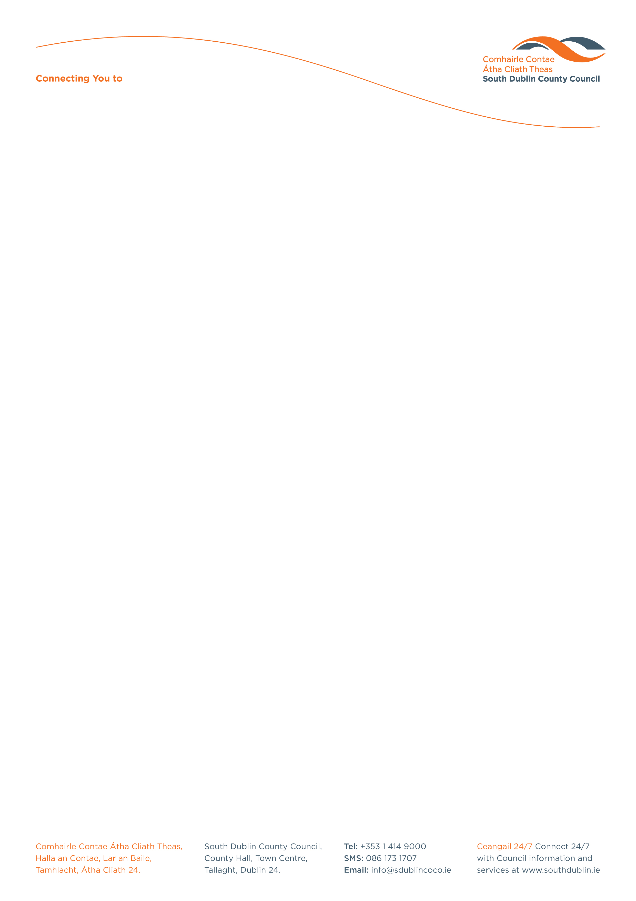

Halla an Chontae, Lár an Bhaile County Hall, Town Centre
Tamhlacht, Baile Átha Cliath 24 Tallaght, Dublin 24
Telefon: 01-4149052 Telephone: 01-4149052

Facs: 01-4149332 Fax: 01-4149332
www.southdublin.ie

09th September, 2008

Customer Services
An Post
Ground Floor
GPO
Freepost
Dublin 1

RE: Tallaght Area Committee Meeting – 23rd June, 2008

Dear Sir/Madam,

At the Tallaght Area Committee Meeting of 23rd June, 2008 the following motion was passed:

“That this Committee calls on An Post to locate a post box at Old Court Shopping Centre.”

I should be obliged if you would let me have a reply on this matter at your earliest convenience.

Thanking you in anticipation.

Yours sincerely,

JOAN KELLY,
SENIOR STAFF OFFICER,
HOUSING ADMINISTRATION.

Housing Administration

