Halla an Chontae  Lár an Bhaile  Tamhlacht,  Baile Átha Cliath 24  Telefon: 01-4149052  Facs: 01-4149332 | 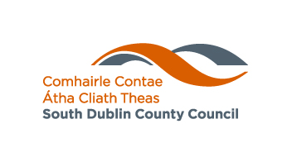 | HOUSING DEPARTMENT  County Hall,  Town Centre  Tallaght  Dublin 24  Telephone: 01-4149052  Fax: 01-4149332  www.southdublin.ie

15th July, 2008

Ms Margaret Taheny-Moore
Director
Private Rental Tenancy Board
2nd Floor, O'Connell
Bridge House, D'Olier Street
Dublin 2

RE: PRTB - Tallaght Area Committee Meeting – 16th June, 2008

Dear Ms Taheny-Moore,

At the meeting of the Tallaght Area Committee of the Council held on the 16th June, 2008 the following Motion was passed:

“That this Committee contacts the PRTB with a view to arranging a meeting with Tallaght councillors in order to assess the impact positive or otherwise of the Board in the Tallaght area.”

I should be obliged if you would let me have your reply at your earliest convenience.

Thanking you in anticipation.

Yours sincerely,

JOAN KELLY,
SENIOR STAFF OFFICER,
HOUSING ADMINISTRATION.

